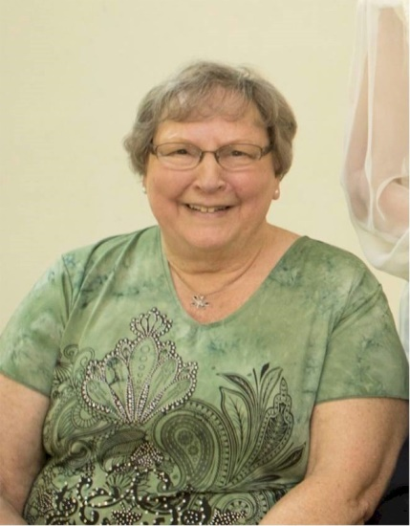
Beverly Zanella

Notable – Accomplishments/Contributions

Beverly Lou (Sulzbach) Zanella was introduced to ballooning when her then boss, Robert Zanella bought a balloon in 1972. Having a large yard, it was decided to do a first inflation at her home. At first, thinking him crazy, she soon was in awe and curiosity had her crewing at every chance. The first ride had her hooked! After Bob got his license, she was one of the first in line to take lessons. It took many calls to the FAA to finally get an examiner to give her a check ride. As a result she was the second woman in Ohio to get a balloon license. (October, 1973).
She became interested in competition and did some local races. There was a need for scoring officers, so she was approved by the BFA to do this. Starting at Peru, Indiana in 1976, she did scoring for many local races in OH, also in IN and PA.
As the years went by, with more and more balloons in the area, there was a need for a repair station. In 1985, she and Bob opened Falcon's Nest Repair Station, spending many all-nighters for people who had damaged balloons at different rallies.
In 1980, she was one of the founders of The Northeast Ohio Pilots Association and served on the Board several times. She was also a presenter at the association meetings and at safety seminars. She received the Annie Pryne Award and the Gayle Myers Award from the
Northeast Ohio Pilots Assn.
Even though she lost her beloved ballooning husband in 2010, she still is involved and hasn't lost her love for ballooning and for the ballooning family accumulated over the years.

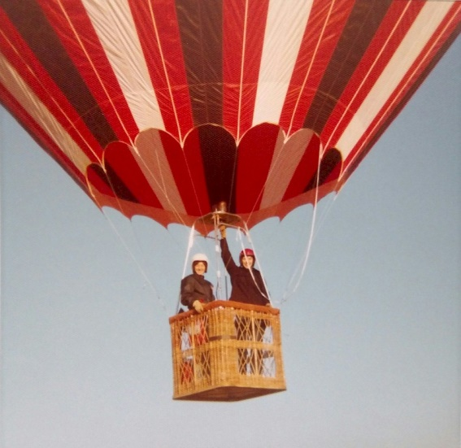

See pictures and additional information on following pages.
