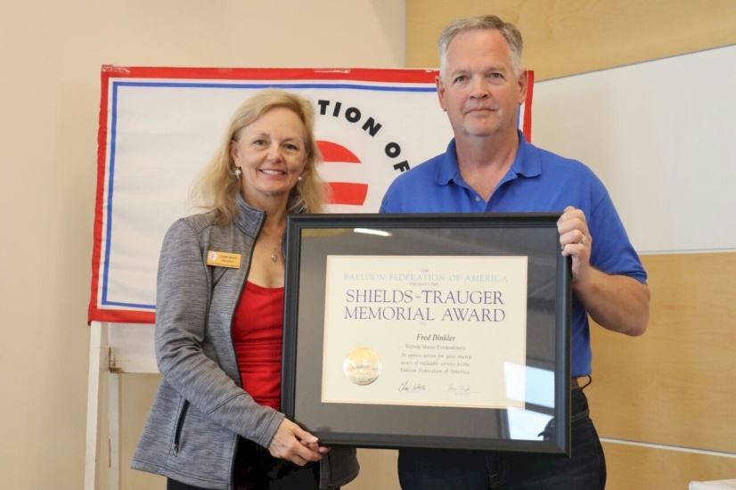
Fred Dinkler

Notable – Accomplishments/Contributions, Ed Yost Award, Shields Trauger Award

Fred was recruited as a teenager to chase balloons in Iowa in the summer of 1970, by the luck of the draw, he was assigned to chase David Schaeffer and Bruce Comstock, legendary pioneers in hot air ballooning. Thereafter, he began a life-long passionate pursuit of aviation. After graduating college in 1976, Fred was commissioned an Officer in the United States Marine Corps, and for the next ten years flew as an Attack Helicopter Commander. Leaving the Marines in 1985, he built a successful career in technology consulting across the globe, while continuing to build lasting friendships in the balloon community. He and his Crew Chief for Life, Christel, travel the United States as full-time RVers.
Fred received the Ed Yost Master Pilot Award for 40 Years of safe flying in 2017 and received the Shields Trauger Award from the Balloon Federation of America at the Annual Meeting in Albuquerque in October 2018.



See the nomination letter for the Shields Trauger Award on the following page.

