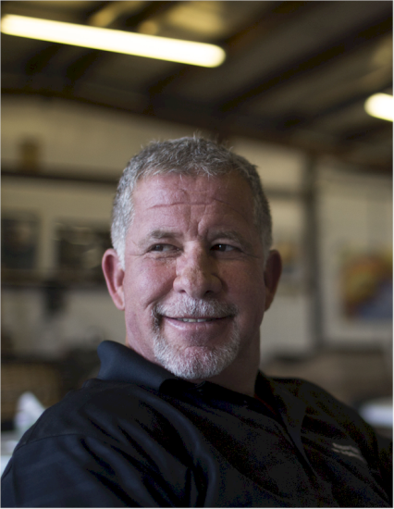
Wayne Scott Appelman

Notable – Accomplishments/Contributions, Records

5601 Eagle Rock NE
Albuquerque, New Mexico 87113
505.379.3640

President/CEO Rainbow Ryders, Inc. Hot Air Balloon Company providing balloon rides and corporate promotion.
Rainbow Ryders is celebrating its 36th Anniversary and is the largest balloon ride business in the United States. We operate 29 balloons year round doing over 2800 flights per year and flying over 25,000 passengers. With full time operations in Albuquerque, Phoenix and Colorado Springs and Las Vegas, with 80 employees.
We have flown in 45 states and have manage events in Bentonville, Arkansas, Albuquerque, Phoenix, Colorado Springs, Chihuahua Mexico and Guadalajara, Mexico,
Experience:
- Commercial Pilot License Lighter than Air, September 1984. 5400+ pilot in command flight hours, 800 tether hours, special shape balloon pilot
- Established and manage RAINBOW RYDERS, INC. a commercial hot air balloon company offering rides, tethers, promotion, instruction and all sales aspects of hot air ballooning, 1984 to current.
- Official Hot Air Balloon Ride Concession for the ALBUQUERQUE INTERNATIONAL BALLOON FIESTA® since 1999.
- Operate Corporate and promotional balloons for:
Heineken USA, Dos Equis Brand, Phillips 66, Intel Corporation, FIGI (Fraternity) Black Diamond, State of New Mexico Centennial Balloon, City of Albuquerque Tricentennial Balloon, Santa Ana Star Casino, Casa Automotive Group, Gateway Computers, General Mills, Inc., Ocean Spray Cranberries, KOB-TV4 , Journal Pavilion, Isleta Gaming Palace and many more
- Dos Equis Ambassador of Adventure, Worlds Most Interesting Balloon Pilot,
- Pilot for GOOD MORNING AMERICA’S “Tour of the Southwest”.
- Managing Partner Hot Apple Productions- Production company for Colorado Springs Labor Day Lift Off Balloon event. 165,000 spectators, 70+ balloons, entertainment, concerts and concessions 2015-current
- Board of Directors of the ALBUQUERQUE INTERNATIONAL BALLOON FIESTA (AIBF) 1986-1991

- Chairman of the Board for the ALBUQUERQUE CONVENTION AND VISITORS BUREAU 2001-2002
- Board of Directors of the ALBUQUERQUE CONVENTION AND VISITORS BUREAU 1993 to 2010. Chairman of Marketing Committee 1996 and 1997, served on Research Task Force, Executive Search Committee, Nominating Committee, and Convention Sales.
- Originator and Organizer of AIBF’s “BALLOON GLOW” 1987- 1992
- Originator and one of the Organizers of Wells Fargo’s “SPECIAL SHAPE RODEO” 1989.
- Originator and Organizer of AIBF’s “ALBUQUERQUE ALOFT”
- Sponsor Recruitment for the ALBUQUERQUE INTERNATIONAL BALLOON FIESTA-1991
- President of TOP GUN, INC., a New Mexico competitive hot air balloon club, top Gun Balloonmeister, Safety Officer, 1988-1994.
- Organizer of the “HANDS ACROSS AMERICA BALLOON RALLY” 1985 and headed “HANDS ACROSS NEW MEXICO” steering committee.
- Competitor of the “US NATIONAL HOT AIR BALLOON CHAMPIONSHIP”
- New Mexico “TOP GUN” Hot Air Balloon Champion, 1987.
- World Record Holder-altitude flight.
- Inductee State of NM Tourism Hall of Fame

Education:
University of New Mexico
R.O. Anderson School of Management
Bachelor of Business Administration
Financial Management and Economics

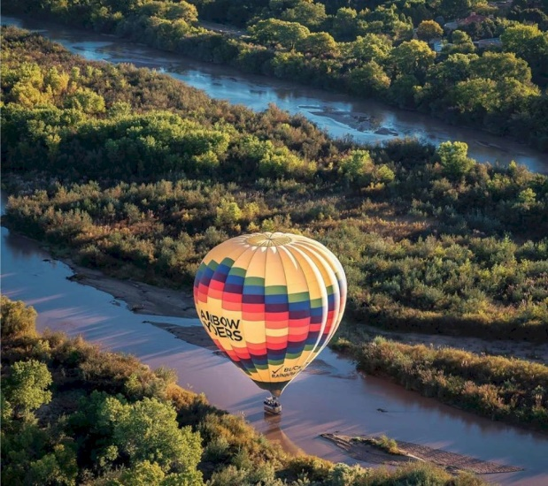

The following was taken from the Rainbow Riders Web site:

Scott Appelman
Scott Appelman is the founder and president of Rainbow Ryders, Inc.- the largest balloon ride business in the United States. Rainbow Ryders operates 26 balloons year round doing over 2200 flights per year. Flying over 22,000 passengers annually. Rainbow Ryders’ pilots have flown in 45 states and managed events in Colorado Springs, Phoenix, Chihuahua and Guadalajara, Mexico.
After graduating from University of New Mexico’s Anderson School of Management, Scott wanted to make his hobby of hot air ballooning into a career…. In September of 1984, Scott received his Commercial Pilot’s License, Lighter than Air rating.
In 1983, Scott established Rainbow Ryders, Inc. a commercial hot air balloon company offering rides, tethers, promotions, instruction and all sales aspects of hot air ballooning. Rainbow Ryders, Inc. has operated the Official Hot Air Balloon Ride Concession for the Albuquerque International Balloon Fiesta since 1999. Scott has logged more than 5100+ pilot in command flight hours, 700 tether hours, and is also a special shape balloon pilot.
Scott flies ride balloons and operates corporate and promotional balloons for Rainbow Ryders’ commercial clients, which include Dos Equis Beer, Intel, Phillips 66 Fidelity Investments, NM Pinon Coffee, KOB TV-4 to name a few
Scott has held positions on the Board of Directors of the Albuquerque International Balloon Fiesta ® (AIBF) 1986-1991, Chairman of the Board for the Albuquerque Convention and Visitors Bureau 2001-2002, Board of Directors of the Albuquerque Convention and Visitors Bureau 1993 to current. He was the originator and organizer of AIBF’s “BALLOON GLOW” 1987 through 1992, co-originator of AIBF’s “SPECIAL SHAPE RODEO” 1989 and 1990, and AIBF’s “ALBUQUERQUE ALOFT” 1991. Scott was honored with the Heritage Award from the Albuquerque International Balloon Fiesta in 2013, and he currently serves as the President the Anderson Abruzzo International Balloon Museum Foundation board of directors.

