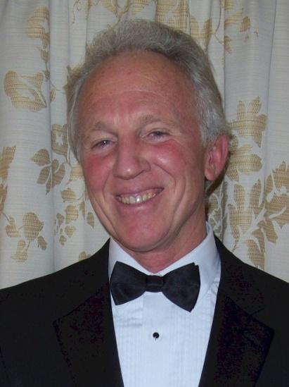
Bill Arras

Notable – Accomplishments/Contributions, Record

- Rotary International Exchange Student to Brazil in 1972-3
- World traveler with visits to more than 100 countries
- Avid outdoor sports enthusiast, adventurer and photographer https://balloonbill.smugmug.com/
- hang glider pilot since 1980, with 3000+ pilot hours
- first US manufacturer of paragliders and a current paraglider pilot
- hot air and gas balloon pilot since 1986, with ~2500 pilot hours
- 1990 first person to fly a balloon between US & USSR, in the Bering Strait
- 1995 set the FAI World Record for Duration in AX-5 balloons
- 1995 first to fly a balloon above Antarctica
- 1995 first person to fly a balloon above all seven continents
- 1999 Hot Air Balloon World Champion
- Top finisher in numerous US and international balloon competitions
- 2000 Director of Brazilian Hot Air Balloon National Championship
- 2005 winner of America’s Challenge Gas Balloon Race with a 46 hour nonstop flight of 1495 miles
- 2018 hydrogen gas balloon flight of 29 hours duration, 845 miles from Germany to Estonia
- Designed, built and registered 9 hot air balloon

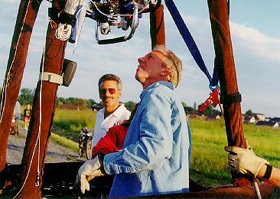
David Levin and Bill Arras

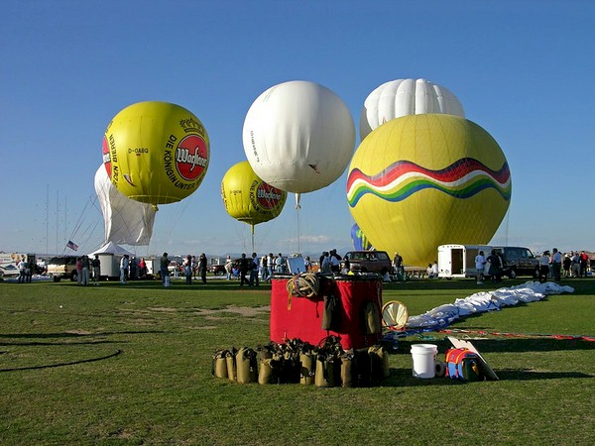
America’s Challenge 2004

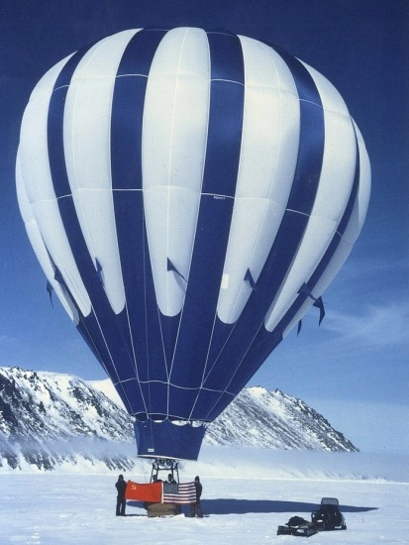
"Morning Star" on the ice after making the first balloon flight between the US and the USSR, in 1990 in the Bering Strait.
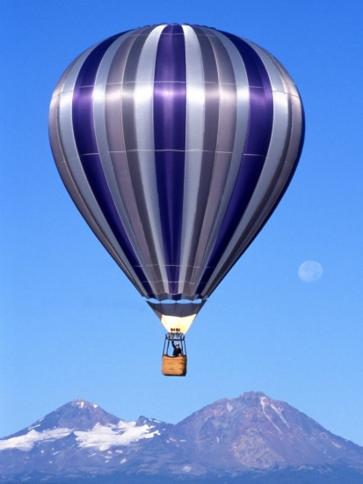
"Jimi", the first balloon built. 54,000 cu. ft., made from 1.1 oz. calendared non-coated rip-stop nylon, with lightweight load tapes. The first balloon flight above Antarctica was made with this balloon.
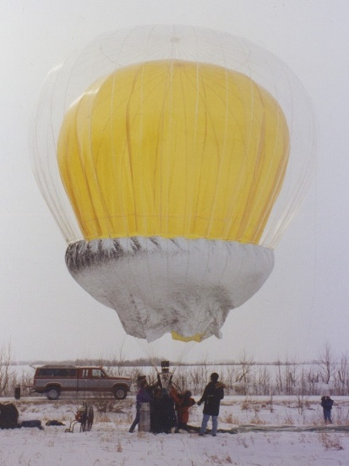
"Jellyfish", one of the experimental balloons designed and built. The inner layer is high temperature kapton film, the outer layer is nylon film, with an aluminized mylar film for the skirt
Three covers made for the 1999 Antarctica flight, and the 2002 HAB World Championships:

