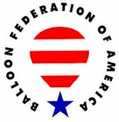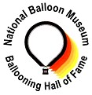

UNITED STATES BALLOONING HALL OF FAME
A Partnership of the Balloon Federation of America and the National Balloon Museum

Candidate Information Form

Date Submitted: August 11, 2018

CANDIDATE NAME: Tucker Comstock

Address: City: Ann Arbor State: MI ZIP: 48106

Telephone: (888) 414-6023 E-mail: tucker@ix.netcom.com
Briefly describe the basis for the submission:

Beginning in 1970, Tucker Comstock became a unique force in the development of ballooning in the U.S. Her contributions in the early years of the sport were significant, and they were many. These helped to shape the national organization, ballooning safety, competition, balloon design, and the very culture of ballooning.
As her husband, I was a close observer of her energetic engagement with everything ballooning. She saw needs, and she responded. All of us are the better for this.
Tucker is an important part of ballooning history. She has herself done, or has been closely involved in, every ballooning activity listed as a possible qualification for induction into the U.S. Ballooning Hall of Fame. I urge you to consider her for this honor.
Thank you.

Bruce Comstock
.
Provide references: Identify two individuals that can speak to the quality and significance of the achievement, and to the character of the candidate.

Reference Name: Debbie Spaeth Telephone or E-mail: dasdeb@sbcglobal.net

Reference Name: Andy Baird Telephone or E-mail: baird@cameronballoons.com

PERSON MAKING THE SUBMISSION:

Name: Bruce Comstock
Address: 467 Williamson Way City: Ashland State: OR ZIP: 97520-1250

Telephone: (541) 944-2237 E-mail: brucecomstock@ix.netcom.com

CANDIDATE HISTORY:

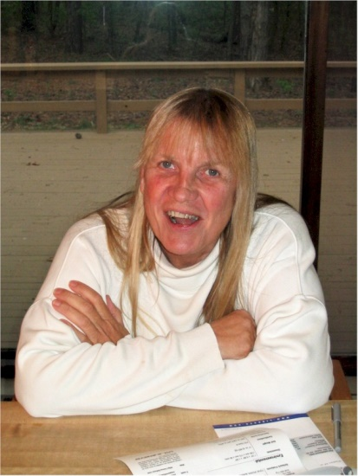
TUCKER COMSTOCK

Notable – Accomplishments/Contributions, Shields Trauger Award

Tucker Comstock’s ballooning began in the summer of 1970, a time when there were 40 or so active balloonists in the U.S. She engaged with the sport in many ways. Sharing a home with two active balloon pilots and another soon-to-be balloon pilot, Tucker was the one who took many of the ideas generated in the lively dinner conversations and made them happen. Some of these follow.
- In 1971, in concert with her husband Bruce, she resurrected Ballooning magazine and turned it from a newsletter into a reliably published magazine with a slick, full color cover. This was only possible because of her enthusiastic commitment and energetic work. This included ignoring labor contractions until she had finished preparing the spring 1972 issue – then rushing to the hospital and giving birth less than two hours later.
- In 1972 she organized the first FAA-certified balloon repair facility in the U.S., Aerofixica, Inc., even taking care to consult with a classics professor at the University of Michigan to be sure the Latin motto, “inceditis, reficimus”(“you burn it, we fix it”) correctly conveyed the appropriate thought. Almost a half-century later, this repair facility continues to function – as the Cameron Balloon US factory repair station.
- In the winter of 1972-73, seeing the need, Tucker created the first computer-based system for keeping track of BFA membership at a time when the organization was rapidly growing towards a thousand members. She did this at no cost to the BFA, using computer time she was able to scavenge.
- In 1973, Tucker started the BFA Pilot Newsletter to allow balloon accident and safety information to be disseminated to balloon pilots without any concern of misunderstanding by the wider public. Tucker served a second stint as interim editor of the Pilot Newsletter in 1978.
- Tucker was licensed to pilot hot air balloons on August 23, 1973. Five days earlier she had landed during a solo flight in 800 foot per minute thermals on what would, by chance, 12 years later become the balloon test inflation lawn of Cameron Balloons U S, the balloon manufacturing company she and Bruce later founded.
- In 1973-74, she led the work to create what quickly became the standard international competition drop marker which, with only minor adjustments, has been in use ever since.
- In the mid-1970s she conceived of the envelope squeezer, then as a conical fabric device that was clipped around the envelope at the mouth and pulled towards the crown by a strap on each side. This later inspired the metal squeezers popular today.
- In 1975, while a member of the BFA Events Committee, Tucker worked with Karl Stefan to develop standardized task rules for balloon competition, and with Tom Sheppard to create overall event rules. She was also the Events Committee Scoring Manager and served as scoring officer at the first ever BFA sanctioned event, the 1975 Kettle Moraine Balloon Rally in West Bend, Wisconsin.
- During the mid and late 1970s Tucker worked to advance ballooning safety, including creating a seminal article on power line avoidance published in one of the early BFA Pilot Newsletters. The heart of the article forcefully advanced the idea of “when in doubt, rip it out”. She chaired the BFA Education Committee from 1978 to 1980, and was instrumental in the creation of the concept of ballooning safety seminars. She organized some of the earlier safety seminars and spoke at many. She also served as safety officer at balloon meets.
- In the later 1970s, Tucker served as an FAA Designated Pilot Examiner for ballooning, until an auto accident in 1980 interfered.
- In 1979, when Bob Kinsinger had the idea of having a world championship in Battle Creek, Michigan he turned to Tucker for her knowledge and expertise in balloon competition organization. In a series of meetings with local Chamber of Commerce people Bob and Tucker sold the idea and shepherded the process along. After her husband Bruce qualified to compete in this world championship, Tucker felt she had to withdraw from any further part in the organization. As a result few know the critical role Tucker played in the genesis of this event in Battle Creek, which was the beginning of the big annual balloon competitions that have been held there ever since.
- In 1980 Tucker was a principal in the planning and conduct of two world hot air balloon records: the first ever 24-hour flight and the (at the time) longest distance flight.
- In 1980 Tucker received the BFA’s highest honor – the Shields-Trauger Memorial Award – for her contributions to, and accomplishments in, ballooning.
- In the early 1980s Tucker and Bruce built Cameron Balloons U S into one of the major balloon manufacturing companies in the U.S. More than thirty-five years later the company continues in this position.
- In 1983, Tucker received the BFA President’s Award in recognition of her many contributions to ballooning and the BFA.
- In 1989 and 1990, during the breakup of the Soviet Union, Tucker organized groups of American pilots to attend balloon events in the Soviet Union, first in Vilnius, Lithuania and later in St. Petersburg, Russia. As a result of friendships made during these events Tucker sponsored memberships of two Russian test pilot/astronauts into the Society of Experimental Test Pilots, making them the first Soviet members of this elite organization.
- In 1991 Tucker brought ballooning to the nation of Costa Rica, and in 2011 made the first balloon free flight in Panama.
- She has trained many balloon pilots in safe and competent balloon piloting practice. Tucker has more than 2,500 hours as balloon pilot-in-command. She has also made multiple gas balloon flights and piloted a hot air airship.
- For the two decades up to the early 1990s, she was the respected crew chief of a team that won six national hot air balloon championships and one world hot air balloon championship. David Levin, one of the other top competitors in the U.S., was later quoted as saying: “I sure wish I had had Tucker as my crew chief.”
- In 2002, Tucker organized a balloon project to fly scientific research ice core samples down from the top of Mount Sajama, a 22,000-foot extinct volcano in Bolivia. An Admiral Byrd Institute expedition, sponsored by National Geographic Society, needed a way to get the ice samples off the mountain quickly to prevent the ice from warming in transit. The project included a uniquely designed balloon that could be separated into pieces small and light enough to be carried up the mountain by individual porters to fly the ice samples down off the mountain to a freezer truck on the altiplano. When she recognized the need during the project, Tucker additionally organized the supply of food, medicine, and safety equipment to the climbing team carrying the balloon and other gear to the top of the mountain.
- Tucker’s impact on ballooning extends beyond the U.S. Her extensive collaboration on product improvements with designers at sister company Cameron Balloons Ltd. and at shared fabric and burner suppliers has benefitted balloonists throughout world.

Tucker has been deeply and actively involved in ballooning on many different levels for many years. She variously conceived, executed, and/or assisted. When she had a good idea or saw a need, she acted on it. For most of the first quarter century of hot air ballooning she was near the center of much of the action. Her accomplishments and contributions to the sport of ballooning are countless. The enumeration of her ballooning record here fails fully to do justice to her impact. Just about everyone involved in ballooning in the 1970s was touched by her energy, enthusiasm, and commitment to improving ballooning. She played a big part in shaping hot air ballooning in the U.S. and is an important part of its history.

Additional Comments from Bruce Comstock supporting the nomination of Tucker Comstock to the BFA Hall of Fame

Assembling documentation to support this nomination has been challenging. Many pieces of evidence with which I was quite familiar simply no longer exist, or, despite considerable effort, I have been unable to locate. This is partly due to the passage of time, but it is also due to an unfortunate chance event. When I moved from Michigan to southern Oregon 16 years ago, six banker boxes of ballooning-related files from those early years ended up in the dumpster due the time pressure of organizing that move. Were these files still available, a perusal of them would have resulted in the discovery of many more documents from those early years.
Finding other persons who were most familiar with, and could best attest to, Tucker’s achievements has also been challenging for similar reasons. Tucker discovered and engaged with ballooning in 1970 – the summer of 2020 will be the 50th anniversary of her involvement in this sport. Many of Tucker’s most important accomplishments in ballooning occurred in the 1970s and 1980s. Searching my memory for others who could best corroborate these, the names Bill Grabb, Karl Stefan, Thom Sheppard, and Bill Murtorff come up – persons with whom Tucker had collaborated to move ballooning forward in its formative and earlier years. All of them are giants in the development of ballooning in the U.S. All of them have already been inducted into the U.S. Ballooning Hall of Fame. Unfortunately, all of them have already passed away. Incidentally, all of these people are former presidents of the BFA except for Karl Stefan, who was a long-time chairman of the International Ballooning Commission of the FAI.

Following is an article about Tucker published in the Battle Creek Enquirer prior to the first World Hot Air Balloon Championship held in Battle Creek.

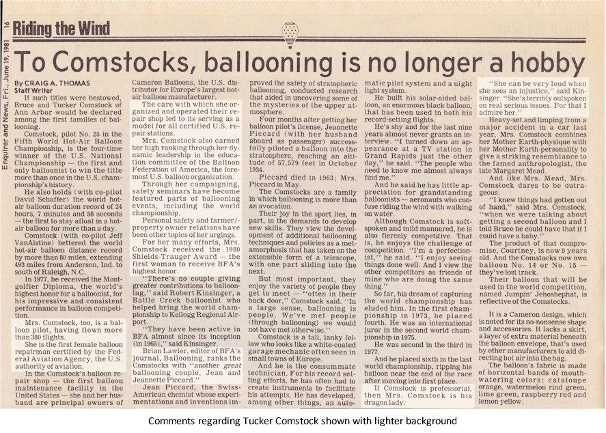

Following is a copy of a letter that supports Tucker Comstock’s role in creating the 1981 World Hot Air Balloon Championship in Battle Creek. This letter from a vice president of Michigan National Bank, a sponsor of the 1981 World Hot Air Balloon Championship in Battle Creek, Michigan, both congratulates me for my performance in the championship and thanks Tucker for her critical part in having sold Battle Creek on the idea of holding a world championship. Unclear in the letter, unfortunately, is that all of the work of planting the seed and convincing the Battle Creek Chamber of Commerce to undertake this giant project was done exclusively by the team of Tucker, with her knowledge of world championship competitions, and Bob Kinsinger, with his contacts in Battle Creek.

See letter and additional information on the following pages.

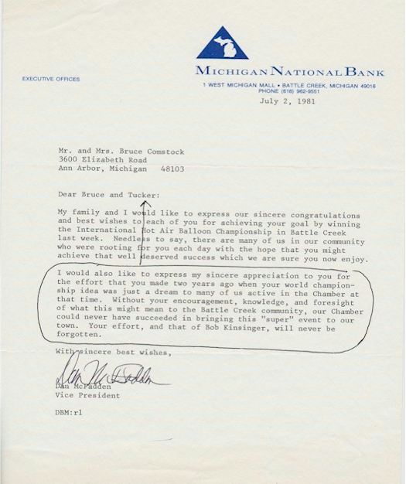

Another of Tucker’s contributions to ballooning was her taking the initiative to solicit and obtain the solution to a question that had been disrupting the conduct of ballooning events in the U.S. Following is a copy of the FAA headquarters response to that formal request by Tucker for a ruling on which balloon rally perquisites do or do not constitute “remuneration” to a participating private pilot. In the 1970s, as more and more balloon events were being held, the Federal Aviation Regulation barring remuneration for flying by those holding balloon private pilot certificates was being inconsistently enforced in the field. This had been both unfair and had resulted in confusion as to whether or not private pilots could participate in any particular event. On her own, Tucker took on the task of getting this ruling from the FAA headquarters to clearly and permanently end this confusion.

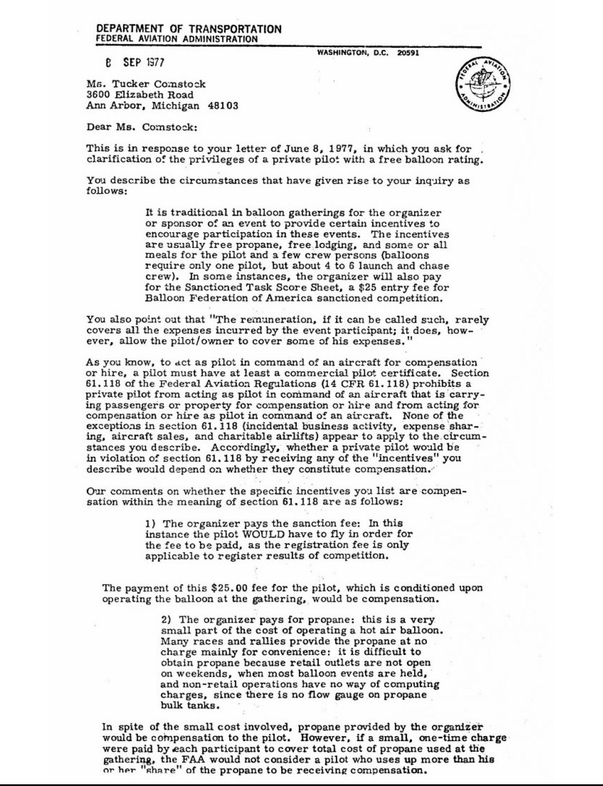
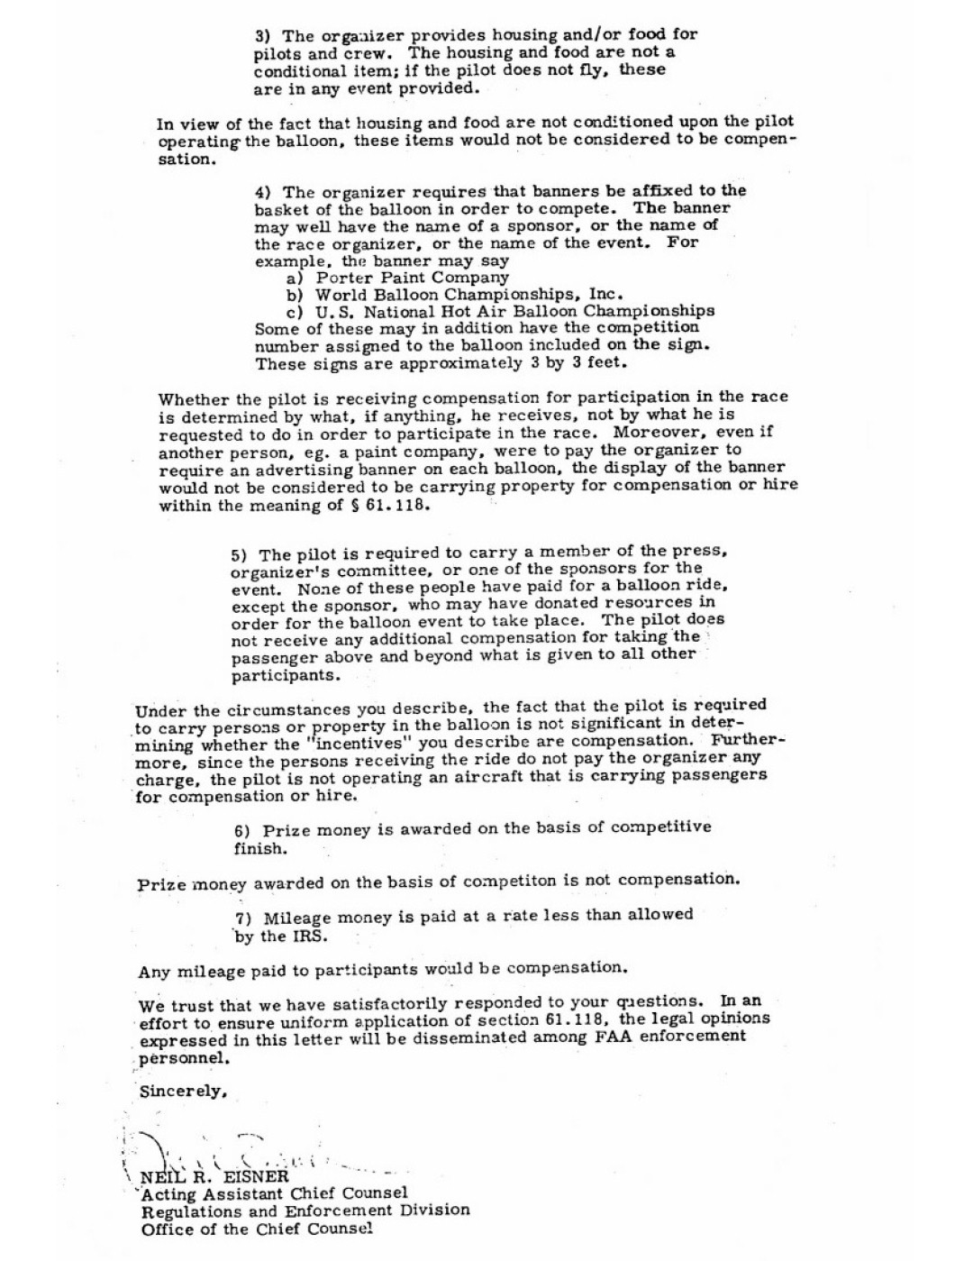

See pictures on following page.

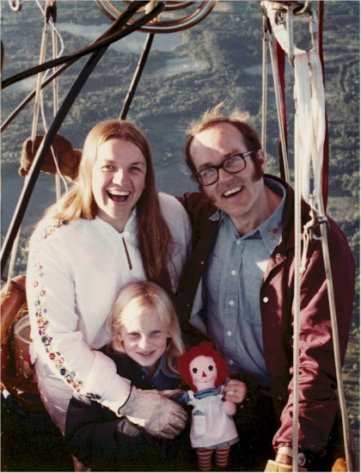
Tucker, Courtney, Bruce
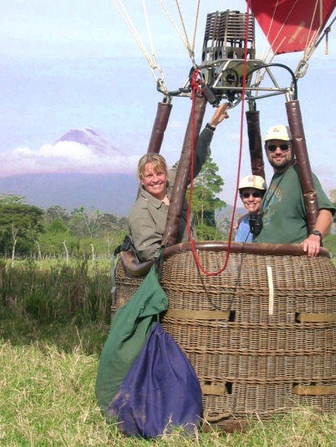
Tucker flying in Costa Rica with passengers

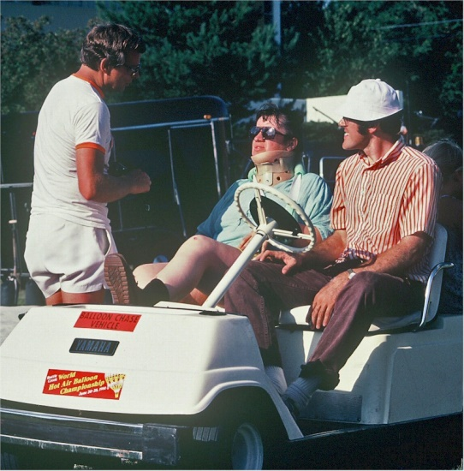
Tucker at Battle Creek event after auto accident 1980

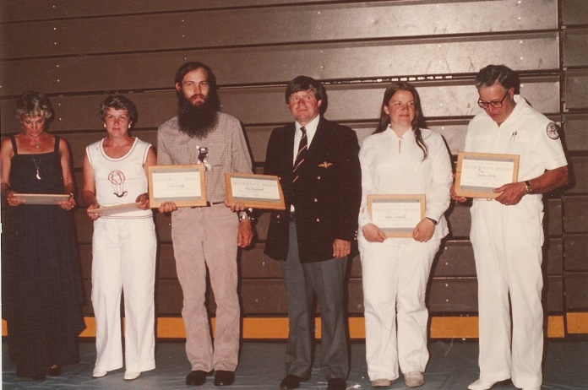
L to R: Unk, Sandy Buckelman, David Schaffer, Tom Sheppard, Tucker Comstock, Chuck Laverty. Comstock receiving the BFA Presidents Award 1978

