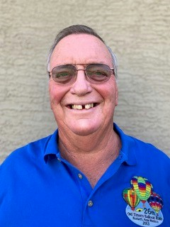
Bill Glen

Notable – Ed Yost Award

The Glen family has been involved in ballooning as a family hobby for over 40 years.
Bill Glen was raised in the San Francisco Bay Area and recalls seeing blimps and balloons as a child growing up on the peninsula. A hot air balloon flown by Deke Sonnichsen is his first recollection of seeing a balloon inflate and fly while a high school student at Menlo Atherton HS. Bill is married to Susan Glen. They have two sons, Michael and Chris, who are balloon owners and pilots.
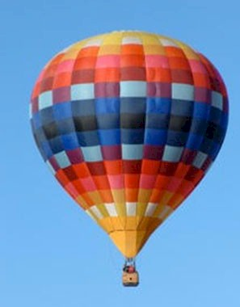
Bill served on a chase crew for the First World Championships in Albuquerque in 1973 and that is when it all started. He transported balloons to several events in New Mexico, Kansas, Texas and Colorado and took his first ride in Atwood, Kansas. He was one of the first Fiesta Launch Directors in 1974. He received his pilot’s license in 1974, flying in many events and fiestas over the years. Bill has been a member of the Balloon Federation of America since 1974. He helped with the first BFA Youth Camp in Albuquerque serving as a dorm parent, instructor and pilot.
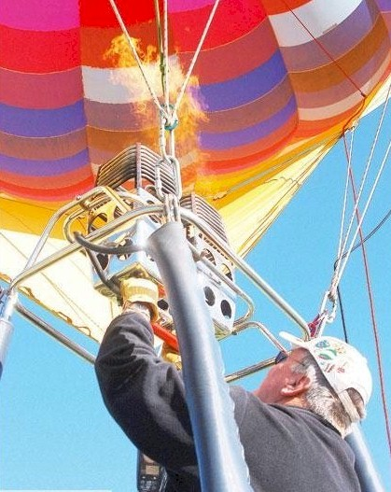
Bill enjoys participating in balloon festivals all over the country. He has flown in 15 states and three countries, Ireland, Canada and Mexico. Bill helped plan, organize and host over thirty successful balloon events in Roswell, New Mexico, including the Wool Bowl Rallies and the Old Timer Balloon Rally. He and his cousin organized the first balloon events in Pahrump, Nevada, and MacArthur, California.
Heavens Quilt

The largest event the Glen family participates in is the Albuquerque Balloon Fiesta. Bill has participated in 44 Balloon Fiestas. In 2002 he was lucky enough to win the Key Grab competition, winning a 2003 Ford Expedition. Four years later his youngest son Chris, also a pilot, won the 2006 key grab. They are believed to be the only father and son to have done so.
Bill and Susie’s oldest son Michael is also a pilot. He was injured in an accident March, 13, 1996 and is paralyzed from the waist down. This did not hold him back as he became the first licensed paraplegic balloon pilot in the world. Michael lives in Mesa, AZ and their younger son Chris and his family live in Spokane, Washington.
Bill and Susie currently reside in Maricopa, New Mexico. Bill worked for the Roswell Independent School District in Roswell, New Mexico for 33 years as a Physical Education Teacher and Technology Specialist before retirement. His wife Susie worked for New Mexico Military Institute. Both are enjoying their retirement years by traveling, ballooning, camping and spending time with their grandchildren.

See additional information on following pages.
