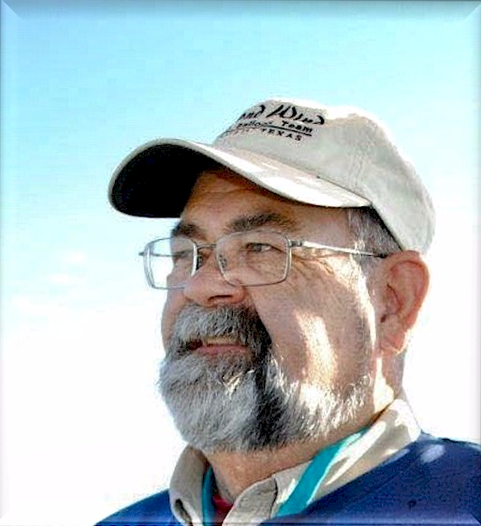
Paul “Buzz” Wills (1950-2018)

Notable – Ed Yost Award

Buzz was a kid in Amarillo, Texas who happened to see the Piccard family inflating a gas balloon near his high school in 1968. He was curious about the sport, but said, “it looked like a lot of work.”1974, he began working for Jack B. Kelley Inc. of Amarillo, transporters of helium gas. He found himself in the world of gas ballooning, filling manned and unmanned gas balloons. A friend purchased a hot air balloon, and although Buzz never thought he’d be interested in being a pilot, once he took off over the mountains of Angel Fire, NM, he had experienced the sublime-he was hooked.
In the mid-70’s when Ed Yost brought his gas balloon training operation to the Texas Panhandle, Buzz got to be involved with all the guys who were trying to fly the Atlantic-and many memories were made. Ed became his mentor and treasured friend for life-they enjoyed many gas and LTA flights together.
He began his training and soloed in a Raven RX6 on April 29, 1977. Buzz became a commercial pilot in 1979 (he never was a private pilot), and got his gas rating in 1980. After becoming a Barnes dealer, he sold a balloon to Amarillo National Bank in 1980 and campaigned that commercial balloon for 8 years. He helped start the Amarillo Balloon Association and taught a class called “The Fundamentals of Ballooning” at a local college for 6 years in the ‘80’s. He taught prep courses for the written exams. From 1981-1988, he was a DPE for the Lubbock GADO District. In addition, he was an FAA Accident Prevention Counselor. From the BFA, he was awarded Master Instructor ratings and safety awards. He held a Level 5 PAAP. He flew in the Albuquerque International Balloon Fiesta for 25 Years. He was heavily involved in Amarillo area
balloon events from the 1970’s to 2018.
As a pilot, Buzz was an ambassador for the sport he loved so much. He made friends every place he went, and had people at every town he traveled to that came back to crew for him, year after year. Many of his crew became pilots themselves. He was a mentor to many younger pilots who became like family.
In his later years as a pilot, he spent time speaking at safety seminars and promoted the sport through various educational events and school visits. He was thrilled by the sport, and was eager to share this-especially with kids.
Buzz and his wife Sharon, who he was married to for over 40 years, thought ballooning to be one of their greatest adventures-besides their children, Ashley and Brendan and grandchildren, Charlotte and Ben. They enjoyed friendships and experiences across the globe, across miles, and across decades-all because of the beautiful sport of lighter-than-air flight.

See additional pictures on the following page.

