Ted Watts

Notable – Spirit of Annie Award

On Saturday, June 17, 2016 in Meadville, Pennsylvania former NOBPA President, Alex Jonard presented the Spirit of Annie Award to Ted Watts. Ted joins a long list of worthy recipient including; Mike Gilligan, Jim Dieball, Bev Zanella, Gary Britton, Debbie Spaeth, and Maury Sullivan.
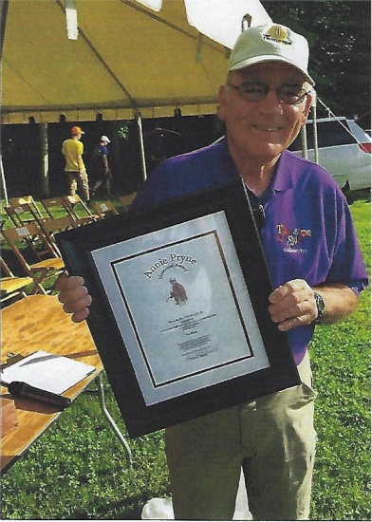
Ted got started in Ballooning in 1988 as the organizer of the Thurston Classic. Ted is an integral part of the organizing committee and is the event announcer. Ted’s commitment and dedication to ballooning can be seen throughout the country. Ted served as the Safety Officer for the Pre-Worlds in 2011 and the Worlds in 2012. He worked extensively with the BFA team on writing the Event Guidelines and is an At-Large Board member of the BFA and is board liaison to the HACD.
Ted has been a presenter at NOBPA Balloonowlege Safety Seminars, as well as a speaker at other safety seminars around the country. He is always willing to offer his legal advice whenever anyone inquires. He has an affinity for details and always strives to do the best that he can.
Ted has a passion for the sport of ballooning that everyone should aspire to imitate. His ability to share his experience and knowledge with others at any time is an attribute to our sport. His willingness to compile a seminar presentation on short notice, or work extra-long hours as safety officer at the Worlds, ensuring that every pilot was safely on the ground and had complete retrievals, demonstrates his commitment and passion for our sport.

