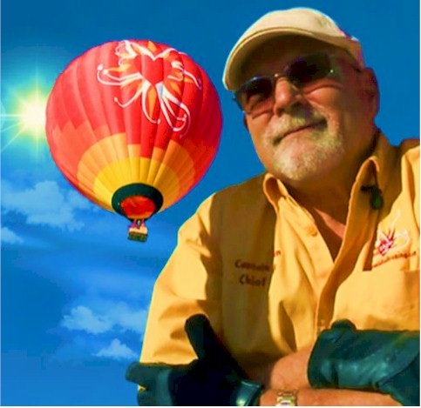
Kevin Cloney

Notable – Accomplishments/Contributions

Kevin@kevincloney.com
505-307-4142
In 1989 I enjoyed my first hot air balloon ride in Del Mar, California as a first prize award for a sales contest but is wasn’t until 1993 when I started chase crewing at Albuquerque International Balloon Fiesta® that I became passionate about ballooning. It was there that I earned my Private Pilot’s Certificate in 2000 and subsequently earned my Commercial Certificate in 2002 and my gas rating in 2005.
With over 2,000 hours as pilot in command, flying both nationally and internationally, I have enjoyed piloting over 75 different styles of balloons from the small Cloudhoppers® to the larger than life Special Shape Space Shuttle. In addition I have had the honor of providing over 400 hours of balloon flight instruction to student, private and commercial pilots training under both parts 14 CFR 61 and 14 CFR 141. Five of those students were FAA pilot/employees and 4 were international students. In addition I have taught over 200 hours of ground instruction including regional Safety Seminars. As a result of my training experience I have created over 59 proprietary balloon related training presentations to instruct and inform students of ballooning as well as Public Safety personnel.
I currently have achieved level III in the FAA Wings Safety program as well as been a member of the Balloon Federation of America (BFA), Valencia Flying and Retrieval Society (VFRS), Aircraft Owner and Pilot’s Association (AOPA) Civil Air Patrol (CAP), Albuquerque Aerostat Ascension Association and Top Gun.
In 2003, as a member of AAAA, I received the Allen Jones volunteer Award and in 2005 was presented the Directors Award for the At-Large Region from the Balloon Federation of America. In 2004~2006 I was President of Albuquerque Aerostat Ascension Association (AAAA) one of the largest ballooning clubs in the world.
Formerly a member of the Anderson Abruzzo International Balloon Museum I was honored to be a part of the grand opening. As a continued supporter of the museum I purchased a balloon tile of my first balloon which is still displayed on the front wall of the museum.
I am pleased to have given live presentations on ballooning both nationally and internationally including 16 years for Albuquerque school district during Fiesta presenting to more than 1400 students in an average year.
At the first Balloon Museum Kid’s Balloon Camp I provided tethered rides and hands on experience for the children actually crewing and flying my training balloon.
2008 I was instrumental in providing content and support for the production the “Balloon Fiesta” video produced by KNME a local PBS affiliate. This video plays continuously in the entrance lobby of the museum
Toastmasters International® certified me as a Distinguished Toastmaster (DTM) after years of training at the club, area and regional levels.
Currently I fly a 160,000 cu. Ft. balloon for Love is in the Air ballooning, LLC in Las Vegas, Nevada. The balloon, Chariot of Fire, is one of a handful of specially designed and FAA certified balloons in the world with bracketing restrains and polycarbonate windows allowing those with mobility restrictions or confined to a wheelchair to fly in a hot air balloon.
So far I have published three books, two adult and one child’s, with others under production to introduce my readers to the life changing experiences of lighter than air flying.

