Bill Clemons

Notable: Accomplishments/Contributions

HotAirRepair@aol.com
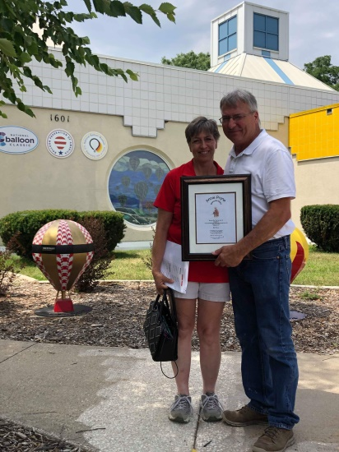
Bill Clemons was presented the 2019 Spirit of Annie Award based upon the following accomplishments. Bill has been a hot air balloon pilot for 35 years and has made a significant impact on the sport, and the community, through his commitment to teaching, educating, mentoring, and encouraging new and existing pilots to achieve their very best.
While Bill is a sought after instructor, and has trained many young pilots, his since belief is that ballooning should be affordable, accessible, and obtainable for anyone who has the skills, interest, and desire; therefore, he does not accept payment for his time and expertise.
Bill has dedicated his life to the sport of ballooning and has adapted his lifestyle and career around flying. And, like so many other pilots involved in the sport, Bill’s family is an important and integral part of his many accomplishments. Bill and his wife Louise are outstanding ambassadors to the sport, and to ballooning events and the communities in which they represent.
Bill’s dedication to safety education has made him a recognized leader within the ballooning community. Bill serves on the Iowa Balloonist Association, which includes planning and organizing the annual Iowa Balloonist Association Safety Seminar. In 2011, Bill helped organize the National BFA seminar in Des Moines, Iowa and he has spoken at numerous BFA safety seminars covering a variety of topics from decision-making and competition to repair and refueling. Regardless the topic, Bill is able to cover important information with authority, ease, and style. Furthermore, Bill’s expertise has led him to serve on the Balloon Federation of America’s US Ballooning Hall of Fame selection Committee.
In addition to serving as the deputy director of the 2009 US Nationals, Bill has also served as race director for several events in the Midwest including:
- 2009-Current: National Balloon Classic/BFA North Central Regional Championship (100 balloons)
- Summer Breeze Balloon Festival, Ames, IA (40 balloons)
- Lake Red Rock Balloonfest, Pella, IA (25-30 balloons)
- My Waterloo Days, Waterloo, IA (12 balloons)
- BBQ, Balloons & Buggies, Marshalltown, IA (30 balloons)
- Ottumwa Pro Balloon Race/BFA IA State Championship, Ottumwa, IA (30-40 balloons)
While serving as Balloonmeister at any hot air ballooning event, Bill mentors the individuals he works with and encourages them to take on greater roles and responsibilities. His commitment to grow, and sustain the sport, is not only fundamental, it’s also commendable.
Ballooning is a changing sport and in Iowa it is a growing sport. Bill’s contributions are a major factor. Bill is one of only three pilots in the state of Iowa who is being considered for the FAA Designated Examiner position once the current Examiner retires. In 2013, when [Staci Scheurenbrand] was appointed Executive Director of the National Balloon Classic, Bill not only embraced the change, he saw it as an opportunity to grow the event, the sport, and showcase the unique flying that Indianola is known for. With Bill’s leadership, he has helped the Classic establish a growth pattern that has resulted in a consistent 23+% increase each year including substantial new and returning pilot registrations. And while Bill understands the importance of all facets of a ballooning event, his commitment, passion, and unwavering dedication to competition flying is not only his legacy; rather, it is his calling to ensure the sport remains vibrant and growing.
Additionally Bill has served effectively on the Balloon Federation of America Hall of Fame Committee for over five years. He has brought an insight to past history of American ballooning to the Committee that has resulted in the consideration of potential candidates from the early days of American ballooning dating back to the Civil War and before.
Bill and his wife Louise operate Midwest Balloon Services, a FAA Certified Repair Station at 104 East Center Street, Truro, IA since 1999.

