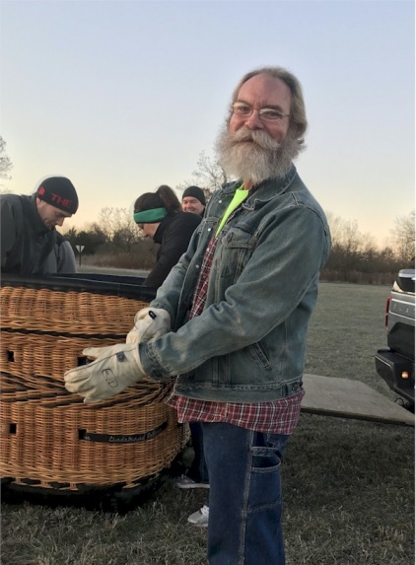
Ed DeVore

Notable – Contributions/Accomplishments

Ed DeVore has always been an adventurist, and he enjoys activities that test his abilities and increase his adrenaline. He also has a constant desire to know how things work, which not only led to his career as an engineer, but also to his exploration of the performing arts, sports, and motor sports. Anything and everything he found interesting, he’d learn all he could to be the best he could be at it.
Living in Danville, Ed was accustomed to seeing balloons in the air, with several local pilots living nearby and having the Illinois Balloon Classic in town for several years. He was first invited to a hands-on balloon flight in April 2010 by Sue Daugherty, a fellow cast member of a stage play they was acting in. She was confident he would enjoy this experience, and she was correct.
At his first flight, he met Dean Carlton and the Danville Balloon Group (DBG). No one could have a better start in this sport than with Dean Carlton as his instructor from the very beginning. Ed was quickly hooked and eager to learn all he could and participate in any way possible. It didn’t take long before he was crewing for multiple pilots, but didn’t seem to have a “regular” pilot like many others. At first this seemed strange, and he thought it might be an indictment of his abilities, which made him work that much harder. Then one weekend, when an out of town balloonist was visiting, Dean suggested that this visiting pilot take Ed as crew because he was skilled. That’s when Ed realized that he was capable. His ability to back up a trailer was an added advantage that continues to be an extremely valuable skill.
During the summer of 2012, after a morning flight, Donna Carlton-Vish, one of the DBG pilots, asked about the last time he had been up. It was a surprise to all that he had not yet been up in the air despite three seasons of crewing. It had never crossed his mind. He loved being hands-on with these beautiful, mesmerizing flyers, and enjoyed being able to “play catch” with them, as his daughter would later call it. It didn’t take long though, and his first in-basket experience took place with Donna on July 29, 2012.
Ed began logging his crew activity in July 2014, and it was three months later that his youngest daughter received her first in-basket experience at age 5 from her favorite balloonist, “tickle lady” Betsy Kleiss. She has since flown more times than Ed did until he began his pilot training.
Ed began the CAAP program in 2016, the same year he became a BFA member. The program was an important aspect for himself, because it provided a means to delve deeper and assess for him what there was yet to learn. About this same time, he began to consider becoming a pilot as well. Sue had encouraged this endeavor early on, as she believed that he possessed the qualities of being adventurous and informed, while exercising appropriate decision-making. His interest, coupled with Sue and Dean’s encouragement, led to the purchase of a system in November 2017. He was now into pilot study and CAAP completion simultaneously. During this time, he was privileged to be tasked with training new crew members and to be a presenter at a local annual safety seminar.
Achieving the Level IV CAAP was his primary goal: to confidently know that he could be accomplished in the criteria set out by the BFA to assure he was prepared to assist a pilot and crew in any given circumstance. Ed’s pursuit was delayed due to a medical need in early 2018, but he did make progress later in the year.
During the Great Forrest Park Balloon Race in 2018, Dean Carlton and Scott Woogie presented several BFA Achievement Awards. When they announced the Crew Person of the Year award was going to a local crew member that would not be able to attend the annual meeting at the AIBF and read the accomplishments of that person, it was a shock when Dean announced Ed’s name. He was standing next to Dean’s son Ryan, who he looked at and asked if they were serious.
Ed achieved the Level IV CAAP in 2019, which proved to be an excellent introduction to some of the piloting requirements. He looks forward to being able to participate in the new Danville balloon event, Balloons Over Vermilion, as a pilot in the not too distant future. Ed is forever grateful to Dean Carlton and the many pilots of the DBG for the time, knowledge, and experience they have shared with him and others who wish to participate in this sport. He is also humbled by the belief and recognition shown by Sue Daugherty, Dean Carlton, and the BFA. Ed received the BFA Crew of the Year Award in 2018.

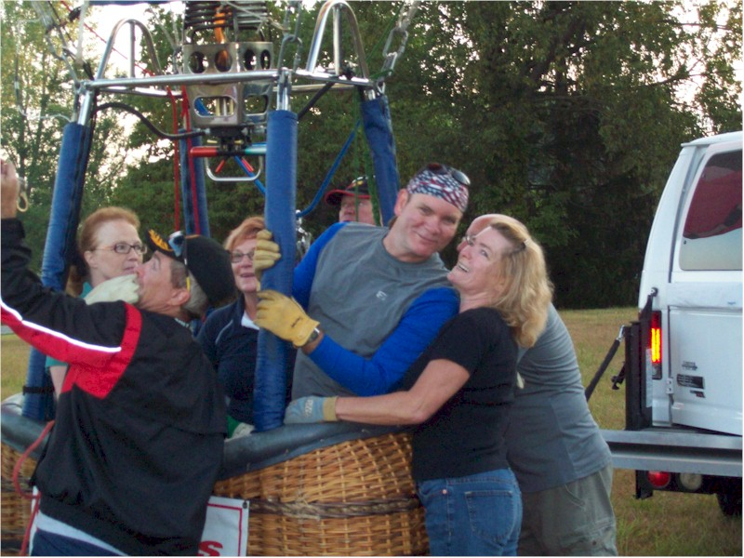
First Flight
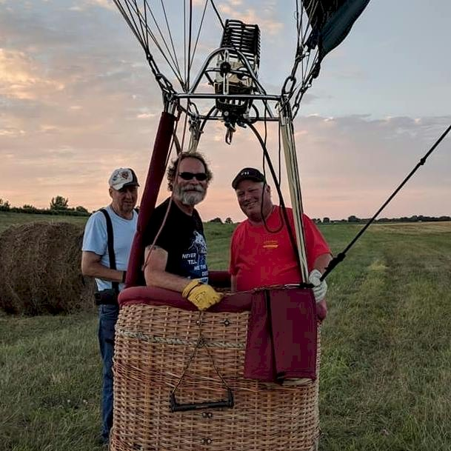
First Landing as student pilot

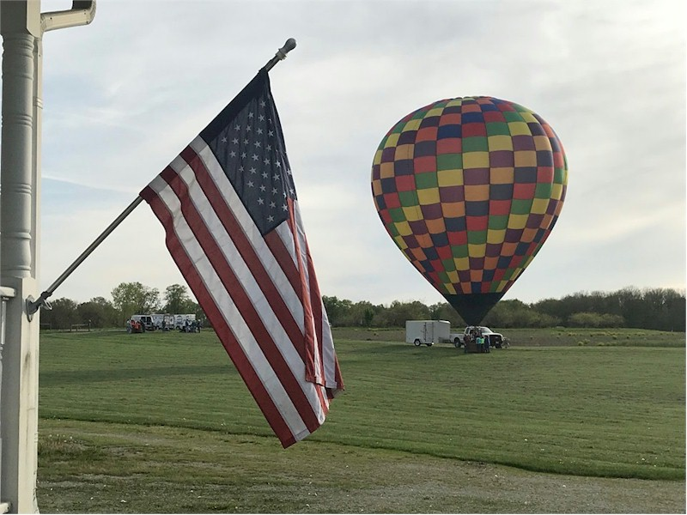
Sweety

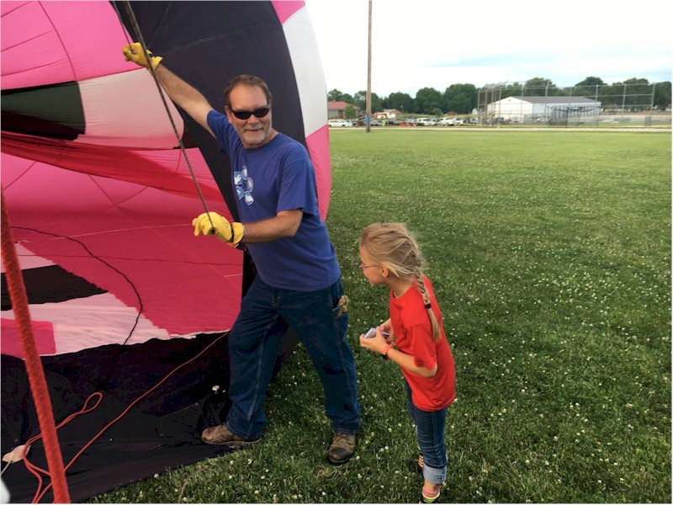
Ed with daughter Nastia
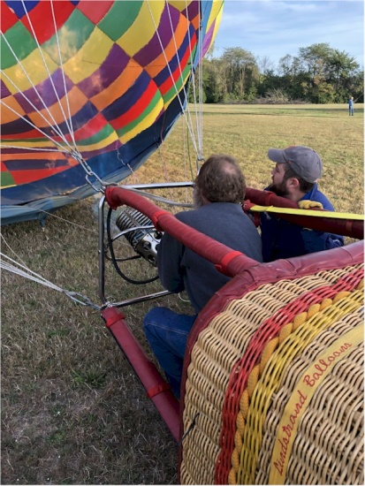
Inflating Sweety

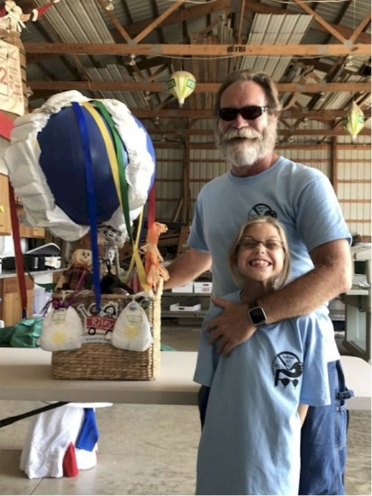
Ed with daughter Nastia

Balloon Federation of America
National Crew Person Award
July 25, 2018
Dear Committee,

Our candidate for National Crew Person for 2018 is Ed DeVore. Ed is one of those persons who, when they decide to do something, they go “all-in”. Ed embodies the spirit we would love to have in all crew persons. He is an engineer by trade and uses his critical thinking skills to work out better and safer techniques in crewing. He is a keen observer and asks lots of questions in order to improve his abilities.
Ed has been crewing with our family of balloons for more than seven years. He generally is the first one to the meeting site (usually before us, and we live next door). He is always prepared, has gloves with him at all times, and even packs an extra change of clothes if needed. He will have checked weather sites before arriving and will have the latest updates for us.
Ed has been working hard proceeding through the BFA’s Crew Achievement Award Program. He currently holds a Level 3 (Crew Chief) category award, and nearly has all the requirements for the top level (Master Crew Chief) award. He is short a few high wind landings, and since we try hard to avoid these, this may be a challenge. But he will get there, I am certain. Ed doesn’t give up.
Ed will even travel at his own expense to crew for others. He wanted to experience crewing with larger balloons, so he spent some time with PRO Operator Tony Sandlin with tether operations in Indiana. Ed and his young daughter drove to Albuquerque in 2017 to experience crewing on the large stage. He crewed for several pilots while out there, and was a great help. In September I will need a skilled truck and trailer driver, so he will drive straight from work 3-1/2 hours to St Louis to crew for me at the Forest Park event. His trailer driving skills are excellent, and I am very comfortable knowing he will be operating our rig.
With a little nudging, we convinced Ed to speak about crew training at our local seminar. He was a little nervous at first, but he gave a great presentation to over 90 people and received great scores.
This Spring Ed did what many really good crews might do – he bought a balloon! This is the realization of a lifetime for Ed, and he is thrilled to begin his pilot training. Even when he becomes a certificated pilot, I still expect he will still crew for us on occasion, and I would be happy to crew for him.
Thank you for your consideration,

Dean, Angie, Ryan, & Kelli Carlton
Candidate:
Ed DeVore
21605 N 1365 East Rd
Danville, IL 61834
BFA Life Member #118816

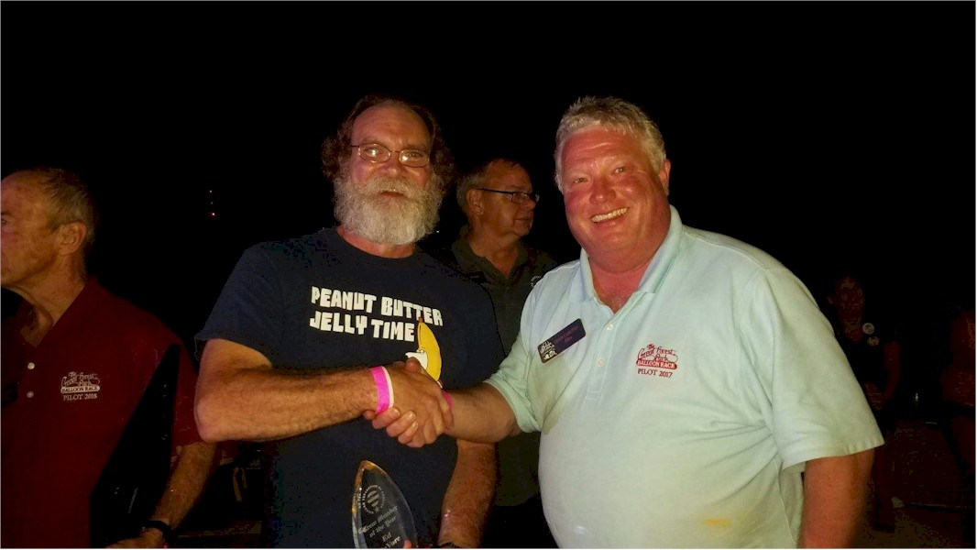
Ed congratulated by Dean Carlton for receiving the BFA Crew of the year Award

