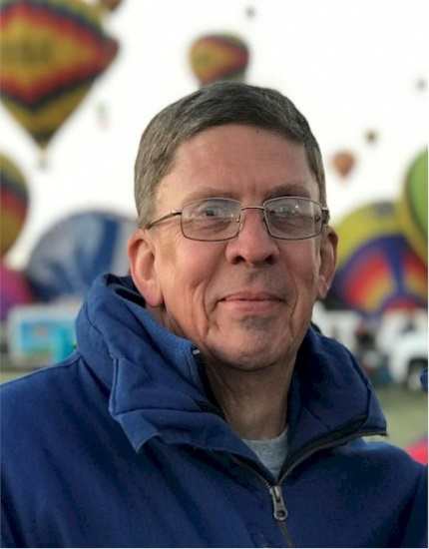
Gary Brossett

Notable — Accomplishments/Contributions

Gary Brossett is a Crew Chief for Joel Jones of Seale, Alabama. He’s been involved in aviation for nearly 40 years. He became interested in ballooning after participating in a tether at his local airport in Columbus, Georgia.
After immersing himself in the BFA Ground Crew Manual and Gordon Schwontkowski’s Hot Air Balloon Crewing Es-sentials, he started logging crews in March of 2013. He worked his way through each level of the Balloon Crew Achievement Award Program (CAAP) and achieved Master Crew Chief in June 2018.
Gary is a 5-time Master Aviation Educator and earned Aviation Safety and Instructional System Design Graduate Certificates and a Master of Aeronautical Science degree in Aviation Education from Embry-Riddle Aeronautical University. He developed and has presented Human Factors in Ballooning, a safety course seminar.
While progressing through the crew achievement program, he started working to add a LTA rating to his pilot certificate. He completed his LTA rating in August 2017 and is currently training for a commercial certificate. He’s achieved Level II, Basic Aeronaut, and recognition in the Pilot Achievement Award Program (PAAP). He also holds a private pilot certificate, single engine land, and Remote Pilot certificate.
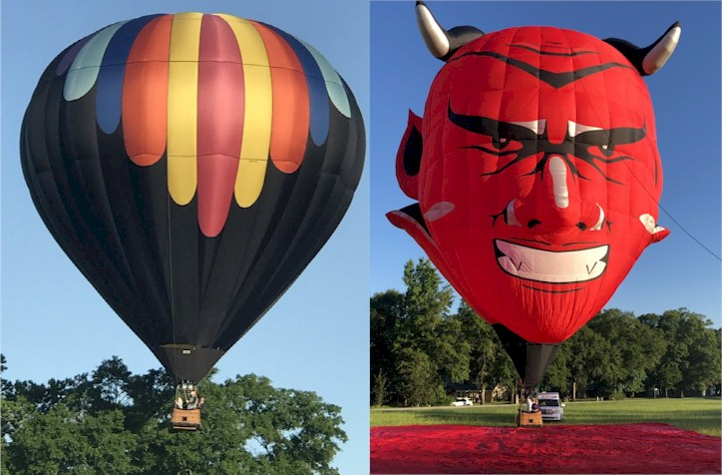
Gary holds an A&P with Inspection authorization and maintains Joel’s Aerostar RX-8 and RVB SS-30 Experimental balloon. He has participated in the William O’Brien Aviation Maintenance Technician Award pro-gram annually 2011-2019.
In his role as FAA Safety Team Lead Representative in Georgia, he has supported the BFA annual online seminar/webinar, by advertising in the FAA Safety Program Air-man Notification System (SPANS) and awarding FAA WINGS Pilot Proficiency Pro-gram credit to participants. He’s also supported the Balloon Association of Greater Illinois (BAGI) and between the two safety events has awarded more than 900 credits in the past five years.
Gary was recognized as the southern region FAA Safety Team Representative of the Year in 2013 and the district representative in 2015 and 2017. He was also selected as the Balloon Federation of America’s Crew of the year in 2019.
The letter recommending Gary for the Crew of the year is on the following page.

