
Kimberly Magee

Notable – Shields Trauger Award, Records

www.theballoontrainingacademy.com

Summary
One of the most accomplished young pilots in ballooning, Kimberly achieved 6 World and 9 National records and received the Shields Trauger award at the age of 28.

Ratings
FAA Commercial Pilot Lighter Than Air FAA Private Pilot Airplane Single Engine Land Amateur Radio Technician License

World Records (FAI/CIA)
AX-02 Female Distance 61.1 miles, 19 Jan 2019
AX-02 Female Altitude 10,331 feet, 19 Jan 2019
AX-03 Female Distance 61.1 miles, 19 Jan 2019
AX-05 Overall Distance 363.4 miles, 17 Mar 2019
AX-05 Female Distance 363.4 miles, 17 Mar 2019
AX-06 Female Distance 363.4 miles, 17 Mar 2019

National Records (NAA)
AX-02 Overall Distance 61.1 miles, 19 Jan 2019
AX-02 Female Distance 61.1 miles, 19 Jan 2019
AX-02 Female Altitude 10,331 feet, 19 Jan 2019
AX-03 Female Distance 61.1 miles, 19 Jan 2019
AX-04 Female Distance 61.1 miles, 19 Jan 2019
AX-03 Female Altitude 10,331 feet, 19 Jan 2019
AX-05 Overall Distance 363.4 miles, 17 Mar 2019
AX-05 Female Distance 363.4 miles, 17 Mar 2019
AX-06 Female Distance 363.4 miles, 17 Mar 2019

Awards
BFA Shields Trauger, 2019
BFA At Large Director’s Award, 2018
Hi-Fly Cup, 2017
BFA Bill Murtoff Spirit of Ballooning, 2013
BFA At Large Director’s Award, 2013

The Balloon Training Academy
501(c)(3) non-profit organization dedicated to promote safety and train new pilots. Co-Founder and Vice President

Competition
Women’s World Championship 2018 Naleczow, Poland, 4th Place
US National’s Top Female Pilot, 2018
Jr World Championship Wloclawek, Poland 2018
Women’s World Championship, Birstonas, Lithuania 2016
US Women’s National’s 2016, 4th Place
Iowa State Championship 2015, 3rd Place
John Petrehn Memorial Cup Winner 2013
National Balloon Classic Newcomer of the Year, 2013

Speaker & Publications
Speaker at BFA Convention and Continuing Education Seminars
Speaker at Women in Aviation – Aviation Day
Multiple publications as part of CIA/FAI Public Media Relations Sub-committee.
Multiple Articles in Ballooning, the magazine of the Balloon Federation of America

Balloon Federation of America
Dubuque Balloon Camp Co-Founder and Director, 2011-2014
Youth Committee, 2011-2018
Social Media Manager, 2017-2019
Great Lakes Balloon Camp Counselor, 2011


20 Jan 2019 AX-02 World record flight North Dakota
to Minnesota
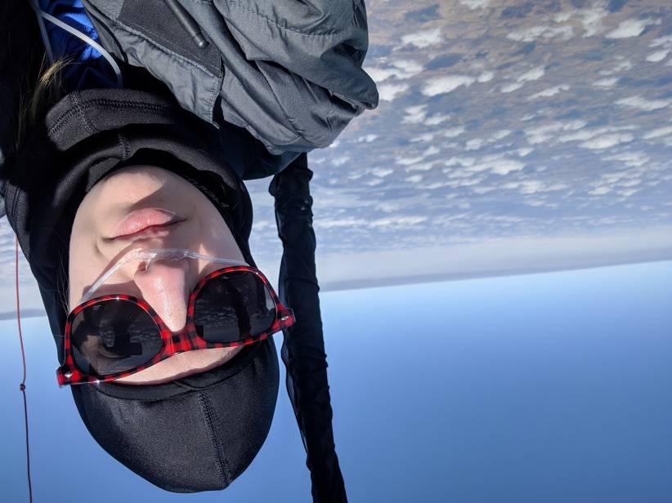
17 Mar 2019 AX-05 World Record Flight South Dakota
to Iowa

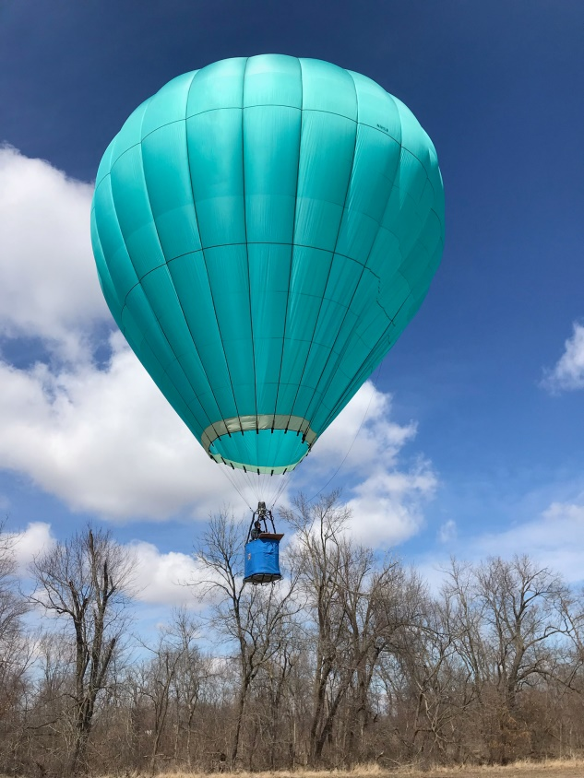
17 Mar 2019 coming in for landing in South
East Iowa AX-05 World Record Flight

