Guy Gauthier

Notable – Accomplishments/Contributions

guyg@balloonrepair.com

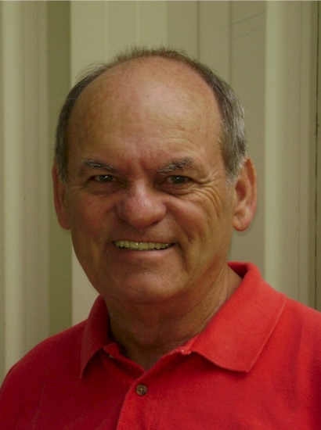
At first glance Guy Gauthier appears too young, too eager, too enthusiastic to be a pioneer of the sport of ballooning, but looks can be deceiving. The modern era of ballooning is only about 40 years old and Guy Gauthier has seen firsthand almost 75 percent of it.
In the almost 40 years since buying his first balloon Guy Gauthier has competed in National and International championships, has toured as a commercial balloon pilot, has taught others to fly, has designed balloons, sold balloons, built balloons, and repaired balloons. He has operated alone in self-employment, managed the US venture for the international balloon manufacturer, Thunder & Colt Balloons, and is now retired from the daily business world. He one of less of less than fifty pilots in the country who has achieved the Balloon Federation of America’s Level 8 Pilot Achievement Award. He still consults with Balloon Repairs of East Texas and Texas Awning; both companies are being run by his former employees. Guy is equally at home sitting at the sewing machine making simple repairs on a sport balloon as he is computing the finite details of a critical subsystem of around the world balloon attempt. It is this vast range of experience and know-how that makes Guy Gauthier a sought after advisor on ballooning projects world-wide.
Gauthier entered the sport of ballooning in 1976 and almost immediately ended up on the business side of things. He bought his first balloon from the late Mike Adams of Adams Balloon Loft with whom he would first partner then continue operating the company after Adams' death. At almost the same time he was both touring the country as a commercial pilot operating a fleet of four balloons for Yoplait while learning to compete on the now defunct Kool Pro Balloon Tour.
The Kool Pro Tour instilled a love of competition in Gauthier but he found that was not enough to win a championship. As he explains it, "I'm not as dedicated to competition as I need to be. Ballooning to me is a pleasurable thing and while I want to be good at it, and I want to win a championship, I don't want it bad enough to have the discipline required." For those that know Gauthier that's OK, for it is his easy smile, quick laughter and willingness to lend a hand to any and all that are the hallmarks of his personality.
Always having enjoyed a good head for business, Gauthier expanded his knowledge from 1991 to 1995 when he served as Sales and General Manager for Thunder and Colt Balloons US. As such he was tasked with developing sales strategies, a national dealer network, coordinating marketing efforts, and supervising a factory staff for the US subsidiary of a UK company. He also supervised the relocation of the company from Michigan to Texas. Dealing with international suppliers and coping with the daily fluctuations of international monetary exchange rates were added responsibilities. During his tenure the company more than doubled its US market share and was continuing to see marked improvement when its parent UK operation was forced into bankruptcy.
After Thunder and Colt, Gauthier opened his 3rd balloon repair station, Balloon Repairs of East Texas in 1995. Not a surprising move since it is the technical side of ballooning that has always fascinated Gauthier. While he once hoped to debut his own Gauthier Balloon, he has instead turned his attention to developing technical refinements and innovations for the "one of" type. His expertise has been sought out by world record setting pilots Dr. Bill Bussey, Jetta Schantz , Pat Harwell and others. In the midst of the around-the-world balloon race Gauthier was an advisor to privately funded pilot Kevin Uliassi, whose round-the-world bid fell short, but set a world distance record for his flight from the US to Myanmar.
In 1998, seeking added space for his growing repair station; Gauthier bought and re-launched Texas Awning Company. Today both it and B.R.E.T. are successful small business operations
Guy Gauthier is indeed a pioneer in the sport of ballooning yet he continues to seek to expand the sport one balloon, on balloon project or just one balloon pilot at a time. Like so many pioneers much of his knowledge was earned through the school of hard knocks. 30 years later he wants to use that knowledge and experience to help make the road a bit easier for the next generation.

