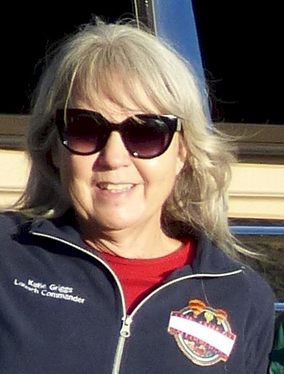
Kathryn (Katie) Griggs
Notable – Accomplishments/Contributions

695 Schaad Lane,
Dayton, NV 89403
katiegriggslta@gmail.com

Katie and her husband (Forrest) have been ballooning since 1988. She got her student pilot certificate in 1988 and her Commercial rating in 1992. Forrest has always been her crew chief and best support team.
Katie has flown a special shape balloon “Sushi” at numerous events across the country since 2001. She has owned and operated a FAA certified repair station for hot air balloon since 2004. She performs annuals and repairs on hot air balloons. She attends maintenance seminars every year at the balloon manufacturers.
She has put on safety seminars for the local balloonist since 2004 considering education and safety very important along with training of new pilots.
Katie has flown the Northern Nevada ReMax Balloon program since 2007. She has been
Balloonmeister for the Great Reno Balloon Race since 2010, tasked with the vetting of the pilots, and making sure everyone is safe and legal for the event. She works closely with the FAA to secure the waiver. She is also Balloonmeister for several other events in Nevada.
She was the Chairman for the Balloon Federation of America (BFA) National Convention, planned for April 2015. She was elected to the Board of the BFA as the Western Regional Director in 2015. In 2020 she became Chairman of the Junior Balloonist Camps Committee.
Katie received the Balloon Federation of America Level 8 Pilot Achievement Award, the highest level, in 2020.
Katie is passionate about preserving and promoting hot air ballooning through education, safety practices, and training.

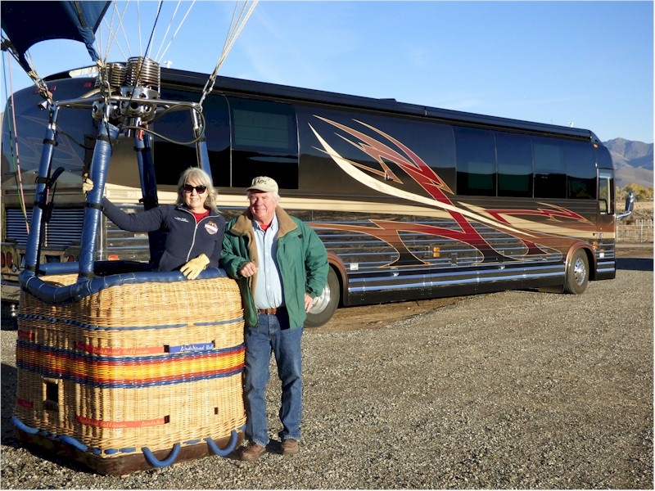
Katie and Forrest Griggs

