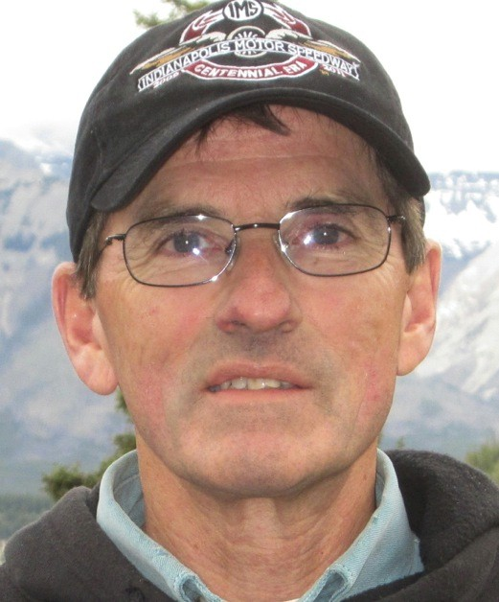
David Bobel

Notable – Accomplishments/Contributions

I was born in Toledo, Ohio in 1944, went to Haskins Elementary School and graduated from Otsego High School in 1962. Received a BS in music education from Manchester College (University), in Indiana, in 1967 and a masters degree in music performance at Bowling Green State University, in Ohio, in 1971. I spent most of my life in Peru, Indiana where I met my wife, Mina, and raised our two children Betsy & Bridget.
I discovered ballooning in 1972 when I came across a book titled “Ballooning” by Peter Dixon. The author made the sport sound relatively safe, and certainly unique, and was a new sport that was open to those who were brave enough to try it. One of the names I found in the book was that of Dennis Floden of Flint, MI. I called him to ask questions about ballooning and he invited my wife & I to Flint where we looked at pictures and talked about balloons for hours. Weeks later I found a guy in Indianapolis by the name of Peter Krieg who owned a couple of balloons and he invited me to Marion, IN to watch him do a promotional flight. I was impressed! Then in the Spring of 1973 I got a phone call from a guy named Don Conner who heard I was interested in balloons. He had just received his commercial balloon license and was eager for me to become his first student. He came up to Peru and made a flight over my town (without me in the basket) but I had already decided I wanted him to train me. So my 46 year adventure started on June 29th 1973 and continued until my retirement in October of 2019.

Timeline:

- 06-29-1973 First Training Flight
- 09-02-1973 Solo Free Flight
- 12-07-1973 Commercial Pilot Rating Issued (3013526) (only 8 hours required)
- 1973 to present, 1,934 Total PIC Hours
- 1972 to present, BFA Pilot Member
- 1974 to present, trained more than 35 students
- 1974 to present, flown more than 3,000 passengers in AX-6’s and AX-7’s
- 1976 to 1986 Principal Pilot “Indiana State Fair Balloon”
- 1979 to present, attended the Albuquerque International Balloon Fiesta as a principle pilot and flying Media personal for many of the 40 years. Won a Honda truck in the 2007 key grab.
- 1980’s, FAA Flight Examiner
- 02-17-2001 BFA Long Jump from Storm Lake, Iowa to Hope, Indiana, 538 Miles in 9 hours and using 37 gallons of propane
- 2017 – Was presented the Balloon Federation of America Ed Yost Master Pilot Award for 40 years of safe flying

Except for the Indiana State Fair contract ballooning has been a hobby for me. (My real job was the owner and manager of two music stores in Indiana.) The part I love the most about ballooning is sharing the experience with other people. I feel a deep since of pride knowing that I have been involved in one of the most beautiful and meaningful sports of humankind.

