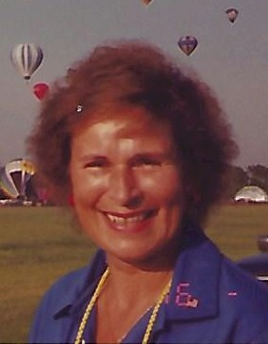
Donna MacTavish

Accomplishments/Contributions

Was a longtime member of BFA and NABA. Served as observer, debriefer, chief-debriefer, assistant scoring officer, and co-scoring officer at many competitive events. Taught courses for event official positions of observer, debriefer, and scoring officer.
Hot air ballooning adventures began in August 1978 as a member of the first observer corps established and trained by Tom Sheppard and Debbie Spaeth.

1997 winner of the Spirit of Annie Award

Ballooning career continued for 23 years at the following events:
- All U.S. National Championships
- All North American Championships
- All U.S. Team Championships
- Molson Canadian International Championship 1989
- World Championships 1987, 1989, 1991, 1993, 1995, 2000
- First World Air Games 1997

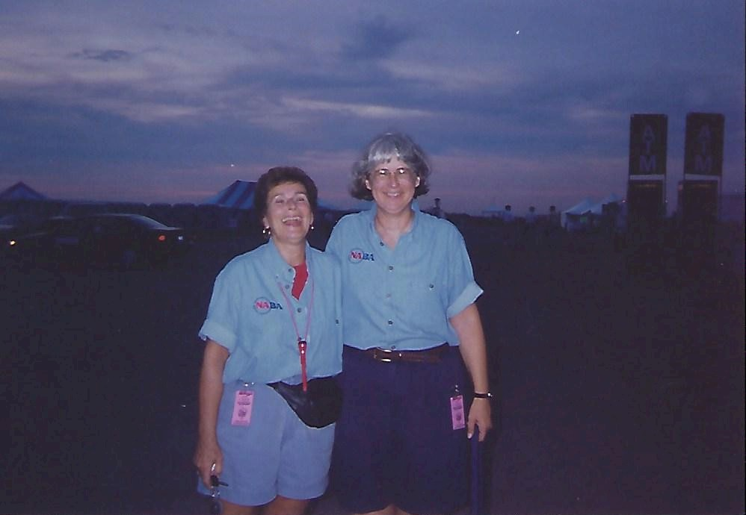
Donna MacTavish and Patty Cramer - Scoring Officers 1998

