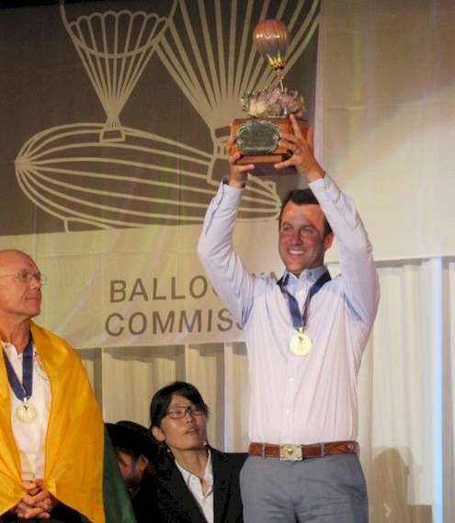
Rhett Heartsill

Notable – Accomplishments

6429 Curzon Ave.
Fort Worth, TX 76116
Email: rheartsill@gmail.com

Rhett’s hot air ballooning career began at a very young age, basically since he was born. Ever since he was big enough to “man the fan” heI was crewing for his father, Joe Heartsill. This led to many crewing adventures across the globe which included Austria, France, Hungary, Italy, Japan, Luxembourg, Spain and various sites around the USA. He eventually followed in his father’s footsteps and got his LTA license in 2006, and competed in his first event in Indianola, Iowa in 2009. Now, he and his dad fly together as a team all over the world at competitive events.
U.S. National Championships:
- 2010 – Rookie of the Year (6th Place) – Battle Creek, MI
- 2013 – 2rd Place – Longview, TX
- 2014 – 3rd Place – Longview, TX
- 2015 – 2nd Place – Longview, TX
- 2016 – 1st Place – Shreveport, LA
- 2017 – 5th Place – Shreveport, LA
- 2018 – 1st Place – Shreveport, LA
- 2019 – 1st Place – Scottsbluff, NE
World Championships:
- 2012 – 12th Place – Battle Creek, MI
- 2014 – 10th Place – Rio Claro, Brazil
- 2016 – 1st Place – Saga, Japan
- 2018 – 21st Place – Grob-Siegharts, Austria
Most Memorable Flight: Flying over the Palm Tree, Dubai UAE

2016 The following Nomination for CIA Montgolfier Diploma for 2016 Sporting Year
For Best Sporting Performance in Hot Air Ballooning was submitted for Rhett Heartsill

On November 7, 2016, in Saga, Japan, Rhett Heartsill was awarded the title of 2016/22nd World Hot Air Balloon Champion. At the conclusion of the Championship, with 9 flights and 31 tasks, Rhett had earned 26,160 points, 2253 over the closest competitor.
His 1st place finish at the World HABC, capped off a spectacular year of flying for Rhett. In July, in Shreveport, Louisiana, Rhett earned the title of 2016 US National HAB Champion. He also earned the titles of 2016 Texas State Champion and Balloon Federation of America/BFA 2016 Southwest Regional Champion.
As you will see with the following list of Rhett’s placement at previous US National and at World Championships, Rhett is a balloon competitor who has consistently placed in the top since beginning his balloon competition flying in 2009.

U.S. National Championships:
• 2016 – 1st Place – Shreveport, LA
• 2015 – 2nd Place – Longview, TX
• 2014 – 3rd Place – Longview, TX
• 2013 – 2nd Place – Longview, TX
• 2010 – Rookie of the Year (6th Place) – Battle Creek, MI

World Championships:
• 2016 – 1st Place – Saga, Japan
• 2014 – 10th Place – Rio Claro, Brazil
• 2012 – 12th Place – Battle Creek, MI

So for 2016, Rhett earned State, Regional, National and World Champion titles. Definitely a “grand slam” of a year and deserving of the CIA Montgolfier Diploma for 2016 Best Sporting Performance in Hot Air Ballooning.

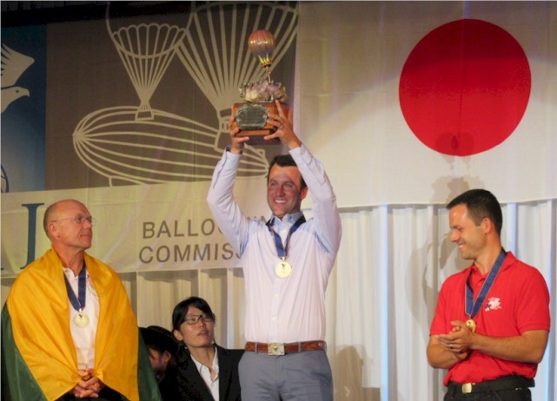
Saga World Champion

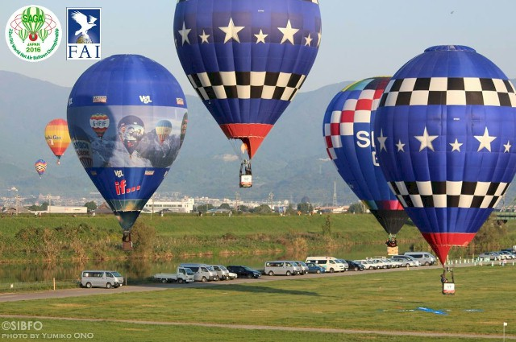
Saga at target with Joe

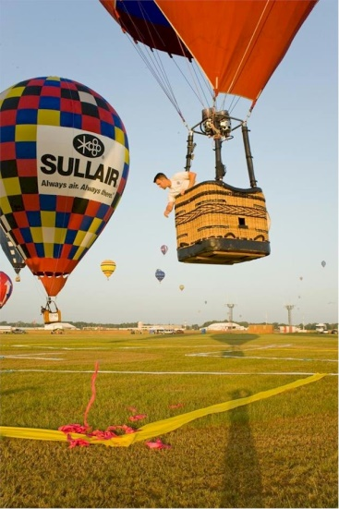
Saga - Target First Drop
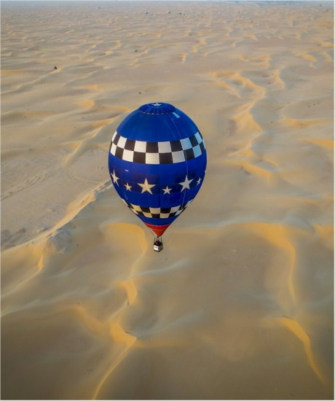
Dubai - Desert

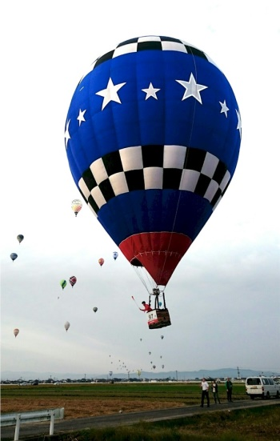
Saga - Target Second Drop
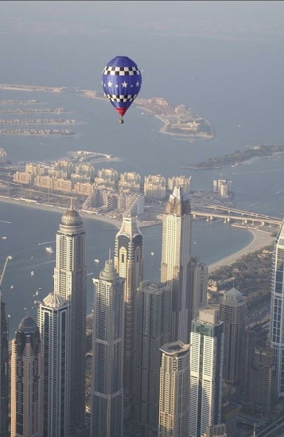
Dubai

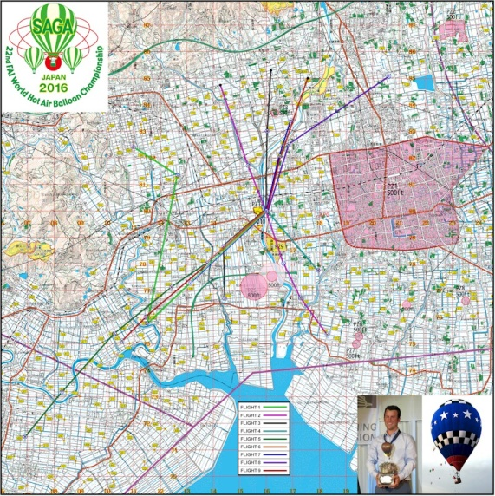
Saga - Competition Map

