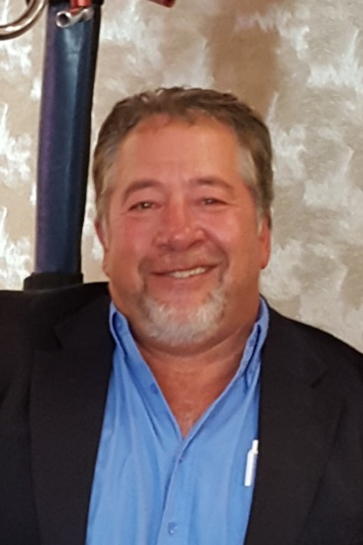
Ken Walter

Notable – Accomplishments/Contributions

Lifetime resident of Waukesha, WI with wife, Kay and three sons, Jack ~ 15, Ben ~ 13, and Max ~ 10

Why Ballooning?
Ballooning is an incredible sport/hobby that became my life’s passion simply by chance in 1988. My dream became reality in 2000 and for the past 27 years my hobby has become my life’s work. My beautiful wife Kay and I co-own our balloon “Kay’s WindDancer II”. We purchased Kay’s WindDancer in 1999 to celebrate our engagement and replaced it with “II”. In 2007 we purchased a “racer” balloon and named it “Jack’s UpSky” after our son Jack and his exclamation every time we go ballooning. In 2008, we designed and had a “new” Kay’s WindDancer built. It looks the same, just a little bit different.
Kay and I truly enjoy sharing our passion for ballooning with our crew, friends and family. The joy and serenity of leaving all our earthly responsibilities behind when we take flight cannot be compared to any other emotion.
Since 1988, I have logged over 1800 piloting hours. In 2014, hot air balloon rides and promotions became my full time career. A lifetime resident of Waukesha, WI, I organize and direct balloon events, provide advertising/promotional opportunities and offers passenger flights. I am an instructor as well as a FAA Safety Team Remedial Trainer also an authorized dealer for Lindstrand Balloons US, the premier hot air balloon manufacturer. My family and I travel attend balloon events across the country and enjoy the freedom and serenity that ballooning provides.

- 1988 – Introduced to ballooning as crew for the Milwaukee County Zoo Balloon.
- 1990 – Obtained student pilot certificate and purchased first balloon
- 1993 - 1998 – US National Championships, Sport Division Event Director
- 1995 – 2007 -- Established the Wisconsin State Championships/Waukesha Skyfest Event Organizer and Event Director, Waukesha, WI
- 1997 – First competitive event as pilot, Rockvale Rally, Rockford Ill.
- 2000 – Present – Operate WindDancer Balloon Promotions and the RE/MAX Hot Air Balloon Program in Wisconsin.
- 2001 – 2011 Organizer/Event Director Hartford Family Fest Balloon Rally, Hartford, WI
- 2001 – 2013 Organizer/Event Director Manitowoc Airshow Balloon Rally, Manitowoc, WI
- 2002 – 2006 – Executive Director of the Wisconsin Balloon Group
- 2003 – 2006 – Staff Member – Honda World Grand Prix International Event
- 2007 – Safety Officer – Carolina Balloonfest, Statesville, NC
- 2007 – 2013 – Regional Director for the Balloon Federation of America
- 2008 – 2011 – Executive Board Secretary
- 2008 – Present – Flight and Ground School Instructor
- 2010 – 2018 – Organizer/Director Waterford Balloonfest, Waterford WI
- 2013 – Present – Organizer/Director Grayslake Colors Aloft, Grayslake, IL
- 2013 – Present – Lindstrand Balloons US Authorized Dealer
- 2014 – 2019 – BFA National Chairman ~ Safety and Education Committee
- 2014 – 2017 – Organizer/Director Manitowoc Balloon Glow, Manitowoc, WI
- 2015 – Present – Event Director Hudson Hot Air Affair, Hudson, WI
- 2016 – Organizer/Director, Staunton Balloon Glow, Staunton, IL
- 2017 – Organizer/Director, Waukesha Winter JanBoree Balloon Rally, Waukesha, WI
- 2017 – Present -- FAA Safety Team Remedial Training Specialist
- 2019 – Present – Organizer/Director Balloons over Mukwonago Festival
- 2019 – Present – HACD Board of Directors – Pilot At-Large Representative

Memorable Experiences
- Participation in the Albuquerque Balloon Fiesta every year as crew or pilot since 1989
- Crew chief of the 1994 World Gas Balloon Championships Fifth Place team.
- Crew of the J. Renee Trans-global Balloon Flight Attempt.
- Crew for the 2011 NFL Super Bowl Balloon Team
- Second Place Finish 2014 National Balloon Classic
- 2018 Lindstrand Balloons US Dealer of the Year

Professional Career
- Commercial Hot Air Balloon Pilot – 1800+ hours PIC
- WindDancer Balloon Promotions, LLC – Waukesha, WI
- 2000 - Present – Professional Hot Air Balloon Ride Operator
- 2000 – Hot Air Balloon Promotions and Corporate Program Management
- 2000 - Present – RE/MAX Corporate North Central US Balloon Program
- 2000 - 2002 US Cellular Statewide Balloon Program
- 2002 - 2005 TDS Telecom Regional Balloon Program
- 2014 – 2016 – Verlo Mattress Hot Air Balloon Program
- 2013 – Present – Authorized Dealer/Factory Demo Team, Lindstrand Balloons US.

