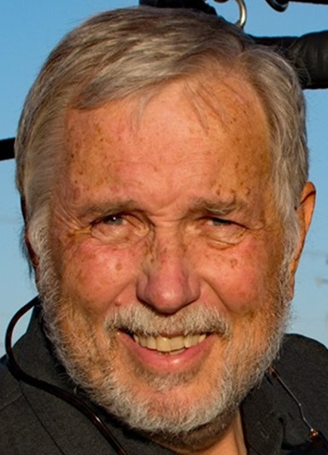
Kent Barnes

Notable – Accomplishments/Contributions

kjbarnes@gmail.com

Kent earned his fixed wing pilot certificate while attending college in 1969. As a fixed wing pilot accumulated time flying for pleasure and flying skydivers for the local drop zone. While taking a break from aviation to focus on a management consulting career and family he did not lose his passion for flying. Then in 2002 the desire to regain “a life in the air” strongly re-emerged after a hot air balloon flight. Within six weeks of that flight, he had added a commercial LTA rating to his pilot certificate and purchased the first of many LTA aircraft.
Since that time he has had the opportunity to fly balloons at locations and events across the United States, as well many international events in the Middle East, Asia Pacific as well as South and Central America. In his desire to grow and share his passion he has/is:
- Earned the BFA Level 8 Pilot Achievement award,
- Been designated a BFA Flight Instructor,
- Recognized as an Elite Balloon Instruction from the Elite Balloon Instructor Program fueled by the National Association of Flight Instructors (NAFI),
- Assistant Chief Instructor for a FAA approved 141 flight school,
- Hundreds and hundreds of hours instructing private and commercial under Part 61 and Part 141
- FAA Safety Team Representative, FAA Safety Team WINGS Pro
- Organized various balloon events and rallies in the Intermountain region
- Organized Balloon Safety Seminars for over 10 years
One of his greatest joys is to introduce the sport of hot air ballooning to people for their first time. He really enjoys his role as an instructor where he is able to see student's progression to earning their pilot certificate. It is Kent’s desire to promote ballooning as a fun filled family activity to the general public and corporate America.



