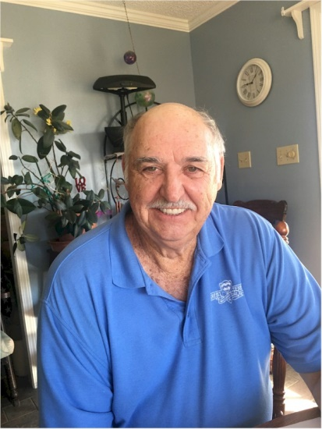
Pat Harwell

Notable – Accomplishments/Contributions

Born March 17, 1948 in Shreveport, Louisiana and remained a lifelong resident of Louisiana. I received a Bachelor’s degree in business from Northeast Louisiana University and a Master’s degree in Business from Centenary College of Louisiana.
I owned three businesses, selling each prior to my 50th birthday and retired from official work in March 1998. I have been flying hot air balloons ever since. Acquiring my private LTA license in the fall of 1990 and my commercial ticket in the spring of 1991, I currently have 3,200+ pilot-in-command hours.
Notable championships include four (4) Louisiana State Championships, two (2) Oklahoma State Championships, one (1) Texas State Championships and two (2) BFA Southeast Regional Championships. I was elected Chairman of the Board of the Red River Balloon Rally from 1991 until 2003.
My wife (Susan Harwell) and I set the US and World record for distance flown in an AX-4 (31,000 cu. ft.) balloon with an airborne heater totaling (139.71 miles – mine and 47.01 miles – hers) in March 1998.
From 2000 – 2003, I served on the Board of Directors of the Balloon Federation of America.
I provided successful flight instruction for 24 students to completion of their LTA licenses while the owner/operator of American Escapes Aerosports in Shreveport, Louisiana (since 1991). We now specialize in commercial rides, tether operations, flight instruction, and balloon event organization for southern communities.

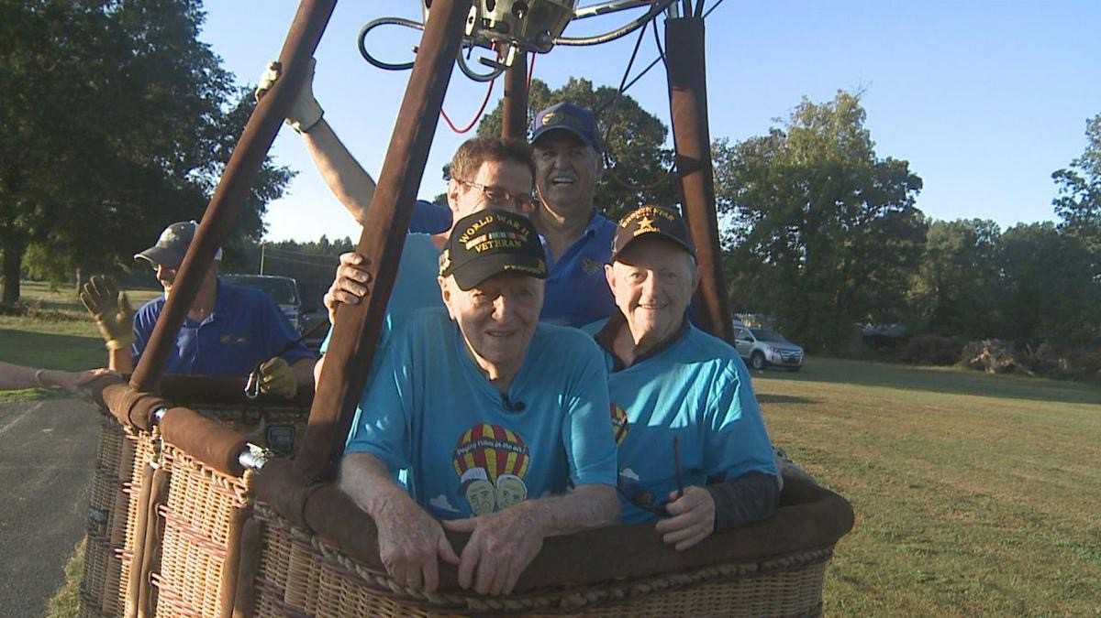
Flying Two WW II Vets

