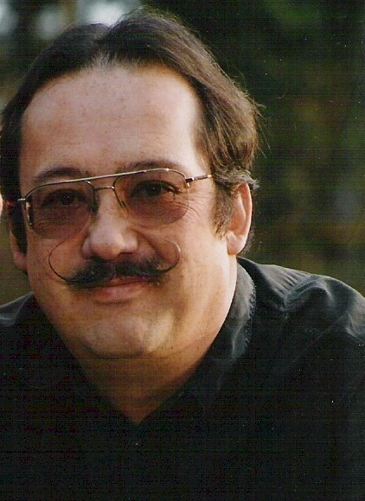
Koh Murai

Notable – Accomplishments/Contributions

16927 NE Morrelli Drive,
Yamhill, OR
97148-8419

Predominantly a sport flyer but also provide some instruction. I also enjoy aerostat construction. One of my other joys in LTA aviation is working on, executing, and helping others with the planning, technical and operational aspects of long distance, long duration, and high-altitude flights. It has been my pleasure to be the launch master for 5 world record flights and many other attempts. Weather, meteorology, forecasting, are also areas of constant interest to me.

History:
- 1978 - First balloon ride, start crewing and student pilot
- 1983 – Private certificate – hot air
- 1988 – Commercial certificate – hot air
- 1996 – Gas rating

I became involved in manned trans-global ballooning in 1991 at the request of the FAA.

- 1991 – Launch crew for Earthwinds II – Reno, NV.
  - For launch of a sky anchor balloon system with a 24,500# payload.
- 1992 – Launchmaster Earthwinds III – Reno, NV
- 1993 – Launchmaster for Earthwinds IV – Reno, NV.
- 1994 – Launchmaster for Earthwinds V – Reno, NV.
- 1996 – Asst. Launchmaster Virgin Global Challenger (VGC) Marrakech, Morocco
This flight attempt was a Roziere balloon supporting a 26,500# payload.
- 1996 – Launchmaster VGC Test Program, Reno, NV. (Set one world absolute altitude record)
- 1997 – Launchmaster Group (4) VGC II, Marrakech, Morocco
- 1997 – Launchmaster VGC Test Program Phase II, Reno, NV.
- 1998 – Launch team member for VGC III, Marrakech, Morocco
- 1998 – Launchmaster VGC Test Program Phase III, Reno, NV. (Set three world records for distance, duration, and altitude)
- 1998 – Launch team member for ICO Global Challenge, Marrakech, Morocco.
- 1998 – Consultant on launch and emergency procedures for Global Hilton, Albuquerque, NM.

- From 2000 – 2005, I was involved with scientific balloon and systems design and flight operations as the engineering manager for a small private firm supporting various government and university agencies. This work included designs and flight operations in earth atmosphere, near space, and planetary exploration (Mars & Titan-largest moon of Jupiter).

Since mid-2007 to present, I have also been the engineering consultant and engineer of record for Firefly Balloons.

Accomplishments:
- FAA Wings (Safety) Level XVIII [Old System]
- FAA Wings (Safety) Basic 11, Advanced 4
- FAAST Representative (former FAA Accident Prevention Counselor) 2002-present
- BFA Pilot Achievement Award Program Level VIII-2009
- BFA Crew Achievement Award Designee, 1987 - present
- BFA Pilot Achievement Award Designee, 1997-present
- BFA Certified Safety Seminar Instructor, 1991- present (Wx, ADM, Flt.Planning)
- BFA Safety Seminar co-organizer 1991 – 1994(NV), 2003-2006,2011-2013(OR)
- BFA Board Member 1997 – 1999
- BFA Treasurer 1998
- BFA – FAI/CIA Sporting Badge Program Chair 2000- Present
- Hot air flights – USA, Morocco, New Zealand.
- Gas Flights - USA

Awards
- 1997 – Excellence in Ballooning from Pacific Coast Aeronauts
- 1999 – Presidents Award from Balloon Federation of America
- 2009 – Directors Award, from The Great Reno Balloon Race
- 2012 – Sportsman’s Award, from the Great Reno Balloon Race

Event Official
- Event Director
Balloons Over Waikato, 2000, Hamilton, New Zealand
The Great Reno Balloon Race, 2003-2009
- Juror
U.S. National Hot Air Balloon Championships, 2006-2007
- Safety Officer
Various local Rallies in Oregon and Nevada (1990-present)
- Weather Officer
Various local Rallies in Oregon and Nevada (1990-present)

Balloon Clubs
- Balloon Federation of America, Life Member, past board member
- Willamette Aerostat Society, Current member, past VP
- Pacific Coast Aeronauts. Past member
- British Balloon and Airship Club, Past member
- Houston Balloon Pilots Association, Past member
- Lone Star Balloon Club, Past member

