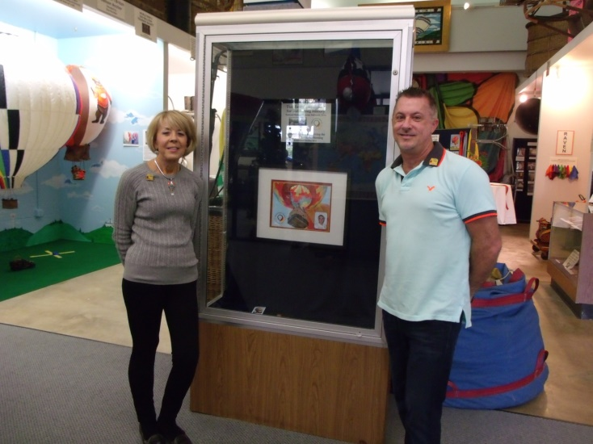
Gary Tarter

Notable – Accomplishments/Contributions

The following article was posted in the National Balloon Museum Newsletter on October 19, 2015.

A Love Affair with Ballooning

One year after the biggest donation the National Balloon Museum has ever seen, Linda Tarter and her son, Gary Tarter Jr., visit the museum, curious to see where all that money has gone. Gary Tarter Sr. left a sizeable donation because he loved the unique charm of this museum.
This year, on October 12, Linda Tarter and her son returned to Iowa to memorialize Gary Tarter Sr. Expecting to be able to sneak through and just look at the National Balloon Museum building and the addition that the donation paid for, they were surprised to find a large gathering of balloon enthusiasts all welcoming them back to Iowa. With over 40 guests in attendance, the Tarters were welcomed with open arms back to Gary Tarter Senior’s favorite museum. Kelly Shaw, mayor of Indianola, presented the Tarters with a proclamation recognizing the importance of the contributions the Tarter family made to the museum.
The National Balloon Museum’s curator, Becky Wigeland, presented the family with a plaque commemorating Gary Tarter Sr. and his contribution.
After 37 years of flying, Gary Tarter Sr. had flown his balloon around much of the United States. His favorite areas included Missouri and New Mexico, but he always held a special place in his heart for Indianola, Iowa.
Tarter got his start in Indianapolis, Ind., when he followed a balloon that was flying for the state fair in 1976. Three months later, Tarter Se bought his first balloon and began a great love affair with the air.
Unlike many pilots, Tarter was very laid back, especially when it came to ballooning. He loved to fly, and crews around the country loved to work with him. From New England to Albuquerque, N.M., Tarter had a loyal crew in each location, and each crew was like family to him. “Ballooning was just such a tight-knit family thing,” explained Linda Tarter, widow of Gary Tarter Sr. and mother to Gary Tarter Jr. The younger Tarter grew up in the ballooning world from the age of nine.
When told the family was headed to a ballooning event, he would promptly ask who would be there. Each event was a chance for him to see his closest friends—children of other ballooning families. “Kids who grew up in ballooning are probably the most flexible you’d ever meet,” remarked Linda Tarter. The children of the ballooning families would be up at 5:00 a.m. with their parents, and they would travel across the country with their parents. They would have to stand around in the middle of nowhere while their parents talked about ballooning after an event. Gary Tarter Jr. even spent his birthday in Iowa every year so his father could fly in the National Balloon Classic.
One location both Linda and Gary Tarter Sr. favorited was Forrest Park, Mo. The couple used to live in St. Louis, and flying there gave them a chance to return home. “That’s what she talks about the most,” recalled the younger Tarter about his mother.
Gary Tarter Sr. was only a part-time pilot. He held a full-time job at UPS until 1999. He often looked forward to retirement so he could fly when and where he wanted. His other hobbies included watching NASCAR, playing golf and reading science fiction. However, his greatest passion was piloting hot air balloons.
“To see my dad so happy and to have that life that he always wanted up until the very last day was the best part,” said the younger Tarter about his father. “Everyone needs a hobby, something to do. This was his salvation. To be able to go blow off steam, it’s so peaceful to fly.”
The Tarters, just back from Albuquerque in tribute of Gary Tarter Sr., were overwhelmed with the support of the ballooning community. “He made so many friends all over the country, and it’s just amazing over the last year the enormous amount of stories and admiration for my father,” remarked Gary Tarter Jr. “It’s been really very, very overwhelming. But I never realized… how much they’re missed and how much they really contributed even before the gifts.”
Gary Tarter Sr. collapsed in Albuquerque, N.M. in October of last year during Albuquerque’s International Balloon Fiesta. Gary Tarter Jr. recalls his thoughts during the plane ride over to Albuquerque from his home in Boston and the ballooning family support that existed in New Mexico.
“I walked off the plane and see, really, the army of friends,” remembered Gary Tarter Jr. “Everyone was gathered in one place. He was doing what he loved, where he loved, and with the people that he loved.

The following article was published in the National Balloon Museum Newsletter on
November 10, 2015.

When Old Friends Visit
One year after the biggest donation the National Balloon Museum has ever seen, Linda Tarter and her son, Gary Tarter Jr., visit the museum, curious to see where the money is being put to use. Gary Tarter Sr. left a sizeable donation because he loved the unique charm of this museum.
This year, on October 12, Linda Tarter and her son returned to Iowa to memorialize Gary Tarter Sr. Expecting to be able to sneak through and just look at the National Balloon Museum building. They were surprised to find a large gathering of balloon enthusiasts all welcoming them back to Iowa.
With over 40 guests in attendance, the Tartar’s were welcomed with open arms back to Gary Tarter Sr.’s favorite museum.
Kelly Shaw, mayor of Indianola, presented the Tartar’s with a proclamation recognizing the importance of the contributions the Tarter family made to the museum and the community.
The National Balloon Museum’s curator, Becky Wigeland, presented the family with a plaque commemorating Gary Tarter Sr. and his contributions.
Tarter got his start in Indianapolis, Ind., when he followed a balloon that was flying for the state fair in 1976. Three months later, Tarter Sr. bought his first balloon and began a great love affair with the air.
Unlike many pilots, Tarter was very laid back, especially when it came to ballooning. He loved to fly, and crews around the country loved to work with him.

Indianola’s National Balloon Museum gets Largest Donation Ever

WHO News
Posted: Updated: May 20, 2015 / 04:49 PM CDT
INDIANOLA, Iowa - The National Balloon Museum just received quite an uplifting gift.
Though the exact amount has been asked to remain private by the family, Gary Tarter - a balloonist and friend of the museum's - has left a large donation to the museum in his will. Tarter passed away last October from a heart attack while in a hot air balloon in Albuquerque, New Mexico.
The gift is the museum's largest ever, which also houses offices for the National Balloon Classic and the Balloon Federation of America. A non-profit with only volunteers as its staff, Indianola Mayor Kelly Shaw says the donation will help the museum preserve hot-air balloon history -- and its ties to Iowa -- for years to come.
"We chronicle the history of ballooning here. When you look around, like up to my right, you can see baskets, that date clear back to 1900 that were used by the United States Navy for naval training, and aviation training," he said. "We have other historical balloons here, including the first hot air balloon to cross the English Channel. So, a lot of history here."
The National Balloon Museum in Indianola is one of two historic balloon museums in the United States. The other is located in Albuquerque.

