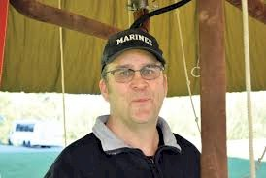
Greg Ashton

Notable – Ed Yost Master Pilot Award

2060 W. Sunny Slope Drive
Boise, ID 83642
208-761-9000
Hotairgerg@yahoo.com
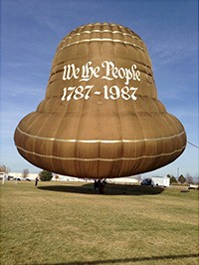
I started my Ballooning career in Denver, Colorado in the mid 70’s when we would bug my Dad to go out to the valley and chase some of the balloon pioneers like Chauncey Dunn, Joe Wood, Bob Walsh etc. as they flew all hours of the day back then. when we moved to Boise, Idaho in 1977, Scott Spencer was just starting the 1st Western Idaho Fair Balloon Rally. I still have the jacket.
I started chasing the local balloonists Charlie Sundquist, Scott Spencer and others after I had Finished my paper route and ridden my bike down to the fairgrounds. It didn’t take them long to figure out if they taught me how to fly, they could haul an extra passenger so that’s how I accumulated hundreds of hours of flight time. I got my Student license at 14, Private at 16 and Commercial at 18 respectively. Things are a little different back there and than they are now. My FAA examiner was afraid of heights. His name was Dale Rice and he sat in his sky blue Pinto station wagon and told me he wanted me to go up 50 feet, fly 50 feet and land and I got my commercial license as I had plenty of hours.
I have owned several balloon and inflatable advertising companies. Oregon Balloon Adventures was my largest company in the 80’s. I was frequently on TV shooting for PM Magazine based out of Portland. I specialized in doing hi-visibility advertising with the balloon and banners, Such as sitting over rush hour freeways with logos pointing at the traffic. I moved to Sioux Falls, SD in 1987 and took a position as the National Sales Representative for Aerostar International, Inc. My job was to work with our Distributors and Dealers around the country and overseas and promote the Aerostar Brand. That job took me all over the USA and I met many wonderful Balloonists, crew and friends.
One of my “official” events took me to Battle Creek, Michigan where I met Angela Lee, the love of my life, and we married the next year. While at Aerostar we fielded a phone call from a highly honored female hydrogen balloon Pilot from Blue Bell, Pennsylvania named Constance (Connie) Wolfe. She wanted a balloon built in the shape of the Liberty Bell to commemorate the 200th anniversary of the signing of the Declaration of Independence. She had called every Balloon Manufacturer and Aerostar was the only company to say “yes”. BFA President, Mark West, was at the helm of Aerostar at that time and he led the build team that built the current Liberty Bell Special Shape “Miss Bell” which we are still flying today. It was built 33 years ago and she still flies at special events.
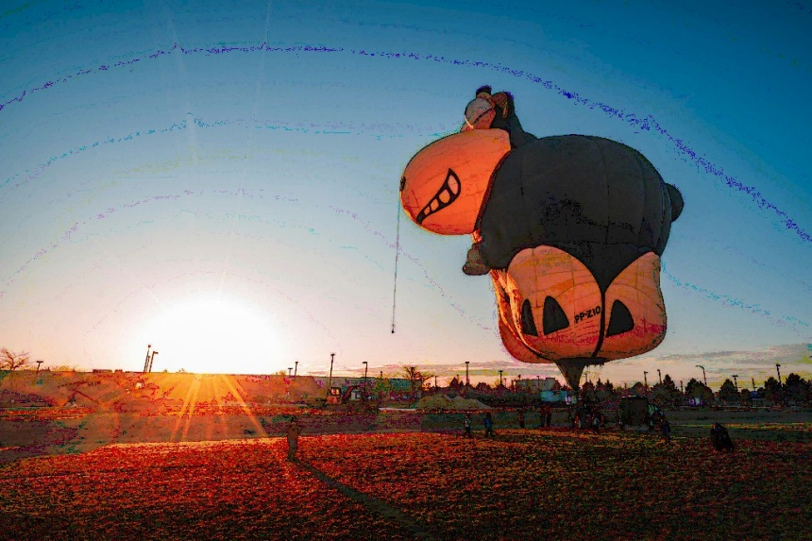
I tethered the Liberty Bell on Penn’s Landing in September, 1987 in a driving rain storm as Ronald Regan was speaking 100 yards away to a huge crowd as they shot cannons over the Potomac River. It was a true once in a lifetime event. After that, Connie said to get rid of the Bell and it switched hands a few times until we purchased her back in 2014. We are in the process of building a new one.
We recently purchased “Montie the Black Sheep” from a friend in Brazil. We are in the process of getting Montie registered in the USA and will be at many events in the coming years. This could go on for a while but I will end it there. I have flown full time and part time for 43 years.

