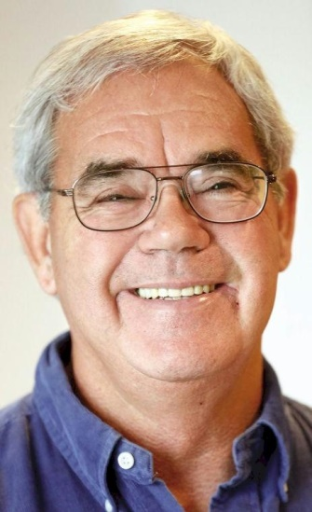
PHIL THOMPSON

Notable – Development, Ed Yost Award

Phil Thompson was born and raised in Indiana and attended Indiana University in Bloomington. It was upon his return to Bloomington, after service in the US Army that his interest in aviation began. While flying ” power line patrol” for the regional power & light company, he spotted the Oliver Winery balloon from the air.
Inquiry at the winery led to crewing at a local balloon event. Within two months Phil had added a balloon-rating to his license and purchased his first balloon in 1976 from Mike Adams. In 1980, Phil opened a certified repair station, “Thermal Air Repair.” It was later located in Battle Creek, Michigan, when he moved to Ann Arbor and became one of the three original employees of Cameron Balloons US.
From 1983 until June of 1994, Phil was employed at Cameron Balloons US where his responsibilities ranged from production manager and technical advisor to flight test pilot for certification of new designs and special shape balloons. Through the Small Aircraft Certification office of the FAA, designations of DMIR and DER were granted to him.
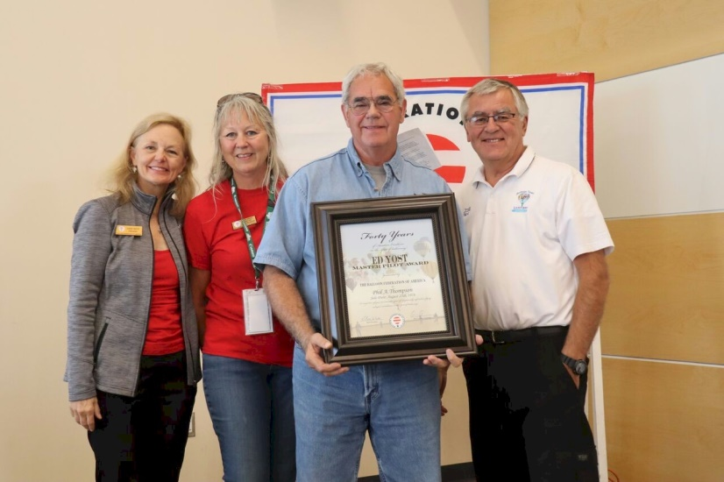
In July 1994, Phil negotiated exclusive distribution and manufacturing rights of Lindstrand balloons in the United States. Lindstrand Balloons USA is wholly owned by Phil, and in 1996 manufacturing of the Lindstrand line began in a small factory building in Hanover, Illinois. In December of 2000, construction of a purpose-built factory in Galena was completed. Lindstrand Balloons operates under three U.S. type certificates; B00010CH, B82EU and B87EU. Phil holds DMIR, DER ratings with the FAA; and in 2007, he was granted a DAR designation which allows him to issue special airworthiness certificates.
Phil participated for over 25 years in sanctioned competitive balloon events; however, in more recent years he has enjoyed attending smaller non-competitive events offering the opportunity to fly in variety of locations; one of the most spectacular being flying the gorge in Letchworth, NY. An active speaker on the seminar circuit, Phil has received the BFA Domont Safety Award and BFA President’s Award. He received the Ed Yost Master Pilot Award for 40 years of safe flying from the Balloon Federation of America in 2018.

