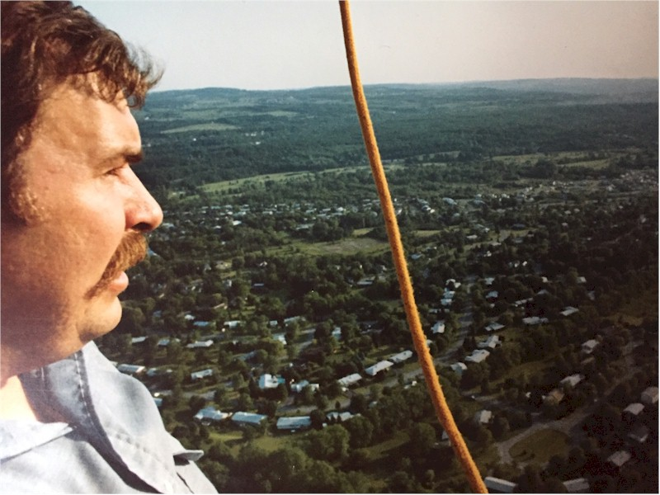
Jim Griswold

Notable – Accomplishments/Contributions
Jim attended the Adirondack Balloon Fest, Glens Falls, NY in September of 1977 as a spectator. His first flight was for his anniversary, with wife Betsy, October 1977 with Dave Stevens in his Balloon Trillium. Jim got about 10 feet in the air and said, “where do I sign?” They purchased a Balloon Works AX-7 and it was delivered in the spring of 1978.
Balloon Career Highlights:
- Private Pilot Hot Air Balloon Certificate Fall of 1978
- Attended Captain Eddie Allen’s Balloon festival at Batavia Downs, NY May 1979.
- Commercial Pilot Hot Air Balloon Certificate October 22, 1980.
- Helped to organize first balloon festival in Central New York in June of 1979. The Salt City Balloon Festival had 4 balloons at Jamesville Beach County Park. He was Balloommeister of the event for years. This event carried on for 40 years and at its peak had 45 balloons and 40,000 attendees. Renamed to the Jamesville Balloon Festival in the early ‘80’s. Both Jim’s son’s Peter and Scott served as also Balloonmeister of the Jamesville Balloon Fest in 1997, 2012, 2013 (Peter), 2018, 2019 (Scott).
- Started Fantasy Flights in 1980. Commercial Balloon ride and advertising business.
- Started and managed the Miller High Life Hot Air Balloon program from 1982 -1990. Consisted of 2 Miller High Life Balloons and a Miller Lite Balloon.
- Became a Balloon Works Dealer 1981-1991, Dealer of the Year 1985.
- Competed in the NBRA National in Corsicana, TX 1986.
- Attended the Calgary Olympics Hot Air Balloon Fest in 1988.
- Trained more than 20 Balloon pilots in the Central New York area throughout his career.
- One of the founders of the Central New York Balloon Club.
- Club created an award, presently at the National Balloon Museum, to recognize contributions to the Jamesville Balloon festival. He was awarded the first award in 1988 then again in 1991; Peter then won it in 1997. The award was subsequently named the Jim Griswold Memorial award and was painted in the colors of his second balloon. It was donated to the museum in 2000. The award was created by Jim’s former student and balloon pilot David Longeill.
- Trained first son Peter Griswold in 1988 in for Private Pilot’s Certificate, obtained at age 16 in 1990. Peter then obtained his Commercial Certificate at age 18 in 1992. Peter then trained his younger brother Scott, who is now a full time balloonist also operating Above All Balloon rides in Selkirk, NY.
- Jim also trained his brother Ken Griswold in 1990, who then trained his wife Amy McCusland-Griswold. They operated Champagne Balloon Adventures in Alexandria Bay, NY from 1994-2015.
- Jim passed away too early from Colon Cancer September 19th, 1991 at the age of 44.
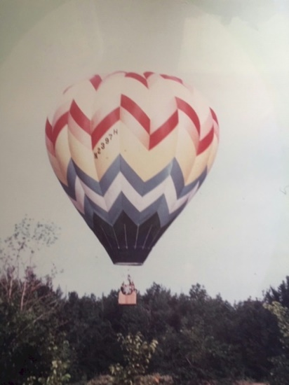
Jim's first balloon, 1978

