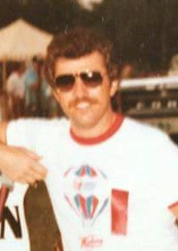
Dave Tallant

Notable – Accomplishments/Contributions

﻿ My first experience with ballooning was at the 1976 Nationals, I was crewing for a pilot who after two races said that it was too stressful and pulled out. I thought, “I can do this“ and bought a balloon. My first training flight was in the fall of 1976 and in 1978 was 7th on the national point list and finished 9th that year at the Nationals and thought that was awesome. However, the greatest accomplishment was the national point leader for 1984 and being given the #1 banner for the Nationals. The run for this award started at the 1983 Nationals and a first-place sanctioned event. The next stop was September 1983 and another first-place at a Storm Lake, Iowa event. The third and last sanction race was a second-place finish at the State championship in Fort Dodge, Iowa in October 1983.
I finished 21st that year at the Nationals. My last balloon flight was in the fall of 2003, 27 years from my first.
I feel very honored to have accomplished the things I have and share this great sport with so many friends, family and countless many others. I miss it very much. It was defiantly my love and my passion. As Bob Hope would say, “Thanks for the memories”.

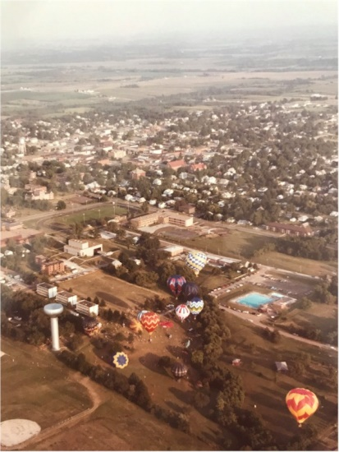
1980 Nationals – Indianola

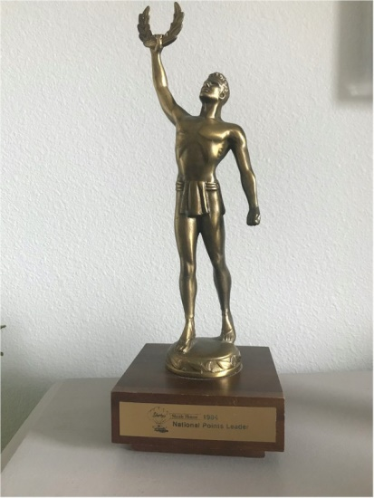
1984 National Points Leader

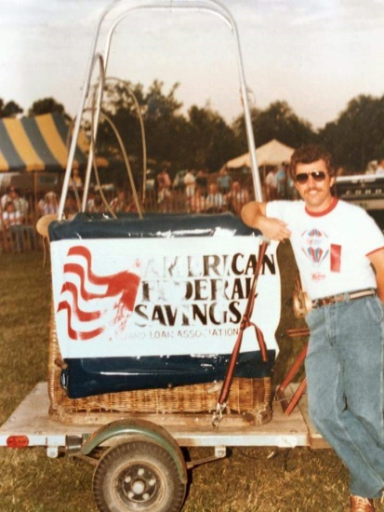
Dave - American Federal Balloon

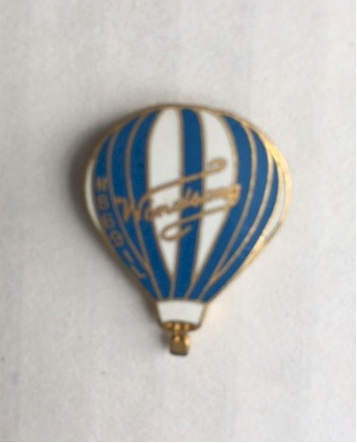
Windsong

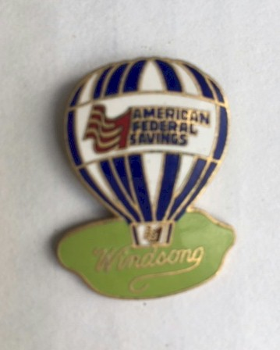
American Federal

