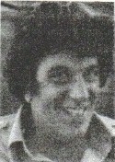
Don Caplan
Notable – Accomplishments/Contributions
Don Caplan was involved in the art of aerostation since 1968 when he purchased his first balloon from Don Piccard, one of the inventors of modern day ballooning. Since that time he has continued his interest in the sport and has been equally active in its promotion.
Don has served as official in many races and tallies in the United States including the National Championship, and the Forest Park Rally in this then home town of St. Louis, Missouri. He took the Missouri Governor’s Cup in 1979 at the North Central Regional Championships and won top honors in both 1978 and 1979 at the Illinois State Fair Competitions, and was the winners of the Kansas Governors Cup in 1980. Although these events were all hot air races, Don is proficient in gas ballooning as well, taking second place at the 1981 National Gas Balloon Event in Indianola, Iowa. In 1985 he was part of the United States team for the Gordon Bennett Gas Balloon Race in Zurich, Switzerland. He won a gold medal for the United States in Johannesburg, South Africa International Championships.
Don was a Life Member of the Balloon Federation of America, Gateway Aerostatic Association and the Federation Aeronautique Internationale. He was a past chairman of the National Gas Balloon Events Committee of the Balloon Federation of America. He has reached the rank of Level VII, the highest rank achievable from the BFA Pilot Achievement Program.
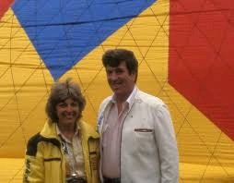
Not limiting his flying to the borders of the United States, Don has the distinction of being the first American balloonist to fly in Japan, and the very first person to travel by balloon over the Taal volcano in the Philippine Islands (a hang balloon – no basket suspended by a parachute harness) an experience that neither Don, or the natives of the tiny islet on which he landed are apt to forget. He has also competed in balloon events in England, France, Spain, Germany, Israel, as well as flying in Korea and Taiwan.
Nikki and Don Caplan
Don and his wife Nikki set many standards for training and safety, which have been adopted by the Federal Aviation Administration. Nikki created safety check lists and training methods. She also set 16 World records for gas balloons. Nikki passed away in 1985. Since that time, a stainless steel bust was made of her by Don Wiegan, sculpture of Charles Lindberg, Amelia Erhardt and Mark Twain are on display at the Smithsonian Museum. Nikki’s sculpture is also located in the National Balloon Museum in Indianola, Iowa as well as the St. Louis Aviation Museum, where there will be a balloon wing, named the Nikki Caplan Hall of Aerostation, when completed.

Don continued the sport both professionally and commercially. He completed a tour of Mexico with the Energizer Battery Company, as chief pilot for the special shape Energizer Bunny Balloon. The tour included the cities of Monterrey, Guadalajara and Mexico City.
