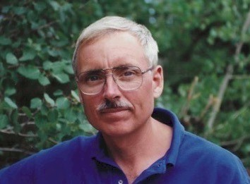
Randy Woods

Notable – Accomplishments/Contributions

Randy Woods was born June 10, 1946 in St. Louis, Missouri. He graduated from Lawrenceville School in 1965 and Vanderbilt University in 1969, where he was commissioned second lieutenant, US Army. He served in 1970 as Protocol Officer at Ft. Ord, California, and in 1971 in Vietnam as an infantry platoon leader in the Americal Division. He earned several combat and administrative distinctions.
At the completion of military service, Woods moved to Aspen, Colorado where he honed business skills, and owned and operated a bed and breakfast as well as a bookstore and art gallery. He developed and invested in residential and commercial real estate. In 1986 he acquired and restored a remote, abandoned silver mining camp near the Continental Divide.
In 1990 + 1991 the Woods family resided on a small, remote island in the British Virgin Islands, homeschooling two small children there. They pioneered the installation of residential solar electricity in the Caribbean. It was here that Woods developed an enduring love of boats and the sea.
Woods relocated from Aspen to St. Louis with his spouse, Fiona, in 1993.
He has four children and three grandchildren (2020). He has been active on several educational and environmental boards, and involved in various clubs and charities throughout his life.
He and Fiona write on diverse subjects for several news media and periodicals.

CREDENTIALS, MEMBERSHIPS & DISTINCTIONS

- Commercial Pilot LTA Free Balloon, Private Privileges, Single Engine Land
- Balloon Federation of America—Life Member
- Balloon Federation of America—Distinguished Aeronaut
- Amateur Radio License KB0YJG
- Advanced Open Water Diver since 1977
- Explorers Club, Member National
- Order of St. John
- U. S. Coast Guard, 100 Ton Master Mariner Credential
- U. S. Coast Guard Auxiliary, Member
Randy and Fiona Woods are residents of Key Largo, Florida. They maintain a home in suburban St. Louis, and operate a 60-foot motor yacht, “Jupiter” several months of the year in the Pacific Northwest, exploring and reporting on remote British Columbia and Alaska.
Please see: https://jupitersway.com/

BALLOON BEGINNINGS

Woods achieved a fixed wing Private Pilot Certificate in 1969 as a student at Vanderbilt University.
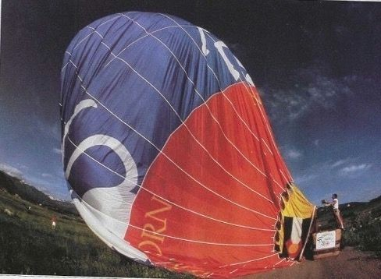
While living in Aspen, CO he purchased a custom Raven S55A (AX7) from Bill Miller (Arizona Balloon Company) in 1980 and earned Private and Commercial ratings. The balloon’s super graphic of rampant unicorns was created by Bruce Hopper, famed designer of the asymmetrical Sea and Ski bottle and other iconic artworks.
In Aspen, Woods owned the Unicorn Bookstore which shared the unicorn balloon graphic. Often, after morning flights of the Unicorn Balloon in the Roaring Fork Valley, locals and tourists contacted the store to inquire about going aloft in the mountains, and an opportunity was found.
Unicorn Balloon Deflation

UNICORN BALLOON COMPANY

In 1981 Woods founded the Unicorn Balloon Company in Aspen to offer mountain balloon rides and photographic services. Convenient launch and friendly landing sites were established in the Roaring Fork Valley and explorations of the micrometeorology and mountain wind patterns on the surface and at high altitude were made. Woods learned to exploit down valley winds and cross winds to travel long distances during early mornings, and nevertheless, benefit from calm conditions for landings.
Woods pioneered the use of nitrogen pressurization of propane tanks in lieu of electric tank heaters for cold weather and high-altitude flights.
He developed innovative, safe and efficient ways to operate a balloon ride business including recruiting top pilots and paying them and ground crew appropriately.
Unicorn Balloon Company safely separated passengers from inflation and retrieval equipment, transporting passengers in comfortable vehicles rather than aboard trucks.
He has long been an advocate for medical certificates for commercial pilots and for assembling an independent advisory board to objectively review operations of balloon ride operators.
During the period of 1981 to 1987 Unicorn Balloon Company grew into one of the country’s largest balloon ride operations. Multiple iconic Unicorn-liveried balloons were acquired, and these became ever larger growing from AX8s to AX9 and AX10s, carrying up to 8 passengers.
The company set extremely high standards for safety, professionalism and quality of experience, and seasonally hired personable and experienced balloon pilots who were well-informed and uniformed, as were many loyal ground and chase crews.
Expensive balloon ride tariffs in Aspen at the time reflected the overall excellence of mountain experiences, accomplished personnel, branded and polished chase equipment and new aerostats, as well as providing gourmet picnics on landing.
The entire experience set a high standard for ballooning in the tradition of Buddy Bombard’s European operations.
Unicorn’s first Chief Pilot for operations was David Grabb, son of pioneering balloonist Bill Grabb. Following David, Jim Christensen assumed leadership and was a stickler for organization and accountability including detailed maintenance of ground equipment and aircraft.
Several other outstanding pilots regularly flew Unicorn Balloons on behalf of the company. These included John Bagwell, Chuck Bell, Butch Brown, Kevin Flanagan, J.J. Garcia, Ted Hunsaker, Suzanne Prendergast, Jake Reyna, Bob Romaneschi, and John Webley.
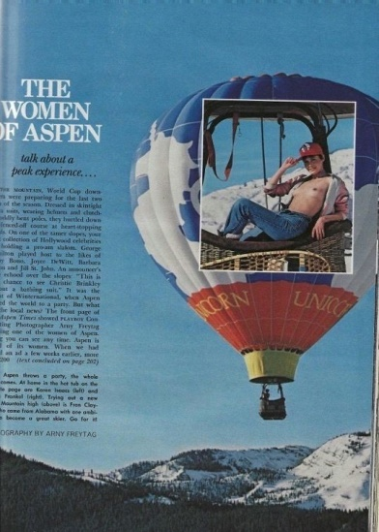
The company seasonally shifted many operations to Scottsdale, AZ during the winter months. This part of the operation was led by amiable commercial airplane flight instructor, Fred Gorrell, who eventually acquired the Unicorn operation from Woods in 1987.
Over the years Woods and Unicorn Balloon Company were chartered to perform at many events, and operations included engagements, weddings aloft, ash scatterings, photography, skydiving, as well as numerous promotions for media and business. Woods also instructed several student pilots, some who went on to commercial ballooning careers of their own.
A winter Playboy Magazine shoot on March 1, 1982 for the February 1983 Women of Aspen edition brought out many volunteer “crew”. Woods, hunkered out of sight aloft with a chaperone in the basket, operated a remote control for the burners. The nude, and very cold, model appeared as if she were piloting the Unicorn Balloon. Photographers in a second aerostat recorded the scene for the magazine.
Playboy February 1983
The company carried aloft numerous interesting and celebrated passengers and enjoyed a large repeat following year after year.
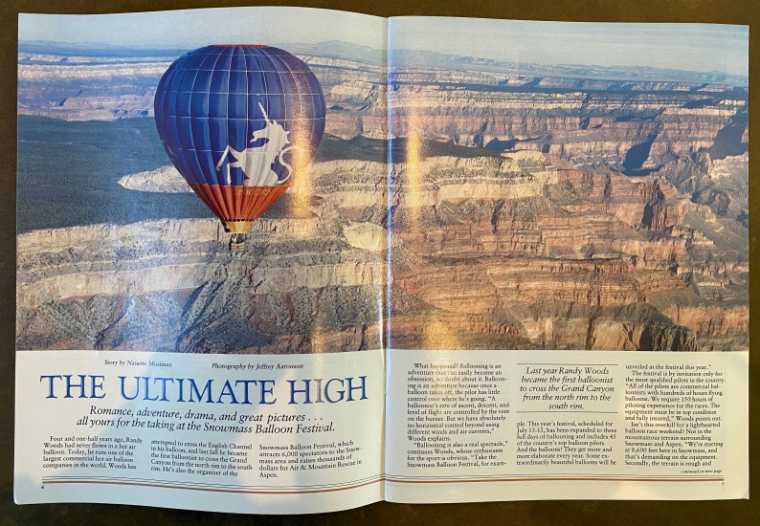
In 1983 Woods was hired to fly across the Grand Canyon for an IMAX film production, and on October 11, after two failed attempts drifting along wrong trajectories, completed a perfect two-hour North Rim to South Rim crossing aboard a Unicorn Aerostar AX10. Crew aboard were Bill Fraley and Allan Price.
This was the first successful hot air balloon rim-to rim flight. Although several days of expensive operations with helicopters and massive cameras were involved, the footage was never used commercially.
Crossing Grand Canyon Oct 1983
Woods and Unicorn Balloon Company became Raven Balloon Dealers in 1983 and subsequently a leading Aerostar Distributor for several states. The company produced many interesting and expensive private and commercial balloons and was always a sales leader.

OTHER NOTABLE HOT AIR FIGHTS

September 13, 1980 Piloted S55A (AX7) from Aspen to 12,700’ MSL Woods descended quickly when he realized he was being drawn over inaccessible wilderness east of Aspen!
September 27 & 28, 1980 Woods piloted the Unicorn Balloon in remarkable Canyon De Chelly in Arizona where, with the permission of the Navajo Nation, the Unicorn and two other balloons were filmed for the dramatic short documentary, Aerscape, which aired on several television stations.
September 23, 1981 Flew S60A (AX8) Woods flew the Western Airlines sponsored balloon from Brands Hatch Raceway to Snodland, England. Landed in the same field where previously a WWI bomber had crashed. This short flight was in lieu of the highly promoted London to Paris Balloon Race which never made a cross channel flight due to unfavorable winds and weather.
May 11, 1983 at Ft. Collins, CO Piloted the Greg Winkler designed S40 Experimental “Hang Balloon” to 11,500 MSL. Woods, typically suffering from acrophobia, perched on a lightly cushioned propane cylinder suspended below the envelope, secured with only a dubious auto seatbelt, was terrified.
Winter 1983 at Snowmass, Woods cold-inflated the Unicorn AX 10 balloon, and David Grabb, having loaded equipment through the side vent, hot inflated his father’s ultralight balloon “Yankee Doodle” inside the big envelope. The small aerostat’s burner eventually erected the host balloon, and David was able to fly inside the large envelope for an hour. Landing and extraction of the smaller balloon through the side vent, resembled a bizarre balloon birth. Asphyxiation was, however, avoided.
December 22, 1984 Piloted S60A (AX8) from Snowmass to 15,500’ MSL in conditions relatively calm to mountain top heights.
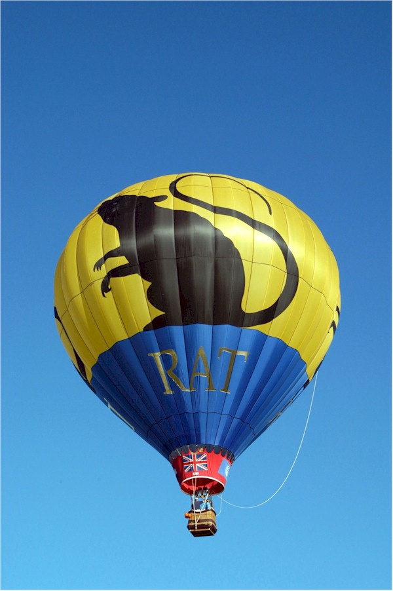
January 15-18, 1985 Flew 4 separate day flights solo from St. Gilgen, in the Austrian High Alpine Balloon Race Aerostar AX8 “Lucy in the Sky” sponsored by The North Face Company. The cumulative distance competition demanded altitudes of 8,500 to 17,900’ MSL. Conditions were extremely cold with surface temperatures often near 0ºF. Nitrogen was used to pressurize the high butane content propane. Woods was penalized one day’s distance for landing within the no-fly zone along the border to East Germany. It was never understood why there was no shooting from the guard houses.
June 8, 1985 Piloted Aerostar S77A (AX10) from Aspen to 15,600’ MSL
Woods participated for twenty years in the Great Forest Park Balloon Race in St. Louis where his famous S60A (AX8) “Rat Balloon” was always popular. Landings in the St. Louis area included an Orthodox Monastery, two cemeteries, several vacant lots in undesirable neighborhoods, the mayor’s house of the community adjacent to Lambert Airport, soybean and corn fields, at family backyard barbecues, in the same park as the race was launched, almost in the Mississippi, Meramec and Missouri Rivers, in quarries and country clubs with no senses of humor, at the school that the Woods kids attended, and at another school which Woods was kicked out of in 1960.
Rat Balloon

INTERESTING GAS BALLOON FLIGHTS

- September 3-4, 1984 National Qualifying Race 32.0 Hrs.
Skypower N34SP Helium, Colorado Springs—Dalhart, TX Co-pilot for Jim Schiller.
First gas flight. High altitude flight exceeding 14,000’ over the plains of Colorado and Oklahoma. From the balloon you could smell and hear the oil wells bowing to the ground and even the sound of a screen door slamming at a house on the plains.
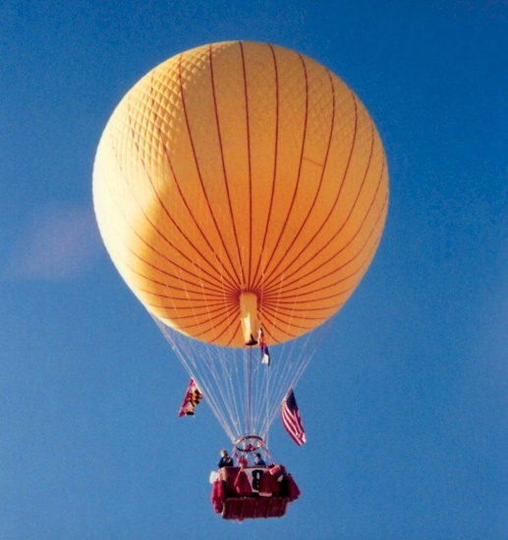
- October 8-9, 1984 National Qualifying Race 21.8 Hrs.
Skypower N34SP Helium, Albuquerque—Sperman, TX Co-pilot for Jim Schiller. Made high altitude “Moon-tea”— like sun tea but steeped under a full moon. Dropped a big battery over the plains and heard it hit many seconds later. No report of any deaths or damage so far.
- November 10-11, 1984 National Race 18.0 Hrs.
Skypower N34SP Helium, Phoenix—Las Cruces, NM with Jim Schiller. Perfect landing on a perfect road that was perfectly inaccessible. Signed off for Free Balloon Pilot, no limitations
- September 3, 1985 National Qualifying Race 16 hrs.
Skypower
First flight of new Skypower N611SP “Moonshadow”, Helium, Colorado Springs—Colby, KS & McCook, NE (2 tasks) with Jim Schiller. Windy landing, as are most daytime plains landings.
- September 28-29, 1985 29th Gordon Bennett 18 hrs.
N611SP, Hydrogen, Geneva, CH—Terascon, FR with Jim Schiller who became ill aboard. 15 Entrants. Becalmed over a nuclear power plant for several hours. The pilot’s sophisticated go-high strategy failed miserably. Landed uneventfully near the French coast south of Avignon.
https://www.fai.org/page/gb-1985
- November 16-17, 1985 Thunderbird World Gas Balloon Championships 15 hrs.
N611SP Helium, Glendale, AZ—San Luis, CO with Jim Schiller.
Landed on a rarely used highway with no contact to crew. Eventually hitched a scary, high-speed ride with two stoned-out locals, “Cheech and Chong”, in a beat-up old car to town to use a pay phone.
- October 7, 1986 National Qualifying Event 6 hrs.
N611SP, Helium, Albuquerque—White Lakes, NM with Fred Gorrell
Went through a lot of ballast during a short flight aborted because of a gas leak.
- October 25, 1986 National Qualifying Event 9.5 hrs.
N611SP, Helium, Allentown, PA (ABE)—Bernville, PA with Fred & Fiona Woods
Soukup/Thomas Event “Greatest flight ever.” (RW log book). NY Twin Towers visible to the East
- November 9 & 15, 1986 World Championship (Thunderbird) 11.0 and 8.5 hrs. N611SP Helium, Phoenix Area with Jim Schiller
https://repository.asu.edu/attachments/188532/content/1986_10_20.pdf
- November 14, 1987 National Qualifying (2 tasks) 6.0 hrs.
N611SP Helium, Soukup/Thomas event from Springtown, PA—Campbell Hall, NY with Jim Schiller. Dropped one of our scoring baggies in the yard of a juvenile prison, which an inmate stole. Fiona eventually charmed her way into lockdown and retrieved it.
- November 17, 1987 Thunderbird Balloon Race 6.0 hrs.
N611SP Helium Phoenix—Safford, AZ with Jim Schiller.
- May 2, 1988 Gordon Bennett 9.0 hrs. 3rd Place
N611SP Helium Palm Springs—Rio del Mayor, MX with Fred Gorrell.
Prior to inflation, Fiona walked into City Hall on some errand to find the Mayor, Sonny Bono in his office standing in his underwear. The night launch proceeded quietly, but even at night the desert produced thermals, forcing the pilots to assume a high altitude which carried them over a wilderness of mountains into the Colorado River estuary of Baja California, Mexico. Landing in the dry river floodplain, the pilots attempted to note their location and walked to a small channel of water where they were given a ride aboard a decrepit dismasted sailing catamaran to a friend’s truck to the highway for Mexicali. Everyone here acted strangely as if they had secrets to hide, which they did, being drug dealers near the US border. Attempts at buying a ride north and hitchhiking failed dismally, and the crew eventually caught a public bus which rocked and rolled to Mariachi music, passing the balloon chase crew which had been warned to stay in the US, headed south into Mexico. Radio communications were unavailable, and no amount of gesticulating through the bus window could slow the determined ground crew. The border towns were eventually reached, and the pilots crossed to Calexico where they phoned Race Control personnel who were able to turn around the errant chase team. All were united late that night, but the business of getting the balloon equipment out had not yet begun. The next morning it was determined that finding the balloon equipment again would be impossible without aerial surveillance. A helicopter was located in Calexico, but unavailable immediately. The crew drove the recovery vehicle back into Mexico and located a fixed-wing pilot willing to overfly the area. The balloon was located, but the chase team was unable to drive through the sandy terrain. The helicopter was available the next day if permission from the Mexican Airforce Comandante could be arranged. Fiona and her compatriot on chase, Betty Pfister somehow convinced the Comandante to authorize the helicopter retrieval even though the entire area was a no-fly zone owing to drug trafficking.
https://en.wikipedia.org/wiki/Betty_Haas_Pfister
The chase crew returned to a roadside sight that could accommodate the gear after the balloon equipment was retrieved from the landing site slung below the helicopter. All equipment (and crew) was eventually recovered and returned to the US.
https://www.youtube.com/watch?v=ViG0VIMakw0
- September 26, 27 and October 1, 1988 World Championships 4.5,3,1 hrs.
Wörner D-BELDRIVE Hydrogen, Gerstofen (Augsburg), GER with Fred Gorrell
Excellent conditions for multiple tasks.
https://www.youtube.com/watch?v=TQ5hL3lt0Js
- October 23-24, 1988 Gordon Bennett 19.3 hrs.
Wörner D-BELDRIVE Hydrogen, Bregenz, AUS—Janjalipa, Yugoslavia with Gordon Boring
Night crossing of the alps with cow bells in the high meadows. Police appeared at landing. Drank enough slivovitz to appear friendly enough to avoid arrest.
https://www.fai.org/page/gb-1988
- September 16-17. 1989 Gordon Bennett 22 hrs.
Wörner D-ASPEN Hydrogen, Lech, AUS—Kosariska, Czechoslovakia with Gordon Boring
Taken to police station with padded doors. Interrogated before eventually being released to bad communist hotel.
http://old.fai.org/gordonbennett/stories-and-articles/426-cia/cia-gbennett-history/35550-event2628-gordon-bennett-1989
- October 6, 1989 Great Divide Race
Wörner D-ASPEN Helium, Snowmass, CO—11 nm S of Flagler, CO with Fred Gorrell
Excellent weather for perfect crossing of the Continental Divide at Independence Pass. Survived a breezy landing in Eastern CO
https://www.chicagotribune.com/news/ct-xpm-1989-09-24-8901150613-story.html
- June 24, 1990 International High Alpine Dolder Ballooning Week 5.4 hrs.
Wörner D-ASPEN Hydrogen, Murren, Stechelberg, CH—Orti, IT
The challenge here is to ascend quickly from the Swiss mountain valley, ride the mountain top fast wind flow over the highest peaks and glaciers of the Alps, then descend just as quickly to a landing in Italy and eat spaghetti. Crews were judged on their flight profile and extensively detailed documentation of the flight. They landed in an apple tree in the Po River Valley, but were extracted, thankfully, by the happy locals who kidnapped us as guests of honor at their weekend celebrations. We suffered from atmospheric compression sickness, wine and food overindulgence. Fiona’s interesting story was published in Balloon Life Magazine, June 1991
- October 8, 1990 National Qualifying Event 7.5hrs.
N611SP Helium, Soukup/Thomas Event at Hidden Manor. Springfield, PA - Fitchburg, NY with Fred Gorrell. Landed at a friendly backyard barbecue.
- February 5, 1991 National Qualifying Event Thunderbird Balloon Race 4.5 hrs.
N611SP Helium, Deer Valley (DVT), AZ—W. of Wickenburg, AZ with Fiona Woods & Don
Campbell. On a rough landing a large sheathed knife in the basket became free and flew at Fiona, slightly nicking her face next to an eye.
- September 21-22, 1991 Gordon Bennett D-ASPEN Hydrogen, 7.5hrs.
Lech, AUS—Oberlandelder, AUS with Fred Gorrell
Terrifying night landing in the Innsbruck Valley full of high voltage wires and
thunderstorms. We missed both by hairs.
- February 18-19, 1992 National Qualifying Event Thunderbird Balloon Race 15.2hrs. N611SP Helium, Deer Valley (DVT) AZ – 10 miles NW of Sells, AZ with Fred Gorrell
- October 4-5, 1993 Gordon Bennett 19.8 hrs.
N611SP Helium, Albuquerque—Buena Vista, NM with Gordon Boring
Flight was truncated by extremely strong convective activity downwind from the Sangre de Christo Mountains. The event and flight were covered by Air and Space Magazine, March 1994.
- September 18-19, 1994 National Balloon Race 15.7 hrs.
N611SP Helium, St. Louis—Pittsburg, MO with Ted Staley.
This is the famous “Eggs over the Ozarks” flight. The pilots’ wives secreted a carton of hard-boiled eggs in the basket with a note attached announcing “both your wives are pregnant!” Landed promptly in a cow pasture.
- October 7-8, 1995 Albuquerque Balloon Fiesta 20.1 Hours
N611SP Helium Albuquerque – Holdenville, OK with Ted Staley
Flight to 15,000’ altitude
https://apnews.com/e05bfb8ce27738885c830b3e2ff6060e
- August 29-September 1 1996 World Championships 3 Day Flights 5.2, 4.5, 5.0 hrs.
Wörner D-ASPEN Hydrogen, Bitterfeld, DE (previously East Germany) with Ted Staley.
Excellent weather, organization and competition in which we did not do well overall, however, took first place on Flight 2, Task 5.
- September 15-16, 1996 National Balloon Race 21.0 Hours
Padelt N611RW (Rat) Helium, St. Louis—Smithfield, NC with Ted Staley
Fabulous weather and flight over the Appalachians. Most of the land inland from the coast was flooded by a recent hurricane. Landed in a sausage factory and local sausage workers were very helpful packing up equipment.
- June 14, 1997 Fun Flight 4.0 Hours
Atisholtz, CH Hydrogen, with Fred & Clede Gorrell
Lovely weather, beautiful scenery, lots of low flight over villages, quiet landing
- October 4-5, 1997 America’s Challenge 14.5 Hours
611RW Helium, Albuquerque to Roswell, NM with Ted Staley
Curious paranormal flight ending up with a capture by alien tractor-beam to a forced
landing near the Roswell Airport. Although they had never seen a balloon before, some locals reported that this sort of thing occurred often.
- November 6-7, 1999 Re-Max National Qualifying Flight 18.0 Hours
N611RW Helium, Denver—Springfield, NE with Ted Staley.
Cold aloft.

BALLOON RACES & EVENTS ORGANIZED (With Fiona Woods)

- Snowmass Balloon Festival, Snowmass, CO 1981-1991
Events included successful key grabs, innovative competition tasks including the Colorado Rat Race which started at sunrise on the Aspen Airport runway and facilitated a pure distance contest down the Roaring Fork Valley with distances flown up to 40 miles. Social events were first class, and frivolity was encouraged.
This event was originally started by the famous Aspen aviator, Betty Pfister,
- Winterskål Balloon Race, Snowmass CO 1982 & 1983
Winter flying over deep snow in the mountainous Snowmass area encouraged landing on a road!
https://www.vintageskiworld.com/Aspen-s-Wintersk-l-Snowmass-Balloons-Poster-p/poster-lr-snowmass-balloon.htm
- Gas Balloon Division Awards Weekend in San Diego, February 3 & 4, 1989
Black Tie events with interesting speakers and activities for gas pilot, friends and family.
- Great Divide Race (Gas) Snowmass, CO October 6, 1989
Four gas balloons crossed the Continental Divide in near perfect weather to land safely in Eastern Colorado. Great helicopter aerial media coverage.
- National Gas Balloon Races, St. Louis, MO 1994 + 1996
Recreated the spirit of many gas balloon races held in St. Louis at the beginning of the 19th century.

BFA EFFORTS & GAS DIVISION

- Woods was very involved with the Gas Balloon Events Committee (predecessor of the BFA Gas Balloon Division) and was Chairman at the time the Division was formed in 1990 with the support of Jim Thompson. (BFA Liaison to the Gas Committee).

- He also negotiated the release of the name Gordon Bennett from Tom Heinsheimer to the FAI

HOT AIR & GAS BALLOONS OWNED AND/OR OPERATED

- 1980 Raven S55A (AX7) “Unicorn” N5706T
- 1981 Aerostar S60A (AX8) “Galaxy” N57238
- 1982 Aerostar S66A (AX9)” Unicorn” N4191T
- 1983 Aerostar S77A (AX10) “Unicorn” N4199E
- 1984 Aerostar RX7 (AX7) Rally N41120
- 1984 Yost Skypower 1000m3 GAS N34SP (Owned by Dewey Reinhard)
- 1984 Aerostar RX7 (AX7) Rally N4398B
- 1984 Aerostar S60A (AX8) “Western Airlines” (For Rent or Sale)
- 1985 Aerostar S66A (AX9) “Unicorn” N2800X
- 1985 Aerostar S60A (AX8) “Unicorn” N4081T
- 1985 Yost Skypower GAS “Moonshadow” N611SP
- 1987 S60A (AX8) “Rat Balloon” N87RB
- 1988 Wörner 100m3 GAS D-BELDRIVE
- 1996 Wörner 1000m3 GAS “D-ASPEN” re-registered as 69RW
- 1997 Aerostar S57A (AX8) “Rat Balloon”
- 1997 Padelt 1000m3 GAS “Gas Rat” N87RB

Woods retired from ballooning in 2010 with 2000 hours of hot air and gas flight time.

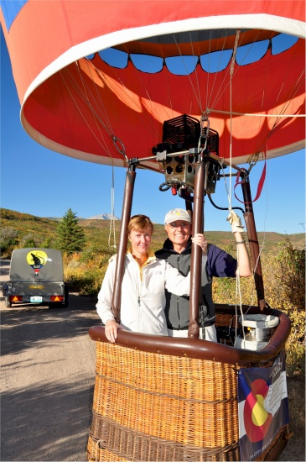
Fiona and Randy

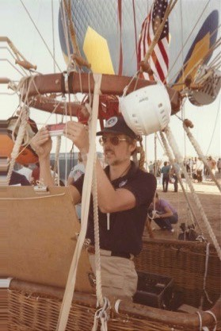
Randy

