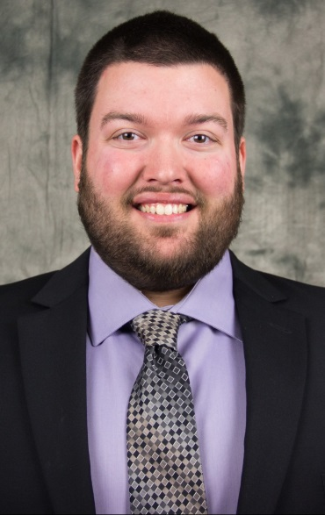
Adam Magee
Notable – Accomplishments / Contributions
- 2019 FAA Flight Instructor of the Year
- Designated Pilot Examiner
- Founder and President of The Balloon Training Academy
- BFA Long Jump Winner
- Competitor at the 1st Jr. World Hot Air Balloon Championship
- Iowa State Champion
Adam is known for his strong passion in aviation safety and raising the standards of balloon pilots. A recognized expert, Adam is the youngest pilot to be designated by the Federal Aviation Administration as a Designated Pilot Examiner for balloons and the only balloon flight instructor to receive recognition as flight instructor of the year.

Pro-Bono Professional Experience in Aviation
Visionary: Adam recognized a lack of quality education and training for hot air balloon pilots and had the vision to go above and beyond all expectations to create a 501c3 nonprofit organization to combat the issue, The Balloon Training Academy. This included filings with the Secretary of State, creation of bylaws, and application/approval from the IRS, creating a website, marketing, all the content and building the organization from the ground up.
Instructor: Adam has created professional online courses to train, educate, and develop hot air balloon pilots. The courses take complex subjects and break them down into easily understood concepts. Courses created include: Private Pilot Test Prep, Commercial Test Prep, Private Pilot Checkride Prep, and various short – sub topic courses for continuing education. He also created a first of its kind private and commercial pilot syllabus to walk an instructor through both the ground and flight training in working with a student. The Private Pilot Test Prep Course in a three year span has helped over 175 students pass the written and over 125 pass their check ride, roughly 40% of all new balloon pilots! Oh, a 100% pass rate as well! At any one time, the Academy has around 75 students enrolled!
He also runs the Balloon Training Academy’s Facebook page which every week posts questions, safety tips, and tricks for training pilots. Every Thursday he posts extremely popular “Thursday Thinkers” which are very challenging questions on the regulations. Over 10,000 people each week enjoy the outside-the-box challenging questions.
FAASTeam Advocate: Adam is an appointed FAASTeam Representative, WINGSPro, and DRONEPro. He actively assists the FAASTeam in creating PowerPoint presentations for the National FAASTeam about ballooning as well as hosting events. The Balloon Training Academy is an appointed FAASTeam Training Provider making courses eligible for WINGS Credit. Adam became the first balloonist to ever be asked to publish an article in the FAA Safety Briefing Magazine. He wrote a featured article about balloon training in the FAA Safety Briefing Magazine November/December 2018 issue as well as an article on powerline avoidance and safety in the September/October 2019 issue.
Mentor/Safety Advisor: Adam has served as Safety Officer, Weather Officer, and Event Director of hot air balloon festivals/events. Adam is also a valued Event Official on the International level and is one of few Americans in the jury pool for International hot air balloon competitions. Adam has mentored local pilots and pilots at events to make safety conscience decisions. Adam has also helped pilots who have located to new flying areas understand aeronautical charts and flying areas. Adam, with the Balloon Training Academy has given away 1,500 hot air ballooning checklists tags to put on pilot bags and tanks to encourage and increase checklist use in hot air ballooning.
Recognized Expert: Adam has spoken and is a sought after speaker at National Balloon Federation of America Safety Seminars across the U.S.A., including being a featured speaker at the Balloon Federation of America National Convention in Philadelphia in the Spring of 2018. He has also written articles for the BFA’s magazine, the BALLOONING Journal, on hot air balloon training. He has also written articles for balloon club newsletters across the USA.
Work with NAFI: Adam spearheaded and developed with the National Association of Flight Instructors the Elite Balloon Instructor Program fueled by NAFI. The program modeled after NAFI’s Elite Flight Instructor program, recognizes hot air balloon flight instructors who are raising the bar on hot air balloon education and training.
Other Service to the FAA: Reviewer/contributor for the new LTA Balloon Airmen Certification Standards (ACS)

Awards and Recognitions Earned
- 2019 FAA Flight Instructor of the Year
- FAA Designated Pilot Examiner
- Balloon Federation of America Directors Award
- Bill Murtorff Spirit of Ballooning Award for youth aviation education
- Represented the USA at multiple Jr. World Hot Air Balloon Championships
- BFA Long Jump Winner
- Iowa State Champion
- Level 8 in the BFA Pilot Achievement Award Program

Additional Service to the Aviation Community
Adam is a life member of the Balloon Federation of America and the Balloon Federation of America Hot Air Competition Division (HACD). In 2016 Adam was elected by his peers to a three year term on the Balloon Federation of America Hot Air Competition Division Board of Directors. He has provided valuable input as a Director including rules guidance and interpretation, communications, and created the game of Balloon Golf. Adam serves as the Safety Manager of the HACD spearheading many safety improvements in the sport of competitive ballooning.
Adam volunteered with the Balloon Federation of America Youth Program since 2009. He organized a BFA Youth Summer Camp in Dubuque, IA from 2012-2014 – Adam and Kim were the youngest to organize and direct a camp at the age of 21. In 2015 Adam wrote the BFA Youth Camp Guidelines.
Adam was a contributor for the BFA Balloon Event Guidelines as well as on the organizing committee of the first ever BFA Balloon Event Symposium in Plano, TX. Adam is also a Board member and Treasurer of The National Balloon Museum in Indianola, IA.

Personal
Adam grew up in ballooning, his mother, Liz, is a commercial pilot as well. Adam took his first ride at 5 years old and his passion for ballooning has never wavered since. Adam met his wife, Kim Magee, through ballooning and the two currently reside in Iowa. Together they have flown across the USA and around the World including Poland, Australia, Taiwan, and Lithuania. Professionally Adam is a Certified Public Accountant (CPA) and holds a Bachelor’s and Master’s degree in Accountancy as well as a Tax Certificate from the University of Missouri. MIZ!

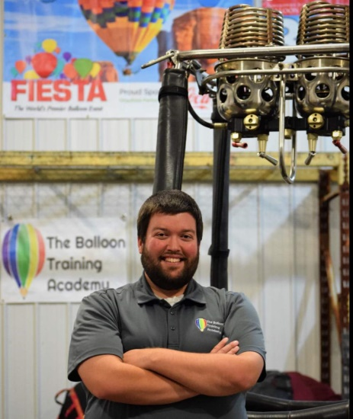


Flying in Taiwan

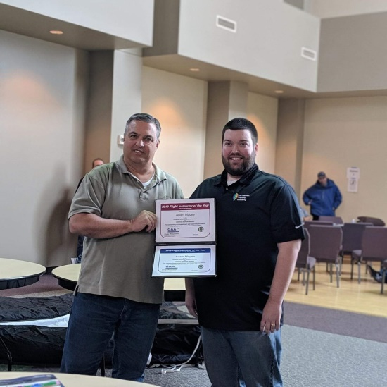
Receiving the 2019 Flight Instructor of the Year
Award from the FAA

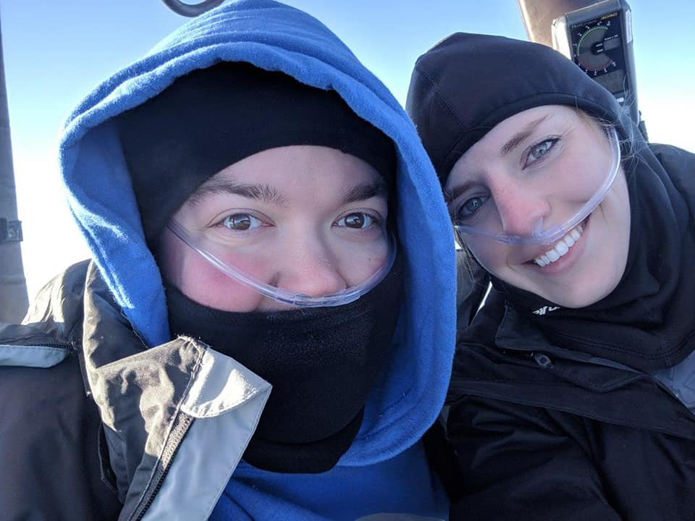
In-flight photo from the 2019 BFA Long Jump
(1st place)

