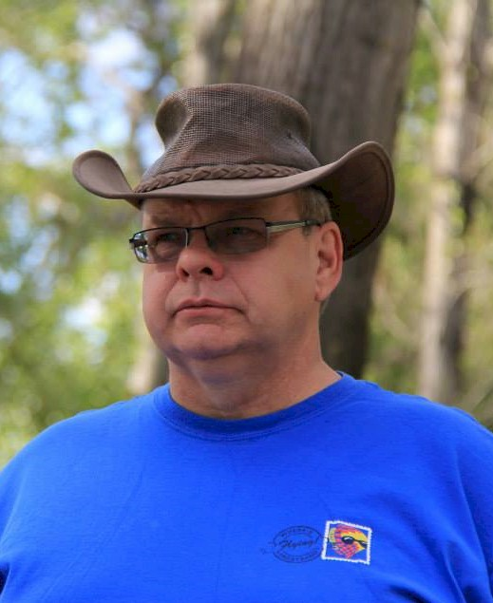
Wooge, (Glen) Scott

Notable – Accomplishments/Contributions

3609 Summer Brook Court
St. Louis, MO 63129-2300
314-845-7746 home 314-422-5873 mobile
Email: scott.wooge@gmail.com

BFA Activities:
- 1st Place- BFA Long Jump Contest 1996: AX7 Category. 320 miles.
- 5th Place- BFA Long Jump Contest 1996: AX8 Category 279 miles.
- 1st Place- BFA Team Long Jump Contest 2010 / Joe Ritchie AX8 Category. 125 miles.
- BFA Pilot Achievement Award Program (PAAP) Chairperson: 6/2000 to present
- BFA Board of Directors Award: 10/2001
- BFA Dubuque, IA Young Camp, Technical Advisor and Crew Chief 2011-2014
- BFA PAAP Level 8 -2012
- BFA National Board of Directors: 2012-2018
- BFA National Board of Directors- Officer, Vice-President: 2014-16, 2017-2018
- BFA Election Team Focal Point 2013- current
- BFA/FAA Ambassador Program SME (Subject Matter Expert) 2016 – to present
- BFA National Convention- Philadelphia, PA- Safety/Educational Speaker 3/2017
- BFA National Convention- Topeka, KS - Safety/Educational Speaker 4/2021 (scheduled)
- BFA HACD Member

FAA Activities:
- Private SEL 7/1990, TT=180 hrs
- Commercial LTA 8/1992 TT= 1,200 +hrs;
- FAA Safety Team (FAASTeam) Lead Representative for Hot Air Balloons: 10/2006 to present
- FAA Wings Level 4 (highest achieved)
- FAA LTA Repair Station Owner and Chief Repair person: 2/2007 - to present
- FAA DPE for LTA 2/2020 - to present
- FAA Drone Pilot: 7/2020

Local LTA Club Activities:
- Helped form new hot air balloon club - Balloon Association of Greater Illinois (BAGI): 1990
- Vice-President BAGI: 1991 and 1992.
- Vice-President, Gateway Aerostatic Association/STL (GAA): 1995,96, 2012
- Treasurer, Gateway Aerostatic Association/STL (GAA): 2013 to present (2020)
- GAA Safety Seminar Committee Board Member: 1995,1996, 2012- to present

Speaking Activities:
- GAA STL Safety/Educational Seminar Speaker (Pilot Restraint Devices): 2/2000
- Media Training: Anheuser-Busch Learning Center: 5/2001
- GAA STL Safety/Educational Seminar Speaker (Hot Air and Hot Wires) 2/2003
- Iowa Balloonist Assoc. Safety/Educational Speaker 3/2015
- Plano, Texas Ballooning Assoc. BFA Safety/Educational Speaker 2/2016
- Wisconsin Balloon Group. BFA Safety/Educational Speaker 3/2016
- Danville, Illinois- BFA BAGI Safety/Educational Speaker 3/2018
- Danville. Illinois- (taped broadcast) BFA Safety/Educational Speaker 4/2019

Crew Activities:
- Crew Chief/ Jr World Championship, Marijampole , Lithuania 2016
- Crew Chief/ Women’s World Championship, Birštonas , Lithuania 2016
- Crew Chief/ Women’s World Championship, Nałęczów, Poland, 2018 (4th Place)
- Senior Director & Chief Technical Manager of Successful World Record Flights (6) and 9 USA National Records: 2018- 2019

Miscellaneous Activities:
- Balloonmiester at LTA Rallies: Quincy, IL 6/2002 (30 Balloons); Millstadt, IL 7/2002 & 7/2003 (12 Balloons)
- Lindstrand Balloons USA- Dealer of the Year: 2005,2009,2012,2015,2016, & 2017
- High Fly Cup Winner for being an ‘Ambassador for ballooning and bring smiles to kids faces’, Centralia, IL 2010
- Lab Instructor for Lindstrand Balloons USA/Aerostar Balloons Maintenance Seminar 2013,2015,2017,2019
- Organized Training Class and Chief Instructor for LTA Students in Centralia, IL Dec. 2015 –April 2016
- Organized Training Class and Instructor for LTA Students in House Springs, MO Dec. 2016 –April 2017
- Ride business, New & Used Balloon Sales, Pilot Training in several manufacturers, Contract Pilot: Anheuser-Busch, United Van Lines, Mayflower Transit, Fox Photo, Ameritech, Verizon Wireless, Sinclair Buick/GMC, ReMax, Touchstone Energy, etc. This includes passenger flights, banner flights, static TV tethers, and tether rides.
- Numerous hours logged as PIC with different balloon systems: Lindstrand, Cameron, Aerostar, The Balloon Works (Firefly), T&C, Head & Experimental systems.
- Total Instruction Given: ~ 150+ hours to 29+ people in 9 different States
- 29 years of Pilot time, Flown in 30 States.

Full Time Work Experience: 33+ years with a Hewlett-Packard. Installation/Repair of Computer system, Team Leader, Training Focal Point, Project Manager/ PMP Certified- Computer Services (Retired).

Private Life: Married with 2 adult children. Wife (Cynthia) has a Ph.D. and is also a Commercial LTA Pilot. Amateur Radio:KB0ZIP. Cynthia and both children have Amateur radio licenses. Youngest Daughter Kimberly Wooge Magee was trained by me for Private and Commercial LTA. She set 6 World Records and 9 US National Records in LTA categories AX-02 & AX-05 Balloons in early 2019.

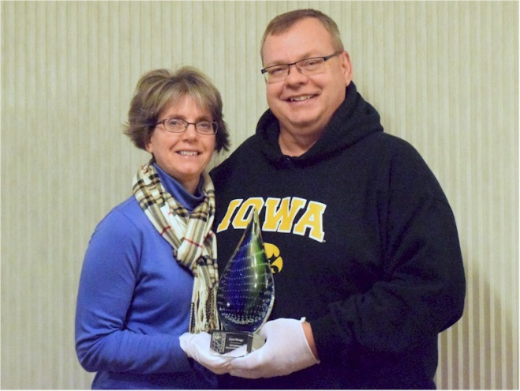
Dealer of the Year 2015

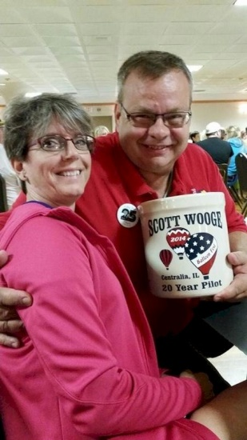
Centralia, IL 2014

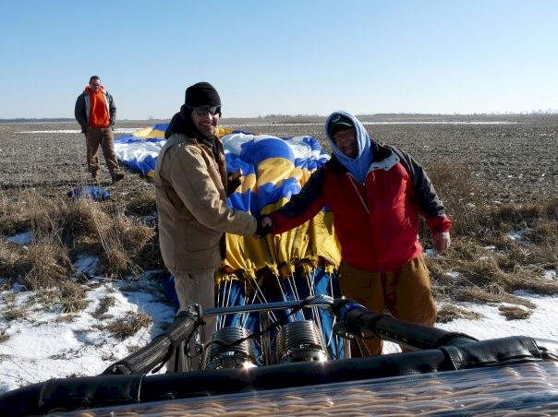
Landing 2010 – BFA Team LongjumpWinner

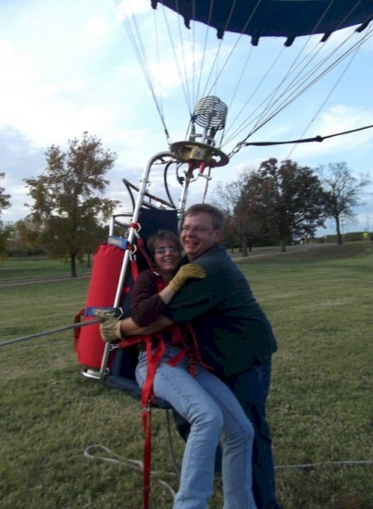
Hopper 2011

