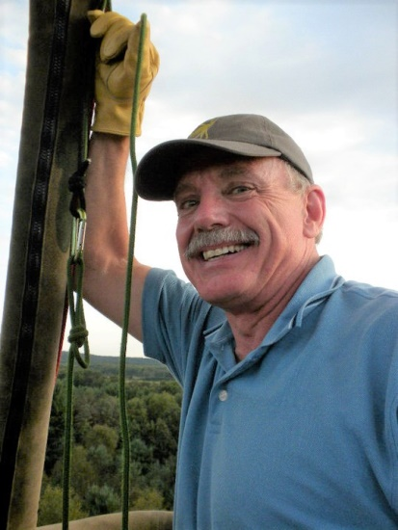
Ronald L. Centers

Notable – Ed Yost Master Pilot

8038 Lake Wood Dr.
Portage, MI 49002
(269) 744-0336
rlcenters@gmail.com

Ronald L Centers started ballooning in the spring of 1976 in Jones, Michigan and has since logged thousands of hours in balloons, thermal airships and airplanes.
Ron was co-founder and director of the Jones Opera House in Jones, Michigan. It was in Jones, a turn-of-the-century "theme park" that Ron got his first taste of lighter-than-air-flight. In 1976 he was operating the park's own balloon, making daily ascensions, exposing thousands of people to the park and the thrill of hot air ballooning.
In 1978 Ron became a corporate pilot for Sid Cutter’s World Balloon Corporation in Albuquerque, New Mexico, piloting the Anheuser-Busch fleet of hot air balloons flying either the Budweiser, Natural Light or Busch Beer balloons. Other clients included Black Angus Restaurants, Westinghouse Elevator Division and Parkay Margarine to name a few.
In 1979 Ron was selected to test and pilot a new type aircraft - a thermal airship, designed and built for Anheuser-Busch. He was one of four people in the world authorized to fly these "hot air blimps" commercially.
Ron's career in ballooning has taken him to many exciting and prestigious events across the country, most notably, the New York and Boston Marathons, the Super Bowl, the World's Fair in Knoxville and for three years, the Indy 500.
Ron was one of forty select pilots from across the nation invited to participate in the 1980 Winter Olympics in Lake Placed, NY by flying his balloon over the stadium during the opening ceremonies.
Ron left Albuquerque in 1981 to return to his home town of Kalamazoo, Michigan and formed SKY SPORTS, INC., giving hot-air-balloon rides and lessons while providing sales and service in both balloons and ultralights as well as doing hot-air-balloon promotions for area businesses including Kellogg's, Standard Federal Bank and PNC Bank.
Always of a mind to "build a better mousetrap," Ron and three business partners designed and built an ultralight balloon. The Solo System was introduced at the World Hot Air Balloon Championships in Battle Creek in 1985 and was immediately accepted as the "Sports Car of Balloons."
As a natural growth and progression, in 1985, SKY SPORTS, INC. changed its name to MICHIGAN BALLOON CORPORATION with the delivery of the 160,000 cubic foot M!CH!GAN balloon. This flagship of the corporation was the largest commercial balloon in the area at that time.
In 1986, Ron was designated by the Federal Aviation Administration to be an FAA Examiner for hot air balloons issuing pilot licenses to new pilots upon their satisfactory completion of a flight exam with him. In 1988, MICHIGAN BALLOON CORPORATION was granted a license to repair all makes and models of hot air balloons.
In April of 2001, Ron borrowed a Russian built hot air balloon and flew it at the North Pole as part of an organized hot-air-balloon expedition at Camp Barneo.
In both 2017 and 2018, Ron participated in the International Hot Air Balloon Festival in Leon, Mexico.
Ron continues to be active in ballooning and loves to promote the sport. Ron is the co-founder of the Kalamazoo Balloon Fest in Kalamazoo, Michigan that takes place every year in August. Ron, along with a friend and past student, founded the Kalamazoo Balloon Fest in 2013, on the 50th anniversary of the first U.S. National Hot-Air-Balloon Championship which was held in Kalamazoo in 1963.
Ron continues to operate Michigan Balloon Corporation, having given countless rides and introducing the joy of ballooning to thousands of people over the course of his more than 40 years as a commercial hot-air-balloon pilot and enthusiast.
Following are two photos of Ron with his 2020 Master Pilot Award. Pictured with Ron in one of the photos is the Honorable Judge Harvey Hoffman, who has been a good friend of Ron’s for many many years (Ron was Harvey's best man at his wedding)! Judge Hoffman was the person responsible for getting Ron into ballooning back in 1976 were Ron began ballooning in Jones, MI. Having Judge Hoffman present Ron with the award was a true full circle moment.

