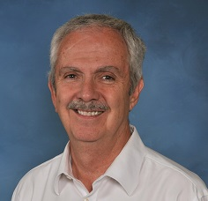
Paul R. Smith

Notable – Accomplishments/Contributions

Executive Director
ALBUQUERQUE INTERNATIONAL BALLOON FIESTA
4401 Alameda NE
Albuquerque,
NM 87113

Education
- Arizona State University, Tempe, AZ, B.A. cum laude, 1976
- University of New Mexico Law School, Albuquerque, NM, J.D., 1979

Employment
- Law Practice, private practice, 1979-1997
- Albuquerque International Balloon Fiesta, Executive Director, 1997-Present

Ballooning Flight Certificates
- Private Certificate: Lighter than Air, Airborne Heater-January 1, 1982
- Commercial Certificate: Lighter than Air, Airborne Heater-July 10, 1983
- Gas Balloon Certificate (Removal of Airborne Heater Restriction)-April 23, 2000

Ballooning Awards and Offices
- Empire Balloon, Wine & Polo Festival, Palm Springs, CA, 1st Place, 1991
- U.S. National Championship, Baton Rouge, LA-13th Place, 1991
- North American Championship, Baton Rouge, LA-3rd Place, 1992
- New Mexico State Championship, Albuquerque, NM-1st Place, 1999
- Balloon Federation of America-Competition Division, Chairman’s Award-1993
- Balloon Federation of America-Competition Division, Chairman’s Award-1995
- Balloon Federation of America President’s Award-1996
- Balloon Federations of America Pilot Achievement Award, Level 8-1997
- Albert Desmond Award, North American Balloon Association, 1999
- Federation Aéronautique Internationale Airsports Medal-2008
- Albuquerque Aerostat Ascension Association, Sid Cutter Award-2009

- 43rd Coupe Gordon Bennett, Assistant Event Director, 1993
- World Gas Championship, Safety Officer, 1994
- 1st America’s Challenge Gas Balloon Race, Safety Officer, 1995
- 2nd America’s Challenge Gas Balloon Race, Jury President, 1996
- Great Reno Balloon Race, Safety Officer 1992, 1993, 1995-2000
- Kodak Albuquerque International Balloon Fiesta Assistant Balloonmeister 1996
- Top Gun, Inc., President, Board of Directors 1987-1997
- Top Gun, Inc., Corporate Counsel 1987-2001
- Balloon Federation of America, Competition Division, Corporate Counsel, 1990-1998
- North American Balloon Association, Corporate Counsel, 1999-2001

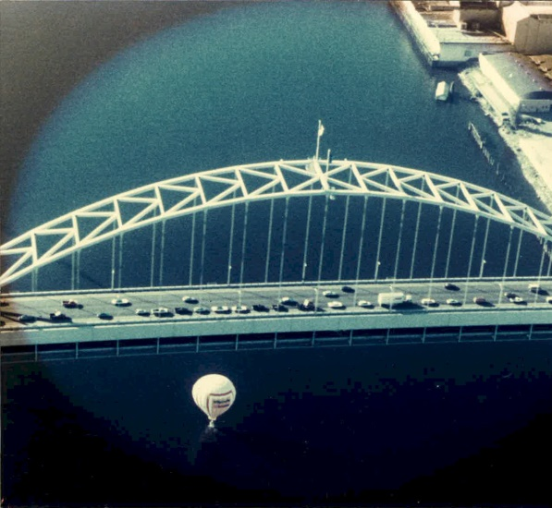
Fremont Bridge-Portland Splash
