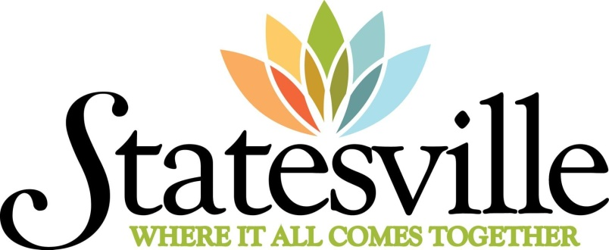

We are Statesville, North Carolina and we are proud of our 250 year history, tightly woven tales of our land, our resources, our people, and our spirit.
Founded by pioneers who were drawn to our fertile soil and abundant water, we were built around the grounds of the Fourth Creek Meeting House. Soon after, we became the gateway to the frontier, as Fort Dobbs was built to protect this rich land from the vast

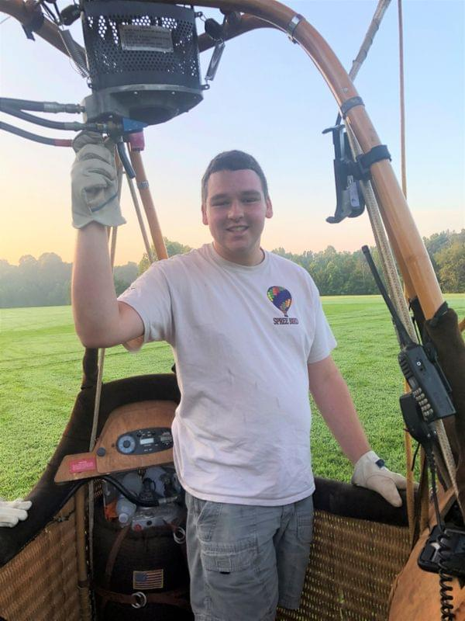
Keep Your Eye on Statesville’s Youngest Hot Air Balloon Pilot

Meet Duncan Dunavant

Serendipity can be an amazing thing. For Duncan Dunavant, a chance happening upon a hot air balloon flying around Statesville, when Duncan was just ten years-old, has changed his life. And, I would say, for the better!
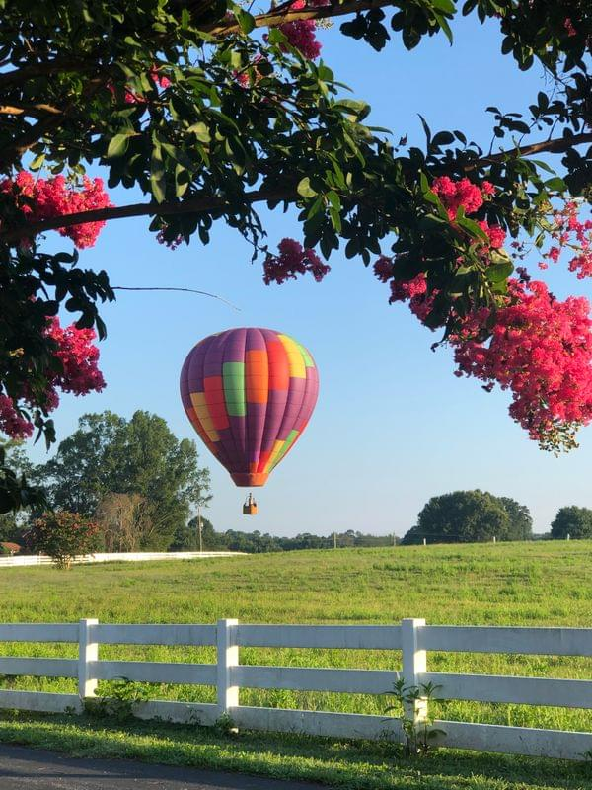
“My dad and I saw Paul Morlock flying. So, of course, we chased him down. Paul said to come out the next day, so we did…and did…and did. As we kept showing up, all the pilots we met started inviting my dad and me to crew. It was soon just about a full-time thing.” After crewing all those years, Duncan bought his own balloon, Spreebird, from Madison Sharpe and started pilot training. “My primary instructors have been Drew Egerton and Marsha Treacy, but I did some training flights with almost every pilot in the Statesville area. I still fly Spreebird—a 1986 Balloon Works model built right here in Statesville. I love the colors and design. It’s kind of cool knowing that I’m flying a piece of Statesville’s early balloon history. Right now, I don't have a crew chief because my crew changes—they are family, Todd, Bonnie, and Dannette, and lots of friends—I couldn't do it without them.”

Riding The Wind
Duncan’s biggest challenge? Navigating the balloon while riding different layers of wind. “That’s how you fly to a specific point. Balloon competition is all about getting to a target, so I’m always trying to get it right, but of course, every flight is different. It takes lots of practice; it can be hard because wind is unpredictable, changing all the time.” Contour flying, which Duncan likes most, is when he keeps the basket following the contour of the tree line. “It’s fun to float right off the trees and fly low where I can really see things close up. There are beautiful places, like the Elmwood Quarry, that I pass by every day. The water is so clear. I love doing a Splash & Dash, just dipping into a pond for fun!”

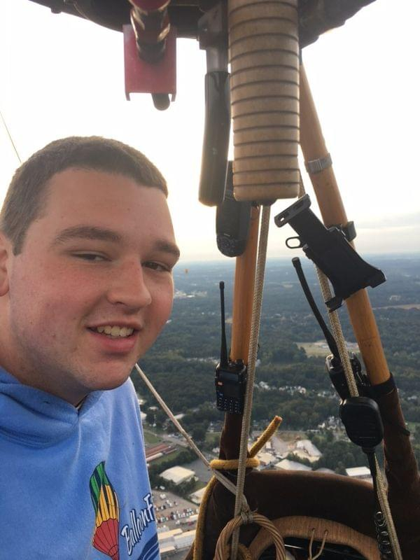
Memorable Moments
Duncan has some impressive highlights early in his piloting career: 2016 BFA National Crewperson of the Year and 2019 winner of a BFA Life Membership. He’s been on staff at Carolina BalloonFest, Freedom Balloon Fest in Raleigh, the Great Lakes Reginal Championship in Findlay, OH, US Nationals in Shreveport and Scottsbluff, NE, and Balloon Fiesta in Albuquerque. Memorable flights? “Over Zootastic in Troutman, where it got pretty exotic up there (just kidding) and also nailing it at Statesville’s Christmas Parade—I flew right over The Square.
Duncan was the first Great Eastern Balloon Camp camper to teach weather class. “And, you might be surprised to know I fly a mascot, a stuffed banana, which started as a prank at balloon camp.”

Going Beyond The Sky
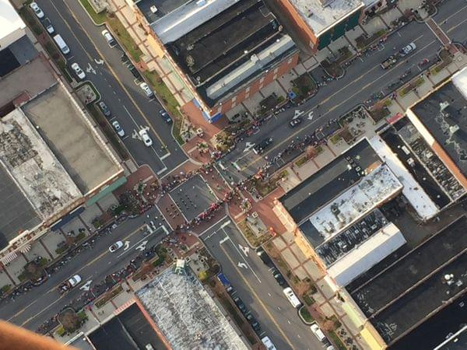
Duncan is a sophomore at NC State. At 19-years-old, he’s been ballooning almost a decade! He’s a volunteer firefighter with the Cool Spring Department where his core belief in helping others serves him every day. “I want to move into Emergency Management with my Meteorology degree. It makes me happy when I can make someone else happy when they see me flying over or when I land at their place and make everyone smile.” Keep your eye on Pilot Duncan Dunavant…one of Statesville’s finest…a young man going places!

