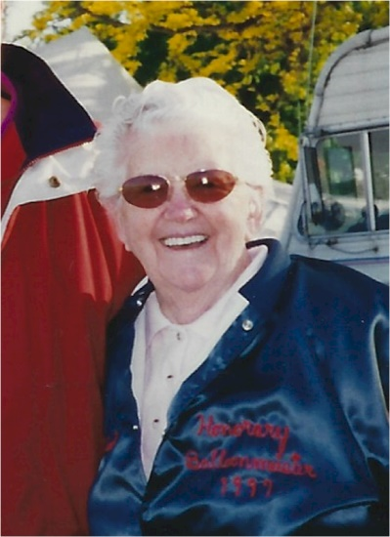
Gladys Buroker

Notable – Accomplishments/Contributions

The following was taken from the successful nomination submitted by Ginger Kelly for Gladys Buroker for the National Aeronautic Association 2000 Elder Statesman Award:

Gladys Dawson Buroker should be considered for this award because she challenged nature and society to carve a career in aviation decade before it was considered normal.
Gladys has ALWAYS had a love of flying . . . anything! She was mechanical and had a healthy thirst for adventure. It took her 6 months to save enough money for her first airplane ride in Herb Buroker’s OX5 Waco10 and less than 6 seconds in the air before she was hooked. Lessons cost $20 per hour, so she convinced Buroker to give her 15 minute lessons for $5. At age 18 Gladys made her first solo flight after only five hours of instruction . . . September 1932.
In 1934, with the tips she made working at the Hamburger Express, she bought her first motorcycle, a four cylinder Indian Ace. She rode to Boeing Field to ask about barnstorming and signed a contract, that day, to do twenty jumps. She jumped in Washington and Idaho towns, living on bread and bologna and rolling up in her sleeping bag under a wing at night. On her 17th jump, she ruptured the cartilage in her knee, forcing her to move on to new adventures.
Gladys was barely 23 when she scraped together $400 to buy a Travel Air biplane. She and Herb Buroker barnstormed towns along the Olympic Peninsula, charging the loggers and Indians $5 a ride. Later, she heard stories about pilots who used wing walkers to bring in big crowds. She’d never seen it, didn’t know how to do it, but decided to give it a try. With a Canadian pilot flying the plane, Gladys would crawl out of the cockpit; cling to the wing and inch out to the struts. When they would buzz the town, Gladys would lean out from the end of the wing and wave to the residents.
Gladys and her new husband, Herb Buroker, partnered with Gwin Hicks to take over the Olympia airport lease to form the Buroker/Hicks Flying Service. The government created a civilian pilot training program to prepare graduating college students for active duty. St. Martins, a Catholic men’s school in Lacey, WA. Administered this program and contracted with Buroker/Hicks to do the training. The only qualified instructor in the area was Gladys, who had earned her certificate from the Civil Aeronautics Authority. She was a professional woman in a traditionally man’s world.
After Buroker’s moved to Week’s Field in Coeur d’Alene, the War Training Service for the Army and Navy contracted with the Buroker’s to teach recruits and enlisted men. Gladys was the only woman out of 35 instructors. Gladys developed a flight school curriculum approved by the Veteran’s Administration.
After raising a family on a farm, Gladys turned to practical nursing, working in nearly every department a Kootenai Memorial Hospital before being promoted to director of education. Nursing never replaced her love of flying; she went up almost every day, teaching many students to fly.
In 1971, the Buroker’s bought property near Athol, ID to build a rcreational runway. . . splitting the cost with Clay Henly. The 2 families spent weekends clearing out pine trees and leveling the ground, with plans to develop the field into and English Aerodrome, complete with a hot air balloon. Of course, Gladys volunteered to fly the 3-passenger Semco.
After her husband died, Gladys built a home on her land and began teaching students to fly planes, gliders and balloons. Until 1990, she worked as flight manager at the aerodrome. She instructed and supervised a team of flight insturctors, oversaw the servicing of aircraft, took part in restoring classic airplanes and flew antques like the trimotor Stinson and the Fokker Triplane plus gliders.
Medical problems put an end to her flying days in 1995. She had a hip replaccement, a knee replacement followed by a mastectomy. So she made one of her rooms into a shop and built wing ribs for the Waco Aircraft Company in Renton, WA . . . the ribs are all wood construction; she learned to do it in the 30’s. Gladys also wrote the story of her life “Wind In My Face.”
Gladys always had the determination, perseverene, attitude and charm to accomplish much more than most people ever dream of. Life has not led Gladys Buroker, Gladys Buroker has led life. When a Spokesman-Review reporter asked Gladys what she thought about the space shuttle, Gladys repied “If they’d let me, I’d go up in a minute; to start out in a biplane and end up in the shuttle . . . it would certainly be one heck of a ride.

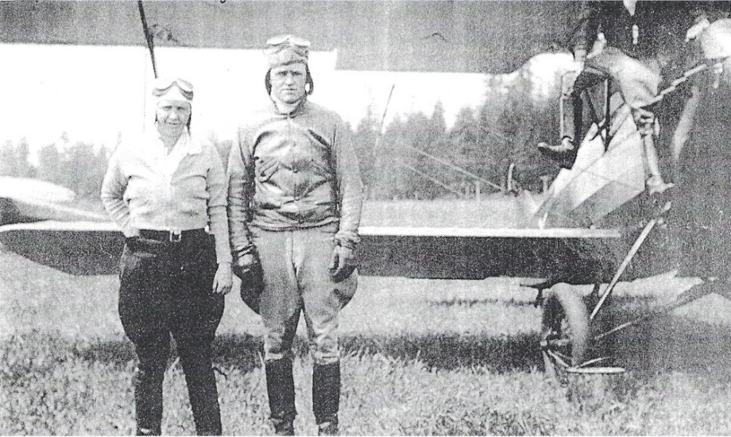
Gladys Buroker poses with her husband, Herb in front of their Travel Air
2000 biplane in the late 1930's

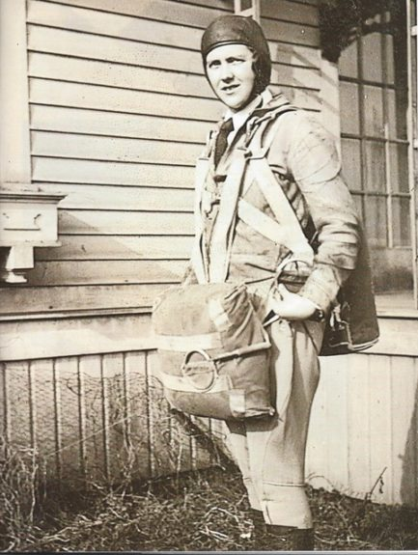
1935, Gladys ready for exhibition jump. Photo provided by Linda Buroker-Melhoff
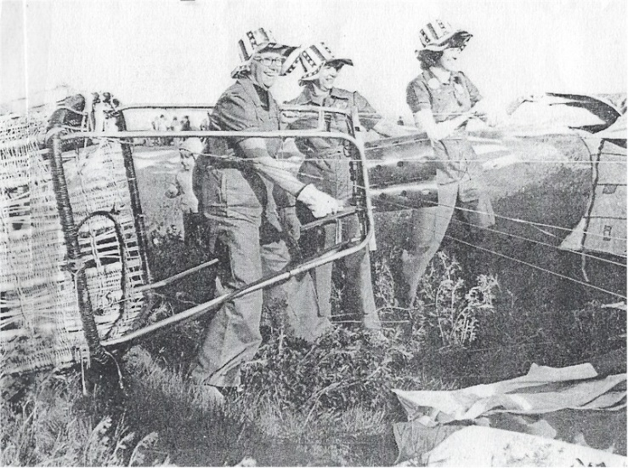
Gladys Buroker, left, crew chief Pearle Manchen and Mrs. Buroker's
daughter, Sally Simundson, Right

The following reproduced with permission of the KitsapNews newspaper

Barnstorming, wing-walking pilot enters hall of fame at 82
— Sep 9th, 1996
KENT (AP)  Gladys Buroker handed over $2 for her first ride in an airplane. That was a fair amount of the money she'd earned picking strawberries and cherries that summer of 1931.
But from the first moment the barnstorming pilot pulled back the joystick and the single-engine biplane lifted upward from a cow pasture on the outskirts of Bellingham, Buroker was hooked on flying.
"It just fascinated me," Buroker said recently, recalling her first flight at age 16, when she felt for the first time the rush of air and motion in an open cockpit as she soared above farmlands and a winding river.
"I remember holding up my hand and feeling the wind against it, forcing it back. I was fascinated from then on, I can tell you," Buroker said.
The former Gladys Dawson obtained her pilot's license in 1932 at age 17, joined a traveling show of barnstorming pilots and performed wing-walking and parachute jumping across the state. Barely a decade later, she was one of few women training military pilots in basic flight instruction during World War II.
In the 65 years since that first flight, Buroker has logged 63 years as a general aviation pilot and flight instructor, and more than 19,400 hours piloting airplanes, gliders, hot-air balloons and seaplanes. Now 82 and a resident of Rathbun, Idaho, near Coeur d'Alene, Buroker was just inducted into the Hall of Fame of the OX5 Aviation Pioneers and Historians during the group's 41st annual reunion.
About 250 members of the group from across the nation attended the recent reunion at the SeaTac Marriott Hotel. The group's name commemorates the Curtiss OX5, an efficient 8-cylinder aircraft engine that went into mass production during World War I.
There are photographs of the young Gladys Dawson Buroker in a display in the Boeing Red Barn portion of the nearby Museum of Flight. She's one of a half-dozen women honored in the display, "Northwest Women Aviators in the Golden Age."
Buroker, now white-haired and walking with a cane because of pain in her right knee from a parachute accident, had to smile during a walk through the Museum of Flight. She made only 17 parachute jumps during her barnstorming days, she said. "Not many, really. But in those days, it would be considered quite a few," she added.
She also did some "wingwalking," making her way along the lower wing of a biplane and waving at people below; that was one way the barnstorming pilots advertised their traveling shows.
After getting her pilot's license in 1932, Buroker bought her first airplane several years later. She married her flight instructor, Herbert Buroker, and the couple became partners in a flight service at the Olympia Airport during the 1930s. She also won certification as a flight instructor.
During World War II she was hired by the War Training Service to teach basic flight instruction and cross-country flying to rookie Army and Navy pilots. One craft she flew during training sessions those years was a Fairchild F-24W Fowarder, originally custom manufactured in 1941 for famed ventriloquist and actor Edgar Bergen.
That same Fairchild now hangs from the ceiling in the Great Gallery at the Museum of Flight, right next to a blue Taylorcraft that Buroker also flew while instructing military personnel during the war years.
Gazing up at the two aircraft, Buroker said the Fairchild was her favorite. "It was just such a comfortable airplane, and so smooth. I always said I could fly it with just my little finger," she recalled.
After the war, she and her husband operated a flight service in Idaho. Herbert Buroker died in 1973, but Gladys continued flying and offering flight instruction until 1994. She quit flying small airplanes a few months short of her 80th birthday because of problems from her old knee injury from the parachuting accident some 60 years earlier.
Over the years she also taught her three children to fly, including Linda Buroker-Melhoff of Kent. But no wingwalking. "My mother wouldn't let us kids do all the wild and crazy things she used to do," said Buroker-Melhoff, a customer services agent for Alaska Airlines.
Now that she's no longer flying, Gladys Buroker says she keeps busy with landscaping and other projects around her home. Of course, she said, she misses flying, but added, "I keep busy, and I'm happy.

Wind In My Face

Bahr, Fran; Buroker, Gladys

Gladys Buroker's autobiography begins with the story of her childhood love of flight and her adverse relationship with her father. Once removed from that environment, her sense of adventure led her on a motorcycle tour of the 48 States, and Mexico, followed by parachute jumping and wing-walking with a barnstorming group.
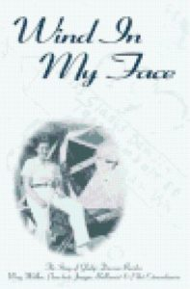
Passing seven exams to become a Certified Ground School Instructor placed her in a position to teach ground school at an all male academy, St. Martin's College, in the Civilian Pilot Training Program. When World War II broke out, Gladys and her husband moved their flight operations to Coeur d'Alene, Idaho where they managed the first municipally owned airport in the United States. During the war, Gladys taught Army and Navy cadets in all phases of their training, including aerobatic maneuvers.
At the close of the war, she took a welcome respite, moving to a farm on Wolf Lodge Creek. Here she pursued her love of the outdoors with farming, hunting, fishing, and was an active 4-H leader.
Gladys challenged herself by embarking on a second career as a Licensed Practical Nurse in her mid-50's. She was also actively involved in the development of the Henley Aerodrome at Athol, Idaho where her new aviation feats included gliding and hot air ballooning.
Wind In My Face tells of a young woman who followed her dreams. She fell in love with her flight instructor, married and raised a family. Who says you can't have it all? This human drama is captivating and inspirational!

The following article was published with the permission of:


OCT 2017 A REMARKABLE LADY’S WACO UPF-7 FOR SALE
in Blog by Judy Birchler 0 Comments
0Likes

When it comes to interesting women aviator stories, sometimes I find out about them in unexpected ways. This one came by way of John Wood from Massachusetts in a message that read: Linda Buroker-Melhoff’s mother Gladys Dawson-Buroker taught flying during World War II in a WACO UPF-7 based at Coeur d’Alene, Idaho. The aircraft has been carefully restored and is for sale. . .
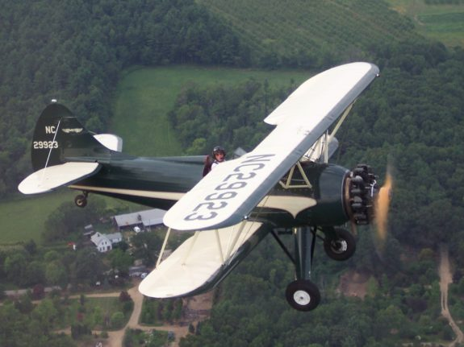
John Wood, Waco-In-Flight

OK, I’ll bite – a gorgeous UPF-7 flown a long time ago by one of our own LadiesLoveTaildraggers’ mother, you bet. We’re not in the business of selling guy’s airplanes but if we can shed some light on just one very early lady pilot (all taildraggers), well, let’s do it. I knew just a tiny bit about Gladys Buroker and John’s brief comments and photo were enough to make me want to know more. And never fear, links to the sale of this beautiful UPF-7 can be found at the end of this article.

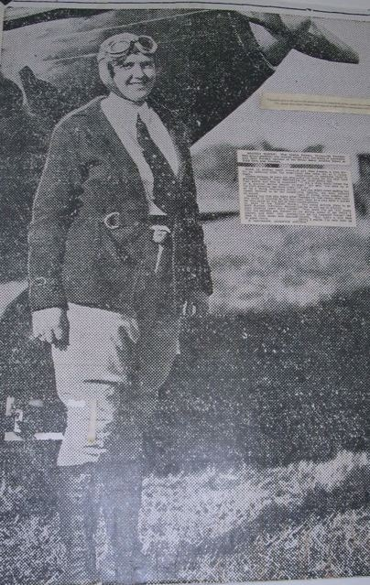
Gladys Dawson-Buroker. Â Photo provided by Â Linda Buroker-Melhoff

Gladys was born and raised north of Seattle, Washington. Her interest in aviation began as a child. At 18, a high school graduate, she made her first solo flight after only five hours of instruction. She flew an OX-5 Waco 10 on a September day in 1932. Her sense of adventure led her to parachute jumping with a barnstorming group, wing walking, and a motorcycle tour of the 48 states.
By 1935 she had saved enough money to buy her first plane, a two year old Travel Air 2000 for $400. The plane boasted a Curtis OX-6 water cooled 100 horsepower engine, the first of its type to be manufactured with dual ignition — it was a hot machine.
On August 4, 1937 Gladys married her longtime friend and flight instructor, Herb Buroker. In November she passed her written exam and flight test to receive her pilot’s license. She continued studying and passed the examination for her commercial certificate and flight instructor’s rating before she logged the 200 hours required for the commercial flight test. She passed her commercial flight test and flight instructor exams in 1938.

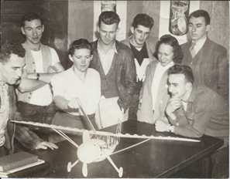
CPT training prior to WWII. Photo provided by Linda Buroker-Melhoff.
As World War II approached she became the first woman instructor at the all-male St. Martin’s College (Lacey, Washington) in the Civilian Pilot Training Program. With the outbreak of the war Gladys and her husband moved their pilot training inland to Coeur d’Alene, Idaho. With the U.S. now at war, their flight training program was part of the War Training Service (WTS). By 1943 their program had grown to 38 flight instructors and 200 students. In January 1944 they received notice that the WTS activities would cease immediately. They were fortunate to be able to obtain a contract through the Veterans Administration for veteran flight training.
A hanger fire in 1950 prompted a change of life for the couple. In the late 1960’s Gladys embarked on a second career as a licensed practical nurse at the Kootenai Memorial Hospital. She remained actively involved with aviation, and participated in the development of the Henley Aerodrome at Athol, Idaho, a base for vintage airplanes. In 1972 she bought a Semco (9GB) hot air balloon, the challenger model, TC-7, which came equipped with three burners and a wicker basket. She flew that hot air balloon on the opening day at the Expo ’74 World’s Fair in Spokane, Washington. In addition to planes and balloons, she was also involved with gliders.
In retirement she became manager of flight operations for the new owner of the aerodrome. She flew gliders, and on occasion, the Pawnee tow plane and the Cessna 182 “jump” plane. At the end of the season in 1990 she chose to retire. Gladys Buroker represents that indomitable will that sparks all who fly.

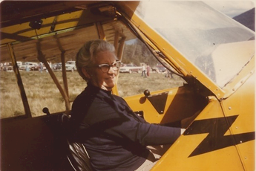

1976, Gladys in J-3 N40184. Photo provided by Linda Buroker-Melhoff

She was the recipient of many awards, a few of which include Hall of Fame Pathfinder Award, Museum of Flight Seattle, Washington; Instructor of the Year Award, Federal Aviation Administration, Tacoma, Washington; she was featured in the Museum of Oshkosh with an exhibit “The Life of Gladys Buroker;” J.C. Penney Spirit of the American Woman Award, Coeur D’Alene, Idaho; Idaho Aviation Hall of Fame Award, Boise, Idaho, National Aeronautic Association Elder Statesman of Aviation Award, Washington, D.C.

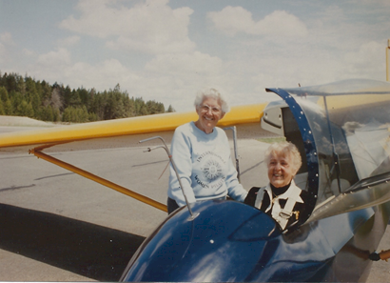
Giving a glider ride to Bobbie Trout, one of the original 99’s. Photo provided by Linda Buroker-Melhoff.
And many thanks to daughter Linda Buroker-Melhoff for giving us the inside track about her amazing mother. “Aviation was her life from age 18 to her last flight at 80 years old.”
Gladys Dawson Buroker was born 3/16/1914 in Belligham WA. Died 11/08/2002 in Coeur d’Alene, ID.Â Early in life she found escape and diversion from her abusive father by riding her bike to a local field to watch airplanes and dream of flying. She married her flight instructor, Herb Buroker, who encouraged her to get a flight instructor rating. This ultimately resulted in her life-long career of teaching people to fly.
Gladys had 3 children, 2 daughters, Sally and Linda, who both got their pilot license through her instruction. Her son, Kelly, enjoyed parachute jumping and hang gliding in his younger years. Yes, we all took her amazing accomplishments for granted and I was even embarrassed as a teenager when other mothers were shown on TV gliding around the house in dresses and high heels. But my Mother, GLADYS DAWSON BUROKER left an amazing legacy. Her courage, strength and pursuit of fun prove that you should dare to be different and follow your dreams.

