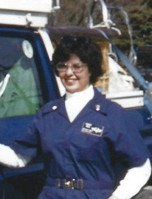
Virginia (Vale) Kelly

Notable – Accomplishments/Contributions

Ballooning for Ginger (Vale) Kelly began in 1972 when she and her husband Nat Vale met Chauncey Dunn at Whitmore College in Walla Walla, Washington. He was there to inflate a hot air balloon for the homecoming event. They invited Chauncey to their ranch for dinner and that was the beginning of a long relationship and was the beginning of her ballooning career. In 1973 she contacted Gladys Buroker, a long time aviator and balloon pilot in Athol, Idaho and began taking lessons in Gladys’ Semco balloon. After 2 training flights she was signed off to solo with an admonishment “not to go out and kill herself.” In 1974 she attended the Albuquerque Balloon Fiesta and was signed off by Sid Cutter as a commercial pilot. She had the distinction of being the first female commercial balloon pilot in the State of Washington.
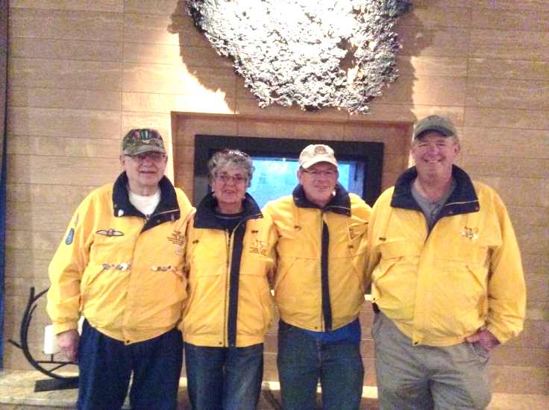
In 1974 the Vales’ along with other Washington pilots, the Lloyd’s, attended the World’s Fair in Spokane where 10 balloons launched at high noon. They made the front page of the Spokesman Review, along with President Richard Nixon who cut the opening ribbon that sent them into the sky, Also, in 1974 Ginger and Nat Vale with balloons flown by the Mick/Sally Vale, Gladys Buroker along with another balloon flew from the wheat fields of the Vale Ranch. The next day, 3 of the same balloons lifted off the Veteran’s Hospital grounds in Walla Walla. That was the beginning of the Walla Walla Balloon Stampede that has survived to this date.
The Surviving members of the organizers of the Balloon Stampede taken at the 40th event.. Mick Vale, Ginger (Vale) Kelly, Scott (Irving) Shields, Jeff (Kong) Shields

Ginger became a member of the Balloon Federation of America and was a 4 year correspondent for the national Ballooning Journal. She was a charter member of the National All Female Balloon Pilot’s Association, a member of the Ninety Niners and the Northwest Balloon Association.
Ginger flew at the National Balloon Championships in Indianola, Iowa from 1974 to 1976. She told a reporter from the Walla Walla Union-Bulletin that the event in Iowa was “sort of like the Pendleton Round-Up without the horses. They’ve got balloons instead.” She flew at the Albuquerque Balloon Fiesta and many more events throughout the Western states and the Midwest. She also participated in Malcom Forbes attempt to cross the Atlantic in 1975.
Ginger’s enthusiasm for ballooning was contagious and she loved sharing her interest with students, adults and many local service organizations. She continued her interest in writing about ballooning and had several articles published in national publications.
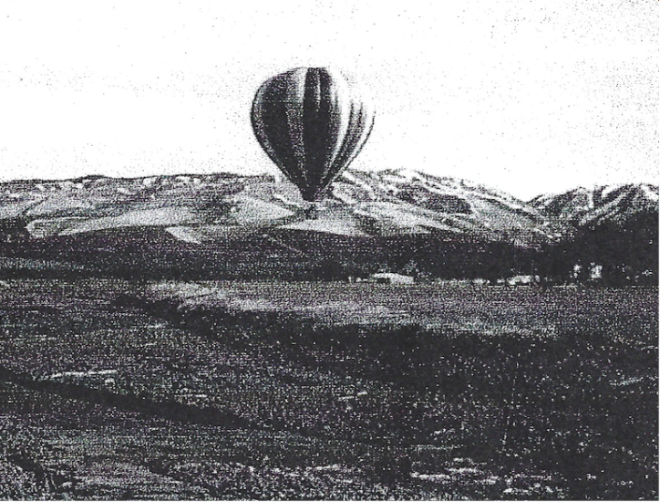
She helped organize the first BFA sanctioned event in the Pacific Northwest and was a scoring officer in the first City of Roses Race in Portland. In 1976 Ginger placed 3rd in the first BFA National all-female competition held in Reno, Nevada.
Virginia Kelly and Nat Vales balloon Demeter flies near the Blue Mountains in the Walla Walla Valley in 1974
In 1978 Ginger was named Volunteer of the Year at the Walla Walla Balloon Stampede for her dedication and support of the event. In 1999, she was the honorary balloonmeister at Walla Walla. In 2004 she was presented the President’s Award by BFA President Charlie Sundquist for outstanding service to the history of ballooning. Ginger is an icon in ballooning. She continued to volunteer in an area that she loves.

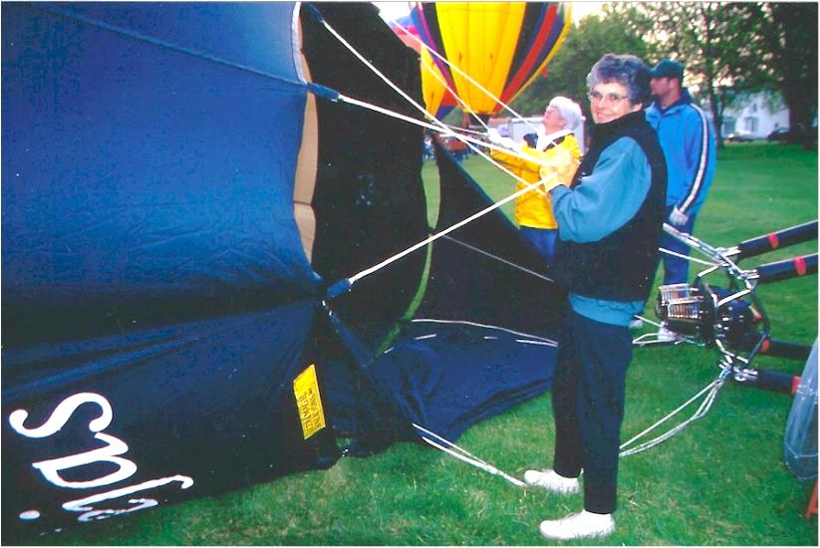

See a 1976 article from the Ballooning Journal on the Balloon Stampede in Walla Walla, Washington and an article from the Fall 2019 Columbia Magazine of Northwest History about Virginia on the following pages:

