Jeff (Kong) Shields

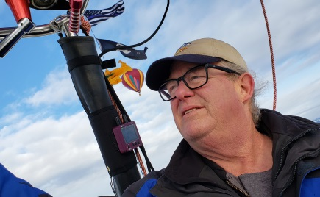
Notable: Accomplishments/Contributions – Ed Yost Master Pilot Award

In 1972, Whitman College was looking for something really different for their Homecoming celebration. The Dean of Students for Whitman had a summer job working wheat harvest, as most teachers around the area did. He was working for local farmer Nat Vale and discussed the issue with Nat who had seen an advertisement in a magazine for an Aeronaut who would bring his balloon to your town and fly. Chauncey Dunn was hired to fly all week for homecoming.
On Chauncey's first flight a 14 year old (Jeff “Kong” Shields) saw the balloon taking off from Whitman a block away from his house and chased it out in the country on a bicycle. Chauncey asked him to crew the rest of the week and he showed up to crew on all the subsequent flights that week. Kong has been involved in ballooning ever since.
While there, Chauncey sold a couple of other local enthusiasts on ballooning, and when Nat Vale and Bill Lloyd took delivery of their new balloons, Kong began crewing with them and learned to fly in 1973. His training was done by 64 year old Gladys Buroker who had been a pilot since the age of 14 starting out as a wing walker and parachutist in Ferndale, WA. She owned a Semco and brought it to Walla Walla to train several local pilots including Kong.
He considered earning his pilot certificate as his first big accomplishment because he’s flown in many places around the world he might have never seen otherwise. He recalls that soloing in a balloon with two hours of instruction was pretty exciting. It allowed him to meet hundreds of people in ballooning all over the globe that has formed who he is and helped him to see things from a world perspective.
Kong’s first trip to Nationals was in 1976. There was a large contingent from the NW.
Nat Vale, Ginger Vale (Kelly) the first licensed female pilot in Washington State and Bill Lloyd from Walla Walla, Harry Wilcox from Lewiston Idaho, Jim Pierce from Post Falls ID, Forey Walter from Spokane WA showing off his new Avian Balloon's and Mick Vale from Cupertino California. Most stayed at the only motel in Indianola with Chauncey and the Forbes contingent. Jeff has fond memories of Malcolm showing up in a raging thunderstorm on a Harley and handing him a towel and a scotch. We had no idea who he was for 2 hours until he asked if anyone had seen his chase crew. They were driving a Mercedes bus with Forbes Magazine printed on it. Kong “I clearly remember us all looking at each other in realization of who this guy was”.
Ballooning has led to Kong to piloting in all 50 states and in more than 30 countries. Among those memorable experiences, are being on a team that flew the first balloons in Colombia; flying over the Swiss Alps at 18 in his first gas balloon flight; flying a balloon to 27,836 feet up, the highest he’s ever been; flying the Mickey Mouse balloon over Portland with Mount Hood in the background; flying over Niagara Falls for a movie shoot with 40 other balloons.
Flying balloons in the Maasai Mara game preserve in Kenya, watching the sun rise at 16,000 feet above Mount Kilimanjaro was pretty hard to beat but the coolest experiences in ballooning have been mentoring young people and getting them involved in ballooning at a young age.
He’s flown corporate balloons with logos on them for many businesses, including Grab On, a manufacturer of foam grips for motorcycles and bicycles based in Walla Walla. The Grab On balloon was the first commercial contract he and Brother Scott sold and operated for themselves.
Other Corporate logo balloons he has flown have been Budweiser, 7UP, Coca-Cola, regional propane supplier Cal Gas that became AmeriGas, ReMax, Kool cigarettes, RC Cola, Wendy’s, Virgin Airlines, Payne Webber, Freixenet Champagne, KOTY (Radio Station), Greenpeace, Black Angus restaurants and Yoplait yogurt. Several times he flew one of Malcolm Forbes fleet of special shape balloons.
He’s flown balloons in four movies; was the first balloonmeister for an event in Albany, OR.; Moses Lake WA. and served at different times at Kent, Wash.; Missoula, Mont.; Portland, Wilsonville, Eugene, Oregon; Greenville, S.C.; and in Walla Walla, where he also served 22 years as safety officer for the Walla Walla Balloon Stampede. He has operated balloon-ride businesses in Walla Walla; Phoenix, Ariz.; Portland, Ore.; and New South Wales, Australia.
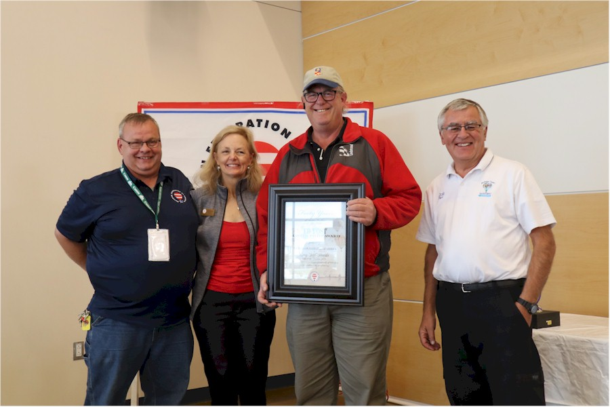
Some famous people he’s taken aloft include TV newscaster Walter Cronkite and his wife Mary, musicians Bonnie Raitt, Jackson Browne, members of The Decemberists, Neko Case, David Bowie, Annie Lennox and Keith Richards of the Rolling Stones. Sir Richard Branson of Virgin Group, and actors Tim Curry, Kurt Russell and Goldie Hawn took some of their flight training with Kong
Kong was presented the Ed Yost Master Pilot Award from the Balloon Federation of America during the 2019 Albuquerque International Balloon Fiesta. The award is presented to balloon pilots who have demonstrated professionalism, skill and aviation expertise by maintaining safe operations for 40 or more consecutive years as active pilots.
Master Pilot Award Presentation - Lt. to Rt. - BFA Board Member Scott Wooge, BFA President Cheri White, Jeff “Kong” Shields, BFA Awards Chair Orvin Olivier

