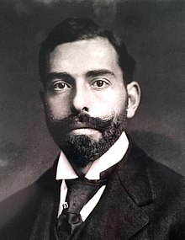
Augustus Post

Notable - Accomplishments/Contributions, Records
The following excerpts have been taken from Wikipedia, the free encyclopedia.
Augustus Thomas Post Jr. (8 December 1873 – 4 October 1952) was an American adventurer who distinguished himself as an automotive pioneer, balloonist, early aviator, writer, actor, musician and lecturer. Post pursued an interest in transportation of every form. In 1898, when Post was 25, following his time at Harvard Law School, he circumnavigated the globe by rail and steamship. He then bought one of the first cars ever made and helped found the Glidden Auto Tours, an automotive distance drive and competition used to promote a national highway system. He was the original founder of what is now the American Automobile Association (AAA), first known as the Auto Club of America. He established the nation's first parking garage, the first bus service, and also received the first driving tickets in New York.
In 1907 he was one of the first civilians to descend in a submarine. Two years later he became the thirteenth man to fly solo in an airplane, and was an original founder of the Aero Club of America In that capacity he served as official timer for Orville Wright's historic 57-minute flight at Fort Myer, Virginia in 1908. The following year Post worked with Alexander Graham Bell's Aerial Experiment Association where he represented the Aero Club and helped test new equipment and gliders. Post then worked with fellow AEA alumn Glenn Curtiss and was present for the historic flight of the Curtiss June Bug. He also participated in the international Gordon Bennett Balloon Races from 1906-1910. In 1910 he set a distance and duration record in a free balloon, flying as aide to Alan R. Hawley in the balloon "America II," a North American record that stood for 95 years.

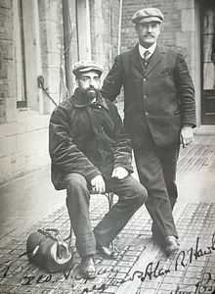
Augustus Post and Alan Hawley returning to New York following their record setting balloon flight in 1910.
Post participated in balloon races, including the Gordon Bennett races of 1906, 1908, 1909, 1910, and 1911. He survived a number of aeronautic disasters, including the rupture of the balloon “Conqueror” in which he was flying with A. Holland Forbes in the Gordon Bennett Race in Berlin in 1908. The balloon fell 4,775 feet and crashed through the roof of a house, but the men were unharmed.
Post's best known ballooning achievement was when he served as aide to Alan Hawley in the 1910 Gordon Bennett race flying the balloon “America II.” The race's ten balloons set off from St. Louis, Missouri; two days later, Post and Hawley landed in a remote, uninhabited area of Quebec near Lake St. John. They trekked through the Canadian wilderness, slowed by Hawley, who had injured a knee just after landing. Post, who had been moose hunting in Canada with Ezra Fitch (of Abercrombie & Fitch Co.) in 1905, had some knowledge of the terrain. Also, though he had grown up in Brooklyn, Post had spent summers with his family at the Mohonk Mountain House near the Catskill Mountains of New York, where he had hiked and developed skills as a woodsman. While the balloonists were lost in Canada, Post created lean-tos to keep them dry when snow and rain fell, and he caught fish, using improvised lures, to supplement their food stores.
Word of Hawley and Post's disappearance ran on the front pages of newspapers across the nation. As the days stretched into a week and the men still had not been heard from, search parties were formed. After ten days in the wilderness, Hawley and Post found a trapper's tent and then ran into two locals, Joseph Pedneaude and Joseph Simard, out on a hunting trip. The men took the balloonists back to the closest town, Chicoutimi, from which they were able to send telegrams to family and friends. They made their way to a train terminus and then home.
At Grand Central Station in New York, Hawley and Post were met with a hero's welcome and informed they had set a distance and duration record of 1,173 miles in 44 hours and 25 minutes for travel in a free balloon, a North American Gordon Bennett record that stood for 95 years. Post's role in the adventure, particularly his survival skills, caught the attention of Daniel Carter Beard, who had founded the Society of the Sons of Daniel Boone for boys in 1905. The Society emphasized outdoorsmanship, self-sufficiency, and pioneering spirit. Post became a governing member of the Society, which was merged into the Boy Scouts of America later that same year in 1910 with Post continuing his interest.
While Post continued ballooning, he was also drawn to the emerging innovation of heavier-than-air flight. He wrecked several planes before successfully taking to the air, and press outlets suggested his signature Van Dyke beard—which was somewhat uncommon at the time— might be to blame for his difficulties. In 1908, Post became thirteenth man to fly. He was an original founder of the Aero Club of America and served as its first secretary. As such he served as official timer for Orville Wright's record-setting 57 minute flight at Ft. Myer, Virginia, on September 9, 1908.
In 1906, Post set off from Pittsfield, Massachusetts, in a balloon called “Le Centaur,” with Alan Hawley and French aeronaut Count Henry de la Vaulx. Twenty-five minutes into the trip, the balloon, having risen to more than 5,000 feet, hit turbulence. The balloon dropped 3,000 feet in fewer than three minutes, then rose up and dropped again. The men cut ballast in an effort to slow the balloon's descent and attempted to land in a farmer's field in North Colebrook, Connecticut, but the basket was dragged a considerable distance by the wind before holding fast. The three men emerged unscathed.
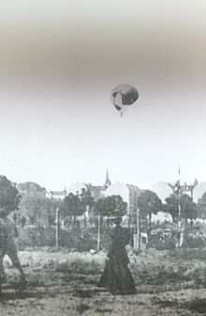
The balloon Conqueror, flown by A. Holland Forbes and Augustus Post in the 1908
Gordon Bennett balloon race in Berlin, tearing open at more than 4,000 feet.

Thousands attended the start of the 1908 Gordon Bennett Balloon Race in Germany in which Post flew in a balloon called "Conqueror" as aide to A. Holland Forbes, president of the Forbes Publishing Company. “Conqueror” was the largest size balloon then used in competition. It had a gas capacity of 80,000 cubic feet, and stood 80 feet high with a fifty-foot diameter. Prior to the race Forbes had lengthened the balloon's appendix in an effort to allow less gas to escape from the balloon's envelope and thereby improve the chances for prolonged flight.
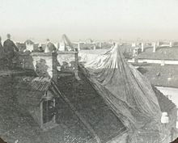
The Conqueror, balloon flown by A. Holland Forbes and Augustus Post in the 1908 Gordon Bennett
balloon race, draped over rooftop in Berlin after falling from more than 4,000 feet.

At the start of the race a gust of wind caught “Conqueror” and propelled it toward a wooden fence where spectators were packed. The crowd parted but the balloon struck the fence and the impact knocked off two ballast bags and split two more, causing the balloon to ascend rapidly and the basket to swing uncontrollably.
The fabric of the balloon then tore and the basket plummeted from a height of approximately 4,780 feet, based on the aneroid barograph record that was signed by the race officials. Forbes cut ballast bags to slow their descent, and the balloon's fabric folded in on itself against the balloon's netting, slowing it slightly. The men took hold of the support ring above them and lifted their feet as the basket smashed halfway through the tiled roof of a house in the Berlin suburb of Friedenau. Forbes and Post sustained only bruises. News of their survival spread and the German Emperor Wilhelm II invited them to be his personal guests that night at the Royal Opera.

