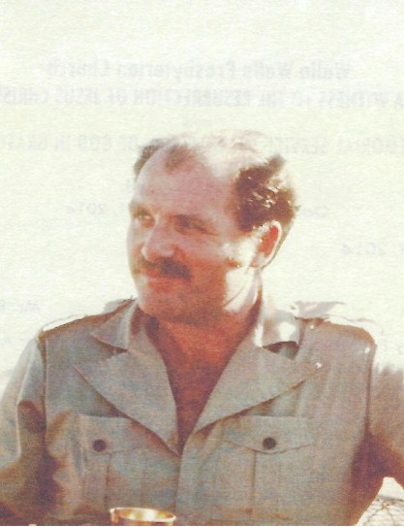
Bill Lloyd

Notable – Accomplishments/Contributions

Bill Lloyd was a lifelong resident of Walla Walla, Washington. After graduating from Walla High in 1950 he attended Whitman College for one year and then transferred to Washington State University where he received his BA in Business Administration in 1954. After serving as a 1st Lieutenant in the 501st Division of the Signal Corps, he was discharged in 1956 and returned to Walla Walla joining the Lloyd’s family insurance business. Bill was a dedicated volunteer and involved in community organizations in a wide variety of areas.
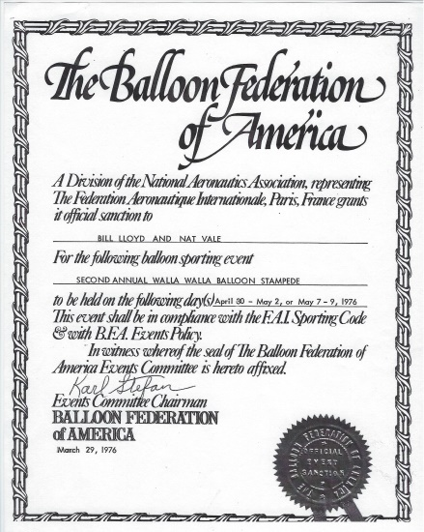
His involvement with aviation began in 1958 when he obtained his pilot’s license from Martin Aviation and in 1968 he owned and flew a glider. His love for ‘lighter-than-air’ craft, specifically gas and hot air balloons began in 1972 when he saw a balloon piloted by Chauncey Dunn. He received his pilot instruction from Gladys Buroker in Athol, Idaho in 1974. On a ranch near Walla Walla in 1975, Lloyd launched his first balloon named Columbia along with three other balloons to create the first Walla Walla Balloon Stampede. The three other balloons were piloted by Stampede co-founders Nat Vale, Mick Vale and Gladys Buroker. In 1976 the Second Annual Walla Walla Balloon Stampede was granted an Official Sanction by the Balloon Federation of America, a Division of the National Aeronautics Association, representing
the Federation Aeronautique International. The Walla Walla Balloon Stampede was the earliest and one of the most successful balloon events in the Northwest. It continues to this date.
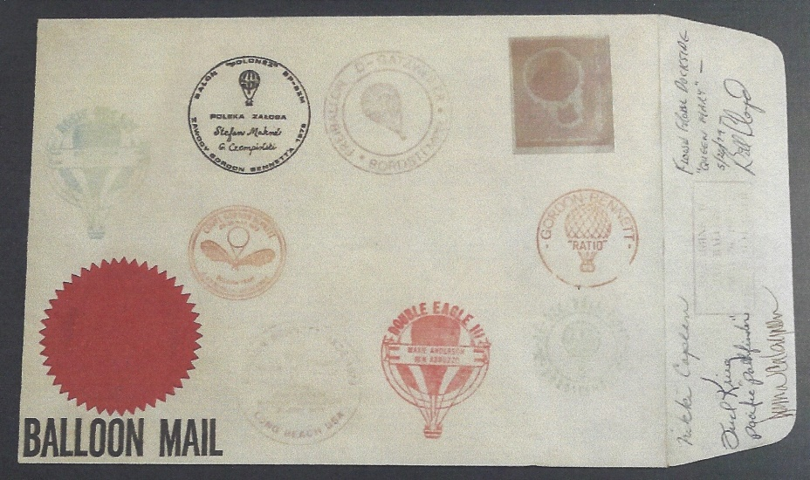
Two of Bill’s most memorable events were flying out of the Expo ‘74 opening ceremonies in Spokane, WA and participating in the 1979 Gordon Bennett International gas balloon race, flown from Long Beach, CA. In the Gordon Bennett he served as co-pilot along with Fred Krieg for Nikki Caplan flying Pathfinder, a 60,000 cubic foot balloon. They landed at Garvey Reservoir in Monterey Park, CA. The event was won by a balloon piloted by Hall of Fame balloonists, Ben Abruzzo and Maxie Anderson who landed near Dove Creek, CO.
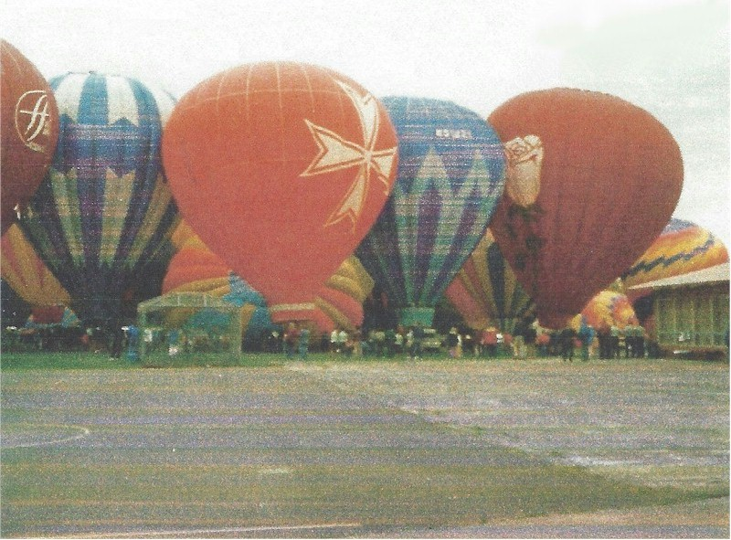
Lloyd and Nat Vale also developed the ballooning hobby into a successful business. The two started a balloon dealership and Lloyd continued that business. Ultimately he had eight dealers and was the distributer in Oregon, Washington, Idaho and Alaska for Aero Star International, the manufacturer of Raven hot air balloons. During his ballooning career, Bill owned five balloons: Columbia, Crusader, Old Blue, Rosebud, and Mariah. He was also presented numerous awards, including the following:
Columbia Crusader Old Blue Rosebud
Columbia Crusader Old Blue Rosebud
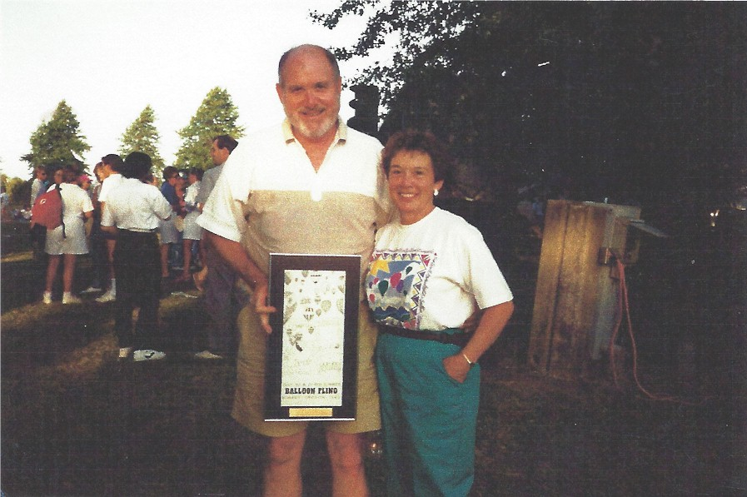
- 1980 – Award from Alaska Air
Mushers Ballooning Association
- 1983 – Award from Salem, OR Great Balloon Escape
- 1983 – Proclamation from Oregon Governor John Spellman celebrating the 200th Anniversary of Maned Flight
- 1991 – Northwest Ballooning Association – Aeronaut of the Year
- 1995 – Contributions as founder of the Northwest Ballooning Association
1983 Award presented by the Great Balloon Escape event in Salem, OR

One of Bill’s most notable and unusual flights was the morning of May 18, 1980 when the Mt. St. Helens volcano erupted. Although he was flying over 250 miles away from the eruption Bill said he felt the electricity in the air and the balloon experienced a little jolt. Needless to say he landed quickly.
Bill always had the desire to fly in a blimp. Although he never completed the task he had a large collection of picture, posters, and books pertaining to airships. He did have the opportunity in 1994 to inflate his balloon inside the Blimp Hanger in Tillamook, Oregon. This hanger housed blimps during World War II and is a museum today. At the time there were about 7 or 8 balloons inflated. Not quite the blimp flight he would have preferred but quite an experience.

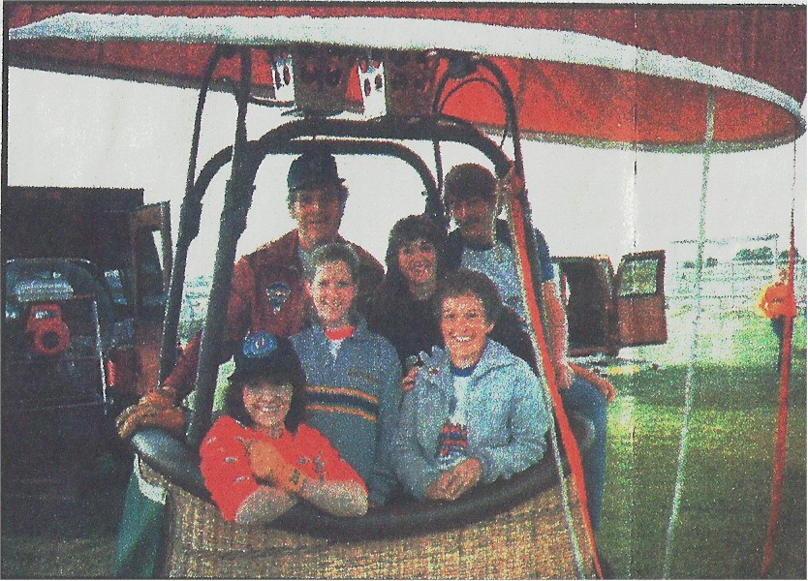
As is the case with many, ballooning is a family affair. Bill and Rosemary’s family have grown up with ballooning. In this 1984 photo, they gathered for a ballooning event in Burns, Ore. Bill is at back, left, and Rosemary is in front at the right. Their children (front to back) are: Cyndra VanDonge of Walla Walla, Melissa Lloyd of Portland, Jennifer Charlo of Clarkston and Steven Lloyd of Seattle.
In 2012 during the 38th Annual Wala Wala Balloon Stampede Bill was inducted along with wife Rosemary into the Wala Wala “Hala” Hall of Fame. Bill was not able to attend because of his Parkinson’s disease, however Scott Spenser made sure that Bill was involved in the event. After launching on Saturday morning Scott realized he was on track to fly towards the care facility where Bill lived. Scott got on his cell phone and called Bill’s wife, Rosie, and asked her to arrange to have Bill brought outside. As Scott maneuvered his balloon into the parking lot, Bill was wheeled out. Bill was wearing a ballooning T-shirt, ballooning jacket and a radiant smile from ear to ear. Bill could not come to the rally but Scott made sure the rally came to Bill.

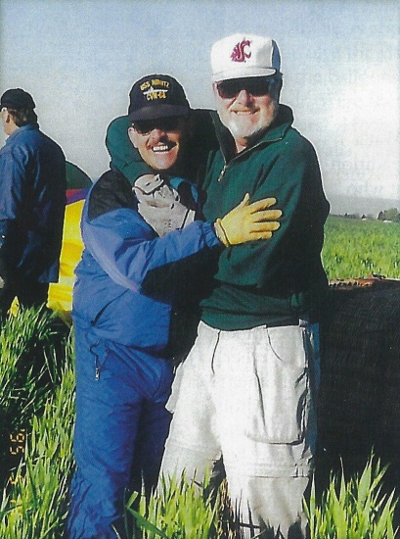
Scott Spencer and Bill Lloyd - 1995 picture

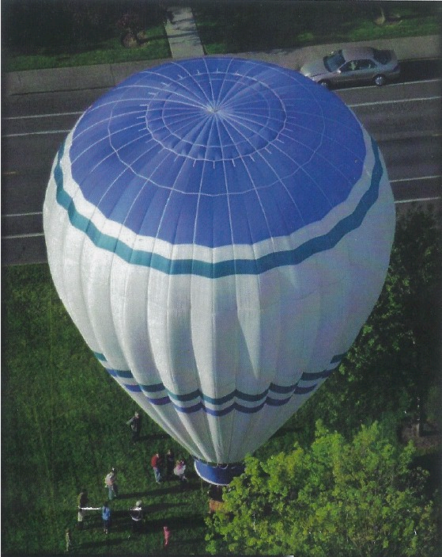
Scott Spencer landing near Bill's care facility

