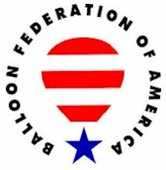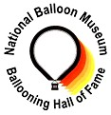

UNITED STATES BALLOONING HALL OF FAME
A Partnership of the Balloon Federation of America and the National Balloon Museum

Candidate Information Form

Date Submitted: 2/4/2020

CANDIDATE NAME: Rob Bartholomew

Address: 18999 Blue Place City: Carlisle State: IA ZIP: 50047

Telephone: (515) 989-3708 E-mail: balloonsoveriowa@wildblue.net

Briefly describe the basis for the submission: The following submission detailing the many accomplishments of Rob Bartholomew was submitted by Jason Jones.

“I would like to recommend Rob Bartholomew for the National Balloon Museum Hall of Fame. Rob has been a staple in the ballooning community in the mid-west, the nation, and on the competitive ballooning stage for well over thirty years. There are so many ways that Rob is a hall of famer when it comes to ballooning. Let me share a few with you.
First: Rob has given 595 check rides to aspiring balloon pilots over the years. That in itself is incredible. This list of pilots Rob has helped join the ballooning community includes numerous well-known pilots including myself. Rob gave me both my commercial and private check rides. A part of being a designated examiner is being willing to train pilots; which Rob has done. In coaching they call it a coaching tree when your assistant coaches go out and get their own head coaching job. Just think how large Rob’s ballooning tree is based on the training and check rides he has provided.
Second: Rob is also a founding member of Balloons Over Iowa. This balloon club is another testament to Rob’s influence on the sport of ballooning. The club has been in existence for over thirty years. The club has always met at the balloon port, Rob’s repair station, once a month for the entire existence of the club. The club has held ground schools throughout the years, kicked the flying season off with its annual Odd to Spring event, and promoted competitive ballooning. With any club you know there are many people to thank for the club’s success, but Rob was a driving force behind the club.
Third: Growing up in Indianola, IA, it was hard not to look up to Rob. He was one of the nation’s best competitive pilots. Rob had numerous top ten finishes and a National Championship while the event was held in Indianola. This success continued after the National Championship left Indianola as well. My family flew and competed in the Nationals as well and we were always looking to see where “Charlie Brown”, Rob’s balloon was in the sky. You knew he would be close to the target. World Championships are also a part of Rob’s resume. Rob flew the Worlds in Battle Creek and Saga, Japan. Rob was also willing to share competitive ideas with those of us that were new pilots wanting to compete. He never acted too busy to answer a question.
Fourth: Rob has established and run many balloon events throughout Iowa. Events in Altoona, Creston, and Oskaloosa are just a few of the events that Rob has helped establish. For many years you didn’t have to leave the state of Iowa to fly in an event every weekend. As a part of working to expand the sport through events Rob also was a part of the BFA Board and the Nationals Balloon Classic Board. Working both locally and nationally Rob has worked hard to build the sport of ballooning.
Fifth: There are many types of balloon flying. From competitive ballooning to long jumps Rob has done many of them. Two that are fore front in my mind are the long jump Rob flew over Lake Michigan and the night flight over the city of Des Moines, IA. Pushing and improving his skill set has always been a part of Rob’s aviation career. This is one of the things that impressed me most. Often you find a pilot that is really good at one aspect of the sport and that is their niche. Rob has always wanted to be good at the sport of ballooning period.
Sixth: Balloons Over Iowa Inc. Rob has for years run a repair station where annuals have been completed, balloons have been sold, and advice has been given. The repair station has a barber shop feel. People stop by and talk ballooning. Rob never shied away from those moments to grow the sport. He has helped many people find a way to get into the sport. I am It is because the greatness around you makes you feel like you are just as important as they are. What Rob Bartholomew does only scratched the surface of all the accomplishments Rob has in our sport. Many times, you are around greatness and you one of those people. I bought my first balloon when I was in college. I had little to no money and was aware that the balloon I was buying would not be airworthy long. When that first balloon wore out Rob found a way for me to stay in the sport. He and Linda helped me make another balloon happen when I could not make it happen on my own. I am forever grateful for that. This same graciousness has happened for countless others as well.
Thank you for considering Rob Bartholomew for the United States Ballooning Hall of Fame. I have tried to lay out a case for his induction and have only scratched the surface of all the accomplishments Rob has in our sport. Many times you are around greatness and don’t even realize it. It is because the greatness around you makes you feel that you are just as important as they are. That is what Rob Bartholomew does.”

Provide references: Identify two individuals that can speak to the quality and significance of the achievement, and to the character of the candidate

Reference Name: Gary Ruble Telephone or E-mail: glruble@gmail.com

Reference Name: Adam Magee Telephone or E-mail: adam.magee1@gmail.com

PERSON MAKING THE SUBMISSION:

Name: Jason Jones

Address: 12600 W 142nd St City: Overland Park State: KS ZIP: 66221

Telephone: (913) 338-2628 E-mail: jnsy588@aol.com

CANDIDATE HISTORY:

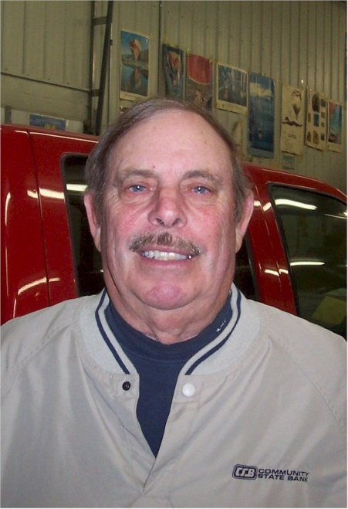
Rob Bartholomew

Notable – Accomplishments/Contributions, Ed Yost Master Pilot Award

balloonsoveriowa@wildblue.net

Rob Bartholomew received his hot air balloon license (Commercial Lighter than Air Free Balloon License) in 1974. However his aviation experience began in 1966 when he received his fixed wing pilot license. The experience continued through the years; In 1978 he became (and is still currently) a Federal Aviation Administration designated Examiner, opened (and still operates) a Federal Aviation Administration Certified Repair Station, and became a Federal Aviation Administration Prevention Counselor. Rob then became a Federal Aviation Administration Certified 141 Flight School Chief Instructor in 1986.
Along with aviation experience, Rob has served on or been a member of the following organizations: Balloon Federation of America since 1974, Balloon Federation of America Board of Directors for the North Central Region of the United States (Secretary 1985-1986, Board member 1986-1988), Founding father and current board member of Balloons Over Iowa since 1979, and a member of the Iowa Balloonist Association. In 1982 he received the Iowa Balloonist Association’s highest achievement award in ballooning, “Distinguished Aeronaut”.
Through the years of ballooning and competing, Rob has received a number of awards and championship titles:
1974- 12th place in the U.S. Nationals
1977 – 7th place in the U.S. Nationals
1978 – BFA National Point Leader
1979 – 9th place in the U.S. Nationals
1982 – 7th place in the U.S. Nationals
1983 – 7th place in the U.S. Nationals , 1st place in the All Iowa Championship, 12th place in the North American Challenge Cup, and qualified for the World Championships in France.
1984 – 4th place in the U.S. Nationals , BFA National Point Leader
1985 – 14th place in the World Championship, the BFA National point leader, and competed in the North American Championship.
1986 – 7th in the U.S. Nationals, 1st in the Storm Lake Race, and 1st in the Miller Pro Balloon Race.
1987 – 2nd place in the U.S. Nationals, 1st in Miller Pro Balloon Race, 1st in the Altoona Balloona Festival
1988 – 1st place in the U.S. Nationals and competed in the North American Nationals Championship
1989 – Qualified for and attended the World Championship in Saga, Japan
1991 – 1st place at the All Iowa Championships
1992 – 1993 - Balloon Meister for the National Balloon Classic
1995 – 10th place in the National Balloon Classic
1997 – 5th place in the National Balloon Classis
1998 – 9th Place in the National Balloon Classic
1999 – 5th place in the North Central Regional Championship, 5th place in the National Balloon Classic
2000 – 2nd place in the North Central Regional Championship, 2nd in the National Balloon Classic
2001 – 3rd place in the BFA Iowa State Champion , 5th place in the National Balloon Classic
2002 – 1st place at the All Iowa Championships
2003 – 1st place at the All Iowa Championships, 2nd place in the National Balloon Classic
2005 – 3rd place in National Balloon Classic
2006 – 9th place at the National Balloon Classic
2007 – 4th place in the National Balloon Classic
2009 – 1st place in the North Central Regional Championship and 3rd place in the National Balloon Classic
In 2014 Rob was presented the Balloon Federation of America Ed Yost Master Pilot Award for 40 years of incident free flying. He also received the Federal Aviation Administration Wright Brothers Master Pilots award in 2016.

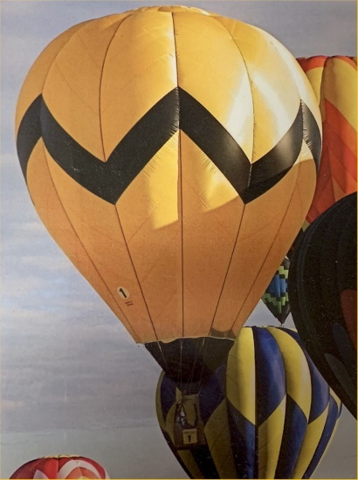
Charley Brown
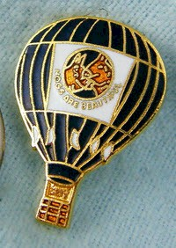
Hogs are Beautiful

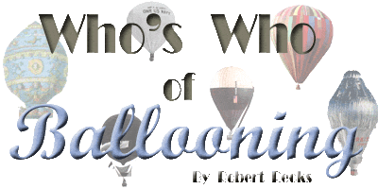

BARTHOLOMEW, Rob USA (1946- (HB)
See APPENDIX-BK/BO/BR/BX. Sport balloonist.
b: 28 Mar.1946 Des Moines, IA.
e: Carlisle High School;
s: U.S.Airforce, 6-years.
p: Farmer; Owner of Balloons over Iowa, Ltd. Balloon repair station & Sales.
f: First B-Solo April 1974 from Carlisle, IA; FAA B-License #1753732 issued 1 May 1974; Airplane pilot; More than 860 B-Hours by 1988; FAA B-Pilot Examiner. l: 1977, BFA-National points winner for the year; 1977, Placed 7th in U.S.National HB-Championships; 1979, Placed 9th in U.S.National HB-Champion-ships; 1982, Placed 7th in U.S.National HB-Championships; 1983, Placed 7th in U.S.National HB-Championships; 1985, BFA-National points winner for the year; 1985, Placed 14th in U.S.National HB-Champion-ships; 1986, BFA-National points winner for the year; 1987, Placed 2nd in U.S. National HB-Championships; 1988, WINNER of the U.S.National HB-Championships; Filmed ballooning sequence for television special. Owner of "Charlie Brown" balloon; Flew in Mexico & Japan.
m: BFA, Board of Directors 1985-88.
r: Bio-Data form 1988.

The following letters of recommendation have been received:

2/7/2020

Rob Bartholomew – Hall of Fame Recommendation

Rob Bartholomew received his hot air balloon certificate (commercial lighter than air free balloon) in 1974. However, his aviation experience began in 1966 when he received his fixed wing rating. The experience continued through the years; in 1978 he became, and is currently, a Federal Aviation Administration Designated Pilot Examiner as well as opened, and still operates, a Federal Aviation Administration Certified Repair Station, and also became a Federal Aviation Administration Prevention Counselor. Rob then became a Federal Aviation Administration Certified Part 141 Flight School Chief Instructor in 1986.
Rob earned the Federal Aviation Administration’s Wright Brothers Master Pilot Award for 50 years of safe flying in 2016. Rob has also received the Balloon Federation of America Ed Yost Master Pilot Award for 40 years of safe flying in 2015. It is interesting to note that while the Ed Yost Master Pilot Award winners is few in numbers, Rob has been a FAA DPE for 40 years! Rob is a true master pilot and master examiner! He has also been an FAA Certified Repair Station for over 40 years! I would bet he is the only balloon pilot to have ever received both the Wright Brothers Master Pilot Award, Ed Yost Master Pilot Award, been a DPE for 40+ years, and a repairman for 40+ years!
In his 40 years and counting as a FAA DPE, Rob has given over 580 successful check rides awarding private and commercial balloon ratings! It is unbelievable to imagine being a DPE for 40 years and successfully awarding over 580 certificates! Even more unimaginable is to think of all the pilots Rob has indirectly had an impact on in ballooning. Could you imagine a family tree created from those 580 certificates awarded? How many pilots trained or involved others who became pilots, who trained or involved others who became pilots? The tree would have thousands of branches!
Rob’s extensive longevity and experience as a DPE alone makes him an easy choice for the US Ballooning Hall of Fame, but of course Rob has more accomplishments which include (in part):

1974 – 12th place in the U.S. Nationals
1977 – 7th place in the U.S. Nationals
1978 – BFA National Points Leader
1979 – 9th place in the U.S. Nationals
1982 – 7th place in the U.S. Nationals
1983 – 7th place in the U.S. Nationals, 1st place in the All Iowa Championships, 12th place in the North American Challenge Cup, and qualified for the World Championships in France.
1984 – 4th place in the U.S. Nationals
1985 – 14th place in the World Championships, the BFA National Points Leader, and competed in the North American Championships
1986 – 7th place in the U.S. Nationals
1987 – 2nd place in the U.S. Nationals
1988 – 1st place in the U.S. Nationals
1989 – Qualified for the World Championships in Saga, Japan
1991 – 1st place at the All Iowa Championships
1992 – 1993 Balloonmeister for the National Balloon Classic
1995 – 10th place at the National Balloon Classic
1997 – 5th place at the National Balloon Classic
1998 – 9th place at the National Balloon Classic
1999 – 5th place in the North Central Regional Championships and National Balloon Classic
2000 – 2nd place in the North Central Regional Championships and National Balloon Classic
2001 – 3rd place in the Iowa State Championships and 5th place in the National Balloon Classic
2002 – 1st place at the All Iowa Championships
2003 – 1st place at the All Iowa Championships and 2nd place at the National Balloon Classic
2005 – 3rd place in the National Balloon Classic
2006 – 9th place in the National Balloon Classic
2007 – 4th place in the National Balloon Classic
2009 – 1st place in the North Central Regional Championship and 3rd place in the National Balloon Classic
2013 – 11th place in the National Balloon Classic

Along with his aviation experience, Rob has served on or been a member of the following organizations: Balloon Federation of America since 1974, Balloon Federation of America Board of Directors (Secretary 1985-1986, Board member 1986-1988), Founding father and current Board member of Balloons Over Iowa since 1979, and a member of the Iowa Balloonist Association. In 1982 he received the Iowa Balloonist Association’s highest achievement award in ballooning, “Distinguished Aeronaut”.
Since 1974 Rob has served as a mentor to many introducing them to the beauty of hot air ballooning. He has trained many pilots as well as sold many balloons as he has been a longtime dealer of Firefly Balloons. He has inspected and repaired thousands of balloons at his repair facility. Since 1978 he has given nearly 600 certificates for balloon ratings. He has competed and continues to compete at the highest level as he still actively competes and continues as a DPE. Rob founded the club Balloons Over Iowa as well as many balloon events across Iowa.
Rob Bartholomew is most deserving of recognition into the U.S. Ballooning Hall of Fame as a Master Pilot, DPE, and repairman.

Respectfully submitted,
Adam Magee
BFA and HACD Life Member

2/20/2020

Balloon Federation
Hall of Fame Committee

Rob Bartholomew is a personification or definition of a “Balloonist”. But what makes him unique among his fellow Balloonists is the diversity of his participation in the sport. In addition to being a forty plus year Commercial Balloon Pilot and recipient of the Ed Yost Award, he is a National Champion Balloonist, the owner of a well-known and much relied upon balloon repair station called Balloons Over Iowa, and an instructor to many of the balloon pilots in Iowa and surrounding states. He also is a long time designated flight examiner and was for many years, a Dealer for The Balloon Works.

I first met Rob as he came to the Indianola Chamber of Commerce office in 1973, looking for information about Hot-Air Balloons, and how to buy a balloon. At the time he was suffering from a broken leg, which he had received in an airplane accident. He had received information about Semco balloons and was leaning towards a purchase of their system. During the discussion I indicated that I thought he should look at Raven balloons of Sioux Fall, SD due to their being much closer, and building a well-known quality product. Whether or not our discussion had any part of his decision, he did purchase a dark blue Raven Rally balloon, which he flew for many years at the U.S. National Hot-Air Balloon Championships with a huge banner which said “Hogs are Beautiful”. While the “Hogs” balloon was a much loved and recognized balloon, a later was even more so. After becoming a Dealer for The Balloon Works, Rob purchased and flew “Charlie Brown”, a yellow Balloon Works with a zig-zag black stripe, mimicking the shirt of the famous character. Every kid in Warren county, or visitor to the Nationals recognized “Charlie” on sight.

The Balloons Over Iowa balloon port owned by Rob was, and is a social as well as business center for most of the balloonists in the central U.S. it became the site for parties and social occasions in addition to providing a location for ground schools, and just a place for balloonists to gather, review weather and “hanger fly”.

Rob Bartholomew is one of those persons who have made our sport available to a great many over the years through his instruction, flight examiner status and repair services. He is richly deserving of the recognition and honor which entry into the National Ballooning Hall of Fame would bring.

Submitted by,

Gary Ruble

