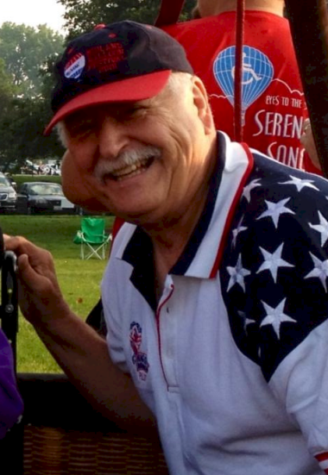
Phil Gray

Notable - Accomplishments/Contributions, Development
MAILING ADDRESS:
2004 West Euclid
Indianola, Iowa. 50125
PHONE: (515) 971-7156
EMAIL: nationalballooningltd@gmail.com
In 1972 Phil Gray took his first balloon flight with pilot, Gene Dennis, at the National Hot Air Balloon Championship held in Indianola, Iowa. Soon after, he helped to form The Hawkeye Aerostation Society Inc., a ten member balloon club which Phil was the president. Members chose Phil as the first pilot to receive flight training. His training began on January 3, 1973 with Matt Wiederkehr. This was a three hour flight from Indianola to Alleman, Iowa and was a high wind landing on frozen ground. He did his solo flight with only six hours of training. The solo flight was two hours and thirty minutes from a balloon filed in Minnesota near St. Paul and landed in Cottage Grove Minnesota. Phil did his check ride with an F.A.A. flight examiner Lowell Sonquist for his commercial license on February 2, 1973 they flew for one hour at which time, they made a brief landing the examiner got out of the gondola and his first student, Walt Burgin, got in. Continuing to fly, they flew for another hour and fifteen minutes with Phil as instructor.
Phil began a certified aircraft repair station in 1973, in August of the same year he was certified as a FAA Designated Pilot Examiner and F.A.A. Safety Officer. Phil became a dealer for Raven Industries, he sold many balloons in the mid-west and trained their pilots as well. To date Phil has trained well over 200 pilots in his ballooning career and continues to do so even as this is written.
Commercial pilot work was started in 1973 and has continued for the past forty five years. Flying for companies ranging from Coke, Miller Beer, Mr. Pibb, REMAX, Peony Park, ATC, SEASPAR, Good Samaritan Society, Health South and Veolia. Including television commercial work for Orange Crush, Tolban Tolerance and The Meadows. When not flying commercially Phil used his artistic talents to create commercial signs for the National Balloon Classic, other pilots and Races that were in need of banners to fly for their advertisers.
Phil had a vision of forming a race circuit for ballooning. He wanted pilots to have the opportunity to race and have prize money that was of some value. A race committee was formed first in Ottumwa Iowa and the name The Ottumwa Pro Balloon Races was chosen; Phil was the Balloon meister there for twenty-five years. He also started races in Creston, Dubuque, Cedar Rapids, Burlington and Iowa City where he served as the balloonmeister as well. His vision to make ballooning a sport not just a hobby was well received in central Iowa and many of these races are still taking place.
Determined to reach for more, Phil then went on to manufacture his own balloon he named Azure. It had its first flight April 28, 1979. This was the beginning of his quest to manufacture his own design and on July 15, 1981, after many long hours of blueprints, flight tests, burner tests, basket drops, manuals and applications National Ballooning Ltd. received Type Certification from the F.A.A. Finalizing this process on July 22, 1982 National Ballooning Ltd. received a Production Certification, taking its claim to fame as the only balloon manufacture in the central region and the state of Iowa.
Always up for a challenge and a man of great compassion Phil was approached by Gary Waldman whose daughter has Cerebral Palsy. Waldman had a dream and Phil was the only manufacture who agreed to undertake the challenge of making that dream a reality. He agreed to construct a special basket that would have a door and a large enough opening for the handicap rider to board by simply wheeling into the basket. Once the basket was constructed Phil then made the one hundred and five thousand cubic foot envelope, unique in its design, it sports a 60 foot high wheelchair accessible symbol, wearing a red heart, on a solid blue balloon. On July 28, 1992 Serena's song was issued a Standard Airworthiness Certificate and became the world's first wheelchair-accessible hot air balloon, approved by the Federal Aviation Administration, which was designed, built and certified specifically for the handicapped.
"I have done all kinds of things with balloons and won many races, but experiencing Serena's Song is the best thing ever," Phil Gray
Phil is still the CEO and Chief Engineer of National Ballooning LTD. Manufacturing hot air balloons and fulfilling clients aircraft dreams as well as a licensed repair station and repairman. He continues to travel and fly Serena's Song offering the handicapped a rare unforgettable experience of flight. He finds time to train students and prepare them to become pilots and of course in between it all, Phil still free flies and has constructed his own ultralight balloon. Phil holds an excellent safety rating reporting zero accidents. His passion for ballooning has reached far beyond a sport, hobby or a dream it has accomplished aeronautical history.

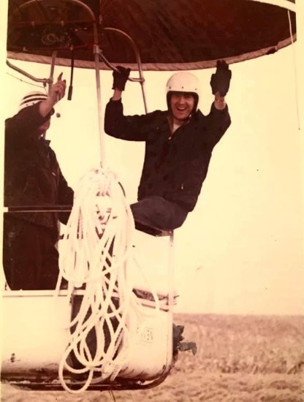

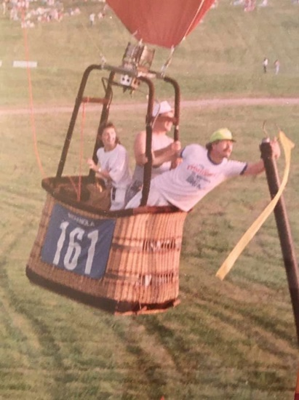

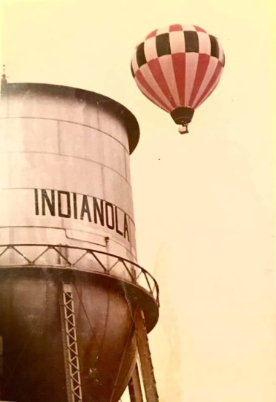

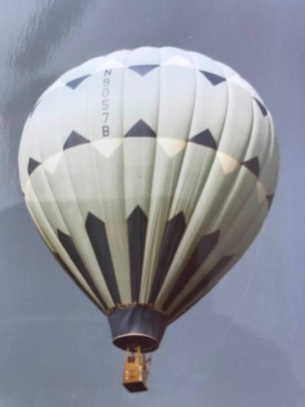

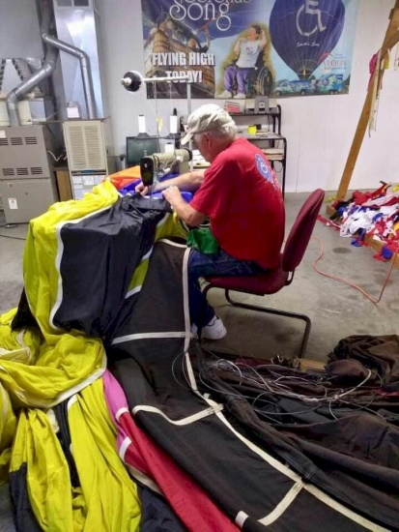

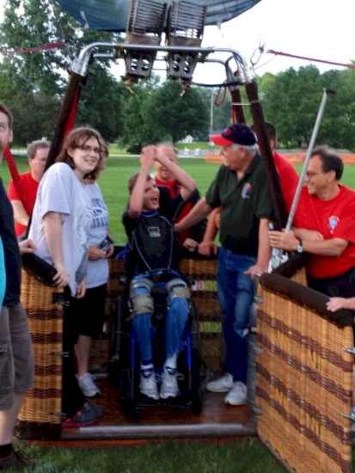

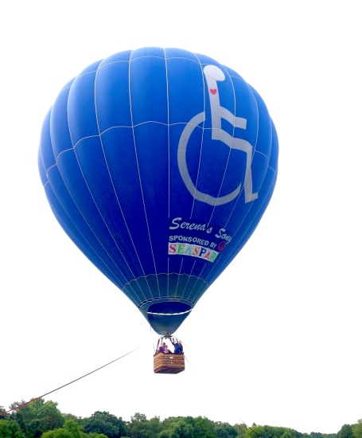

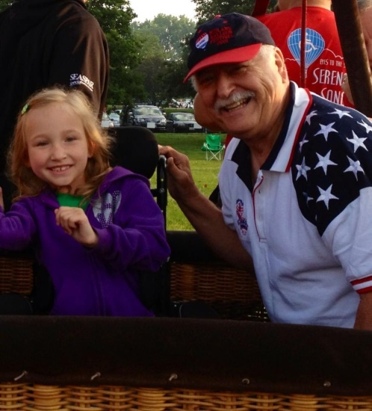

Family Launches Balloon Business
Newspaper article (source not listed) copied from a binder entitled “Balloons” at the Warren County Historical Society, Indianola, Iowa.

The Grays set up the Hawkeye Aerostation Society, devoted to flying balloons and meeting nice people. By 1974 the Grays bought their own balloon, and were flying at rallies as often as possible.

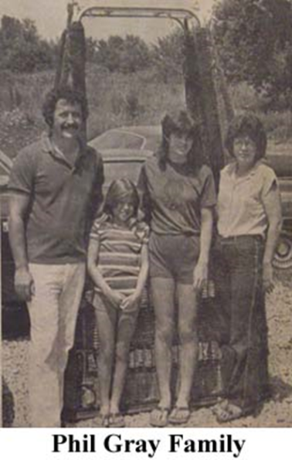
As early as 1972 Phil had engaged in his first competition. Ballooning had got into his system, and he loved it. However, Linda recalled, she was not enthusiastic about flying. But she enjoyed working on the ground crew and seeing the wide assortment of colors and balloons. “Linda encouraged me to get into ballooning. She thought they were beautiful,” Gray said.
Phil began selling balloons and training people to fly and as his interest mounted, the demands for time between his work and his hobby became increasingly difficult to manage. “We got to the point where we either had to do one or the other,” he said. “We decided ballooning was our choice.”
In 1974 they received a certified FAA repair station license to rebuild or repair balloons. They also began studying balloons and building experimental models. In working on the experimental models, they had to submit their procedure for building, testing and inspecting the balloons to the FAA. The first prototype was completed five years ago. It flew perfectly, and is still flying, Linda said.
At the same time that they were submitting design drawings to the FAA engineering department in Wichita, Kansas, writing flight manuals and maintenance manuals, the Grays began building their new house. “We ended up working very long hours,” Phil said. “And we’re still working very long hours to get business into production.” At first, the Grays were building the balloons in their home, using polyester aluminum, wicker, and plywood. It takes about three to four months to build one balloon, they said.

