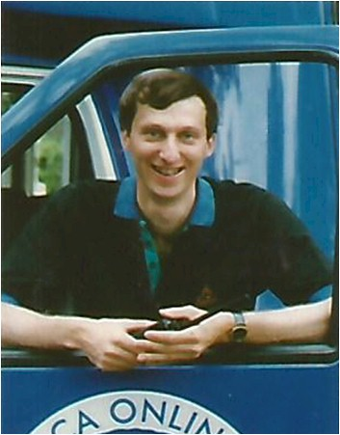
Gordon Schwontkowski

Notable – Accomplishments/Contributions

Gordon Schwontkowski of Cary, IL is ballooning’s driving force behind crew and ground safety. Since 1981 he has led over 3000 commercial and corporate crews on systems ranging from 60K racers to 300K special shapes. His prolific writing on safety – two editions of the standard-setting Hot Air Balloon Crewing Essentials book, 75+ articles for Ballooning Magazine, and contributions to 2 editions of The Balloon Flying Handbook – has helped define industry, insurance, and FAA standards and policy regarding crew. After some of our worst mishaps, state and federal agencies have teamed up with him for both accident analysis and prevention. As a featured speaker in 20+ states, he has delivered 200+ seminar presentations to rave reviews. Ed Yost endorsed his work with safety, describing it as “knowledge presented with gusto.”
“A skilled crew is a virtual co-pilot and no longer optional,” says Gordon. “The days of chasing are over – savvy, skilled, and proactive crew are a necessity in today’s flying environment.” Pilots and crew nationwide agree with this message, constantly ranking him one of the top safety instructors in ballooning.
