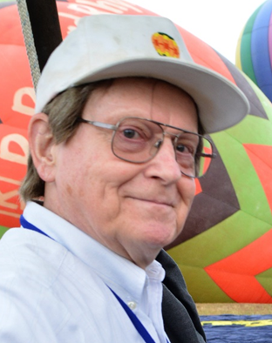
Don Cline

Notable – Achievements/Contributions, Ed Yost Master Pilot Award

dcline@pari.edu

Don Cline is one of the pioneers of modern hot air ballooning. Don became involved early in the sport in 1970. He has made many contributions to ballooning. Jo Cline became a balloon pilot in 1971. She was Don’s partner in all his ballooning adventures and managed the Greensboro BalloonPort for 41 years until her death in 2015.
Don Cline participated in fixed wing aviation in the 1950’s and 1960’s and he started in the sport of Hot Air Ballooning in 1970. He has more than 4,000 lighter than air flight hours. Don made his first training flight from the Balloon Works, which was located in Charlotte NC at the time and Tracy Barnes was his instructor, the date of that flight was April 27 1972. Don successfully passed his commercial FAA check ride on April 29 1973.
Don Became a FAA designated examiner for Gas and Hot Air Balloons in 1978 and a FAA Accident Prevention Counselor in 1980. A Certificate of Honor was awarded to Don by the National Aeronautic Association for contributing to the advancement of the art, sport and science of aviation and space flight. This award was presented at the Smithsonian Air and Space Museum in Washington DC, the night of March 25 1991.
Don has been involved in most aspects of the sport of ballooning. He has been involved in competitive ballooning as pilot, observer, safety officer, competitive director and also competed in the US Nationals each year from 1973-1991, and as one of the team members representing the US in the 1977 World Hot Air Balloon Championship in York, England.
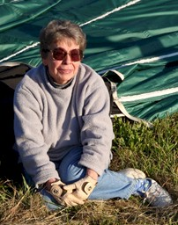
Don was and International Steward for the 1981 & 1985 World Championships in Battle Creek MI. He is a BFA Master Instructor, a Class A Observer and has obtained the level 8, Distinguished Aeronaut in the Pilot Achievement Award Program.
Don has supported the BFA as a Life Member and Treasurer from 1986-1989, BFA/NAA Balloon Record Attempts Coordinator 1988-1996 and is a BFA Safety Seminar speaker. Don and his wife Jo have operated the Balloonport of Greensboro from 1974- to date and provided a FAA approved Repair Station since 1986 to present.
As a Carolina Balloon Association Life Member Don has held the positions of Vice President, Safety Officer, Treasurer, Board Member and Safety Seminar Speaker.
Don is the only pilot to have flown in all 39 National Balloon Rally/ Carolina Balloonfest Events, and celebrated his 40th year when the event started on Oct. 17th 2013.
Jo Cline
Through all these years Don has not had an accident nor has he had any FAA enforcement action taken.

1952-1959 Education
Pisgah Astronomical Research Institute 1
Don attended high school in Statesville, NC, was an Eagle Scout with 46 merit badges, and in1952 became a member of the Civil Air Patrol which fostered his interest in electronics, radio and aviation. Don holds an electrical engineering technology degree from NC State University and a BS in both math and physics from Guilford College. His post-graduate work includes courses in astronomy, physics, optics, mathematics, engineering, computer science, economics, geology, earth science and business administration.

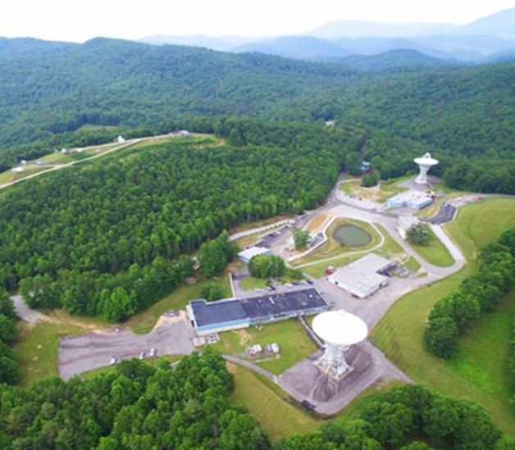
1959-1998 Business Background
Don moved to Greensboro, NC in 1959 for employment by Bell Telephone Laboratories as a member of the technical staff for 18 years. Don left Bell Labs in 1977 and founded Micro Computer Systems which he sold to the Harris Corp in 1995. In January 1998 Don founded the Pisgah Astronomical Research Institute (PARI) where he remains as its president. Located nine miles northwest of Rosman, NC, the 200-acre complex consists of 35 buildings and various optical and electronic telescopes including 2 massive 85’ diameter telescopes. You are invited to go to www.pari.edu to explore this major astronomical facility and all they do. Year round students and educators worldwide attend classes and camps in science at PARI
Pisgah Astronomical Research Institute

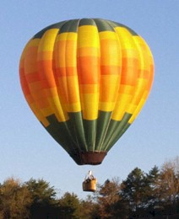
1970 Meeting Tracy Barnes
Tracy Barnes was in the early stages of designing the FireFly balloon, and he needed someone to design and build an electronic temperature meter. Don Cline was introduced to Tracy in 1970 and he designed and Jo and Don built more than 1,000 temperature meters that were used in nearly every balloon Tracy built between 1972 and 1979.
Tracy wanted to move from Charlotte to a place where he would have more room to fly balloons. He selected Rhyne Aerodrome just off NC 90 about 10 miles north of Statesville, NC. Tracy moved with Dodds, Karl, and Terry and started manufacturing his FireFly balloon there in 1974. Don continued to design and manufacture of temperature meters and other equipment as a weekend task.
Daybreak II

1971-1972 Training and First Balloon
Tracy trained Don and Jo (10 flights each) for their balloon certificate in 1971 and 1972. Don has owned nineteen balloons over the years (1972-2020), his first balloon was built by Tracy and was used as the test balloon and delivered to Don as The Balloon Work’s first FAA certified balloon on April 18, 1974. This balloon N48JD, was named “DayBreak”. Jo’s first balloon was N19JD and named “DaySpring”. Both balloons remain flyable today.

1971-1985 Designing and Building Other Equipment
Don designed and manufactured other balloon equipment for Tracy including battery powered inflator fans, digital fuel meters, a powerline detection system, two-wheel balloon transporter, First FAA certified balloon auto pilot for flights to 190 miles MSL and controlled level flight to 10 feet and controlled rates of accent and descents, and a wind speed/direction meter. This engineering support continued to help Tracy in 1980-1985 when Tracy designed and built two 68’ long, single-engine helium airships he named Wind Dancer and Whispership.

1972-1974 Tracy founds The Balloon Works
It was during this time period that Tracy founded The Balloon Works and brought in a team of experienced balloonists and engineers to help him with the design, engineering and testing of the balloon he planned to have the FAA certify. First, Tracy moved from the warehouse in south Charlotte to an abandon women’s prison in north Charlotte. Already working with Don, Tracy then hired Dodds Meddock from Valparaiso, IN, Karl Stefan from Palestine, TX, and Terry Wright from St. Paul, MN. Thirteen experimental balloons were built at the women’s prison between the years 1972-1974.

1973 Inventing and Testing the First Parachute Valve
Tracy had been developing a new design for a more reliable venting/deflation system in the top of a balloon. At the time most balloon valves were not reliable and once opened might not reseal. Tracy developed a brand new design: a parachute sealing the hole in the top of a balloon which could be pulled down into the balloon to either vent or deflate the balloon, and when released, would automatically close. Tracy installed the first parachute valve (12’ dia.) in balloon N64122 and asked Don to make a test flight. On April 22, 1973 Don flew the balloon to 11,000’ but reported the valve was too small for a quick deflation on landing. Tracy replaced the 12’ valve with a 20’ valve, and Don made a second test flight on April 29, 1973 with his wife, Jo. Don reported that Jo had no problem using the larger valve. The parachute valve is now the industry standard used by almost all balloon manufacturers.

1974 Don forms Greensboro BalloonPort
In 1974 Don and Jo built their first BalloonPort. In 1984 a new BalloonPort was built at 136 W. Steeple Chase Road south of Greensboro.
For 47 years the BalloonPort has offered balloon sales, training, balloon annuals, repairs, and rides. Don was a FAA Designated Flight Examiner for 28 years. For 20 years the BalloonPort hosted a Christmas Party for the Carolina Balloon Association (CBA).
Don has owned nineteen balloons over the years (1972-2021), his first balloon was built by Tracy and was used as the test balloon and delivered to Don as The Balloon Work’s first FAA certified balloon on April 18, 1974. This balloon N48JD, was named “DayBreak”. Jo’s first balloon was N19JD and named “DaySpring”. Both balloons remain flyable today.

Don Cline Memberships 1952-2021

- Life member of the Institute of Electrical and Electronic Engineers (IEEE)
- New York Academy of Science
- American Association for the Advancement of Science
- International Society for Optical Engineering
- Astronomical Society of the Pacific
- American Astronomical Society
- American Association of Variable Star Observers (AAVSO)
- Experimental Aircraft Association (EAA)
- Aircraft Owners and Pilots Association (AOPA)
- Life member of the American Radio Relay League (ARRL).
- A ham radio operator K4GBD since 1952
- Holds a general radio license allowing him to act as a station engineer for both radio and TV stations
- Eagle Scout with 46 merit badges
- Civil Air Patrol Member (1952-1986) retired with the rank of Major
- Board member for RWG Licensing
- Board Member Mars Hill College
- Board Member Kenan Fellows Advisory Board
- Board Member NC Museum of Natural Sciences
- Board Member Appalachian State University College of Arts and Sciences
- Board Member ASU Engineering Physics
- Board Member UNC Greensboro University of Arts and Sciences
- Board Member UNC Asheville University Board
- Board Member Guilford Technical Community College
- Board Member UNC Charlotte Industrial Board
- Board Member Education & Research Consortium (ERC) Broadband ,Asheville
- Board Member and President of Pisgah Astronomical Research Institute (PARI)
- Board Member NASA NC Space Grant Consortium

1970-2020 Don’s 50 Years of Balloon Achievements and Awards

1970 Traveled with Tracy to FAA Atlanta to start certification process
1971-1972 Don and Jo trained for their balloon certificates
1971 to Present BFA Life Member and BFA Safety Seminar Speaker
1973 Test solo flight of the first parachute valve to 11,000 feet
1973-1991 Flew in the US Nationals in Indianola, Iowa for 18 years
1974-2019 Only pilot who has flown in Carolina BalloonFest for 47 yrs.
1974-2020 Commercial balloon pilot with over 4,000 flight hours
1974-1986 Served on the BFA Events Committee
1975-1995 Contributed to the Carolina Balloon Association newsletter
1977 US pilot member of World Championships in York, England
1978 Organized and directed the flight of eight balloons to over 24,000 feet AGL
1978-2007 FAA designated examiner giving over 500 check flights
1978 to Present FAA Certified Balloon Repairman for the BalloonPort
1980-2007 FAA accident prevention counselor
1981&1985 Safety officer for two World Championship in Battle Creek, MI
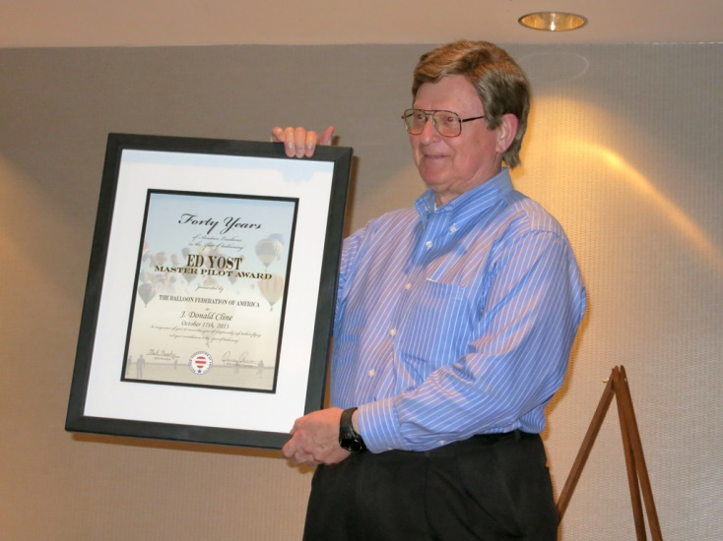
1982&1985 Two gas balloon flights over the Alps from Murren, Switzerland
1986-1989 BFA board member, secretary and treasurer
1988-1989 BFA/NAA balloon record attempts coordinator
1991 March 25 Certificate of Honor awarded for Gas and Hot Air Balloon instrument development by the National Aeronautic Association (NAA) at the Smithsonian Air and Space Museum located in Washington, DC
Don Cline - Ed Yost Master Pilot Award
2013 Ed Yost 40-year Master Pilot Award.

