Jim Gebhart

Notable – Ed Yost Award

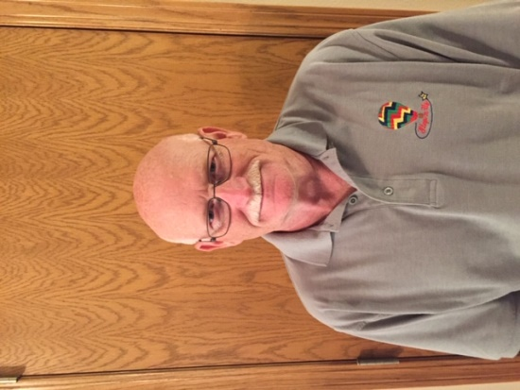
James (Jim) Gebhart got intrigued in ballooning by crewing during the US Nationals in 1974 at Simpson College field located in Indianola, Iowa. Jim crewed for Dr. William Grabb for several years before switching over to crew for local pilot, Rob Bartholomew, of Carlisle, Iowa. After several years of crewing, Jim was very interested in learning to fly and have his own hot air balloon.
Jim received his student pilot certificate on 2-26-1981 number: ZZ-80526. Jim private pilot training was giving by Denny Cattell, Maryellen Smith, and Gary King. His solo flight was completed on 9-11-1981 with a private pilot check ride and certificate issued on 11-29-1981 by Rob Bartholomew. After a couple years of fun flying, Jim decided he would love to train new pilots so he obtained his commercial certificate.
Jim has co-owned several balloons: The Great Pumpkin owned with Rob Bartholomew, DJ’s Delight owned with Denny Anderson, and BJ’s Xcursion owned with Brian Seymour. In 2000, Jim and wife (Cheryl) along with son (Aaron) purchased their own designed Balloon Works called Step-N-Up. In 2016, the Gebhart family purchased a Lindstrand 77X and named it Step-N-Up 2. In 2019, a Lindstrand 90A called Double Trouble was purchased and co-owned by Aaron Gebhart and Christopher King.
Ballooning has been a big part of the Gebhart family. Jim’s son Aaron also received his private and commercial certificates and enjoys the competition part of the sport where Jim enjoys the training aspect. Over his 40 years of ballooning, Jim has logged 897 hours and has trained 39 pilots. He has also been race director over several Iowa/Illinois Hot Air Balloon events and was race director for the National Balloon classics in Indianola for 2 years. He is still currently the race director for The Great Hot Air Balloon Race in Galesburg, Il and The Southwest Iowa Hot Air Balloon Race in Creston, IA. Jim and his family travels to numerous balloon events across Iowa but their favorite event is Albuquerque International Balloon Fiesta. Many friends and memories have been made during these events which makes this sport so amazing.

- He has a passion for helping new students to receive their pilot certificate and continuing their training into commercial certificate.
- He has assisted pilots with knowledge when researching systems to purchase.
- He spent several years as assistant race director under Dick Drake for National Balloon Classics before taking over the role as Race Director for 2 years.
- Jim also assisted Rob Bartholomew with the Southwest Iowa Hot Air Balloon Race in Creston before taking over the Race Director position.
- He has been instrumental with getting Fuelink setup for balloonists in his local area.
- Jim has been involved in Balloons Over Iowa and Iowa Balloonist Association.
- Events that Jim has been race director are: Balloons in June (Clinton, Iowa); BBQ and Balloons (Marshalltown, Iowa); Fun in the Air (Mason City, Iowa); National Balloon Classics (Indianola, Iowa).
- Races he is still Race Director of: The Great Balloon Race (Galesburg, Illinois) and Southwest Iowa Hot Air Bal loon Race (Creston, Iowa).
- The Gebhart Family passion runs deep for the sport of ballooning. Additional family pilots are: son (Aaron Gebhart) and nephews (Preston Gebhart and Shawn Michael). Daughter-in-law (Miranda Gebhart) is a student pilot.
- Jim received the Ed Yost Master Pilot Award for 40 years of safe flying in 2021.

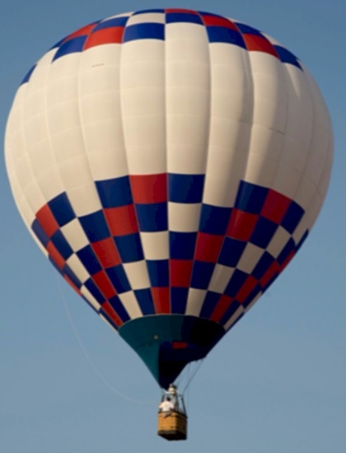
Double Trouble

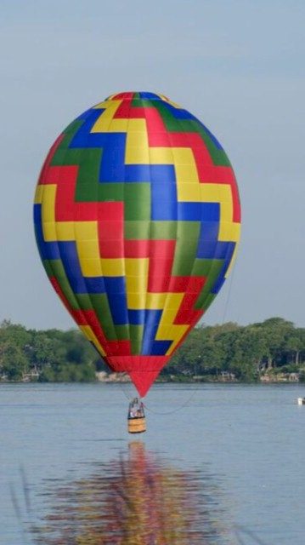
Step-N-Up

Jim’s Previous Balloons
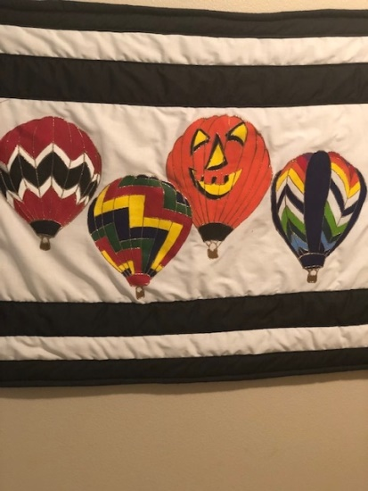
Xcursion, Step-N-Up, The Great Pumpkin, DJ's Delight

