Ron Behrmann

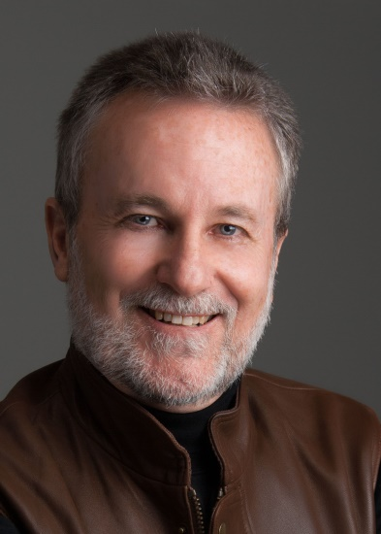
Notable – Accomplishments/Contributions, Shields Trauger Award

“The Balloon Photographer”
8405 Monitor Drive NE
Albuquerque, New Mexico 87109
505-821-8537
rbblnphoto@aol.com

Ron has been involved in ballooning for 50 years and involved with the BFA for 40 years. He recently was appointed to the Anderson Abbruzzo International Balloon Museum Board of Trustees by the current Mayor of Albuquerque.
Following are some of the highlights of his experience in ballooning;
- 1st balloon flight 50 years ago
- Licensed pilot since 1979 with over 775 hours as private & commercial PIC (with zero accidents or injuries). Hot air balloon co-owner 1992-2003
- Commercial balloon pilot for Virgin Balloon Flights in Jordan and Morocco
- Piloted our balloon in 21 states and 8 international countries.
- Co-owner of B&B Ballooning a dealer for Thunder & Colt Balloons, Tempest fans, United Expressline and Haulmark balloon trailers, and commercial balloon rides
- Provided “at no charge” 22 cover photos, 92 stories, and 520 inside photos to Ballooning Magazine. Since 1984 served different times as Staff Photographer, Staff Writer Contributing Editor, Contributing Photographer, National Correspondent, for Ballooning Magazine.
- Provided at no charge 100’s of photos and photographic services to the National Balloon
Museum in Indianola, Iowa
- Provided at no charge 100’s of photos and photographic services to the Anderson Abruzzo International Balloon Museum in Albuquerque, New Mexico
- Publicist and Team Manager for the Soukup-Thomas Balloon Fleet in the mid 80’s
- Served as the Chief BFA Scoring Official in New Mexico from 1983-90. Served as the Chief Scoring Official for Top Gun as well as a Top Gun Board Member
- In 1997 he was awarded the BFA’s highest honor, the Shields-Trauger Award for contributions to ballooning
- Official Photographer at the BFA National Championships in Baton Rouge, LA and Middletown, Ohio. Also Official Photographer at the North American Championships in Baton Rouge, LA and St. Jean sur Richelieu, Canada. Flew in the Championships as the only non-competitor flying with the competitors with permission of the Competition Director Jim Burk to provide photographic documentation.
- Served as the Official Photographer of the Albuquerque International Balloon Fiesta for 13 years.
- In the mid 80’s served on the AIBF Board of Directors, Assistant Media Director, Official AIBF Program Co-Producer, AIBF Calendar Contest Organizer and calendar producer, and AIBF Photo Contest Organizer.
- Have had over 40 Balloon Calendars produced using his photography exclusively.

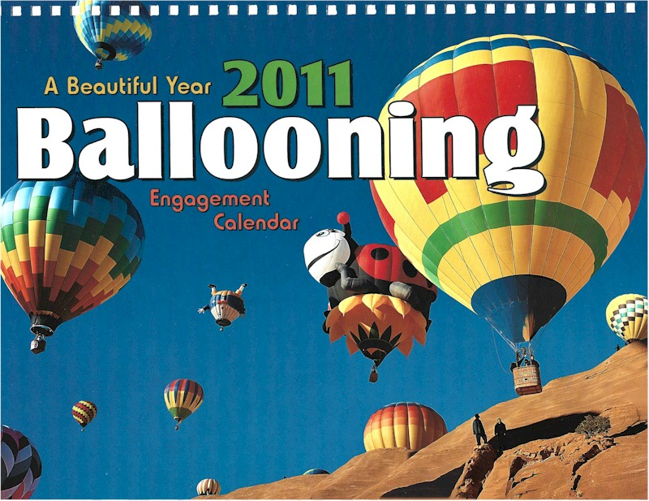

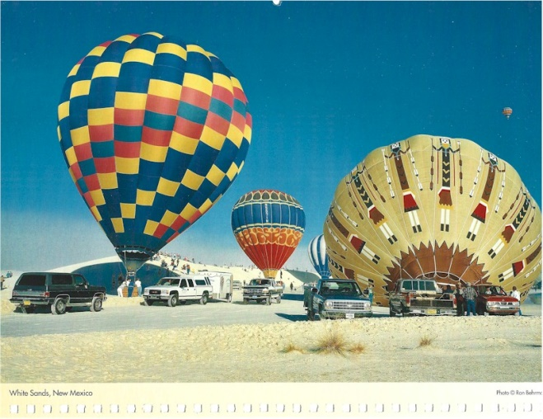
Behrmann's Balloon Lt. – “A Little Exposure”

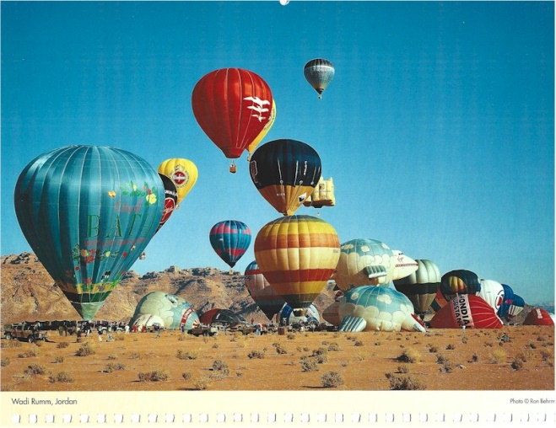

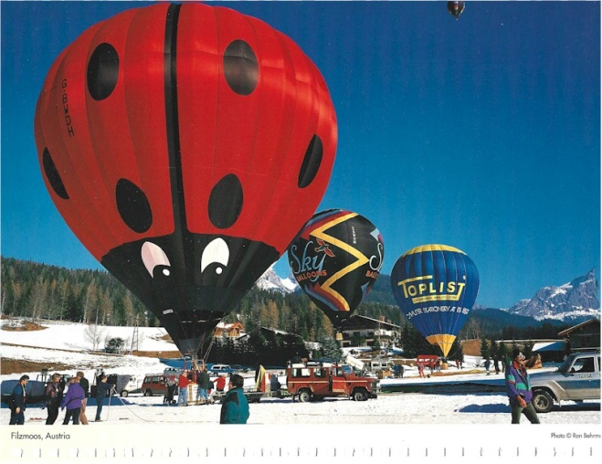
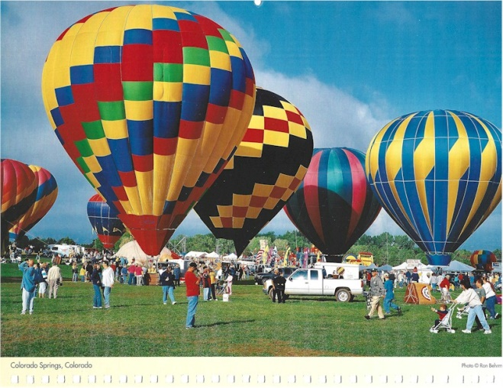

Ron currently serves as the Vice President of Creative New Mexico, an arts advocacy group. He recently left a position as President and Executive Director of the New Mexico Arts & Crafts Fair after 13 years.

