
Dave Reineke
Notable – Ed Yost Master Pilot Award

- 1978 August- First ride in a Piccard 6, Champaign-Urbana Balloon Club
- 1981 June- First solo
- 1981 August-Private license
- 1982 February- Commercial license
- 1982 November- Purchased first balloon, a Balloon Works 6B “Big Bird”
- 1994-2001- Purchased three more balloons, His and Hers Cameron Concept 80s and a Z 77
- 2001-2003- Began my special shape career with Mr. Potato Head and was able to travel to many events in the US and Canada plus some international events as well.
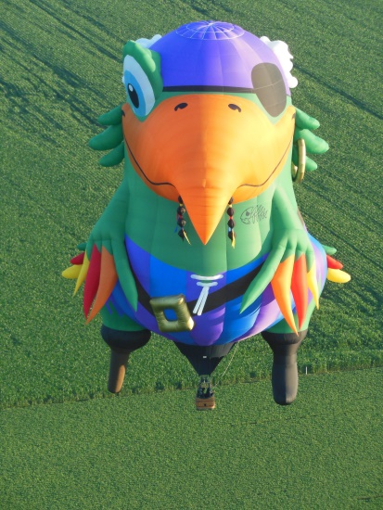
- 2004-2012- Mr. Potato Head had an extreme makeover to “Bud E. Beaver”. We operated Bud throughout the world. Countries besides the US and Canada it included the UK, the Netherlands, Belgium and Australia.
- 2013-Present- “Peg Leg Pete” has become our latest alter ego and we have enjoyed entertaining kids and others of all ages all over the world again.
- 2016-Purhased our current regular balloon, a Lindstrand Racer 77X
- 2021 – Received the Ed Yost Master Pilot Award for 40 years of safe flying

My life has never been the same from my first ride. The joy of having my wife join me in my sport is just an incredible bonus. My kids have grown up thinking nothing of getting up at 5 am for Mom and Dad! We have gained close wonderful friends from all over the world and continue to create new ones. Each flight is a new adventure. I intend to continue to fly as long as possible and hope to inspire some new dreams and lots of smiles at each event.

