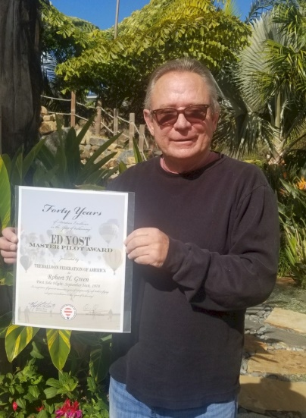
Green, Robert Hamilton

Notable – Ed Yost Master Pilot Award

I have always loved aviation. I grew up in the right seat of my Fathers Bonanza which he kept at the Torrance airport in Southern California. I started taking fixed wing lessons in June of 1971. I accumulated 37.6 hours in fixed wing in instruction, solo and solo cross country. In 1976 A schoolmate showed up with a hot air balloon in his truck and we went flying in the high desert for the next three days. I was hooked. Thank you, Bobbie Willits.
While attending college at Pacific University in Oregon I tracked down a flight instructor for balloons. His name is Chris Kirby. We took our first flight together in June of 1978 and I had my first solo flight on September 16th, 1978 and was signed off for my Private Pilot on October 18th 1978. I flew as often as I could and accumulated enough hours to go for me Commercial Pilots License which I obtained on March 14th 1979.
I flew all over the Pacific Northwest and am a founding member of the Pacific Northwest Balloon Association. Competed in races in Boise, Clarkston Lewiston, Walla Walla, Bend, Moses Lake to name a few. Northwest Balloon Association First Place Overall Champion November 10th 1979. I do not have the exact number NWBA Overall Champion awards I won but it was at least four titles.
I started doing commercial rides in early 1980. It helped pay my tuition through college. I was doing a commercial flight with passengers on May 19th 1980 and witnessed the eruption of Mount St. Helens from approximately 3,500 feet. I later lost my first balloon due to ash from the eruption getting into my envelope over time during inflations. The envelope failed its annual and It was quickly replaced.
In August of 1995 I had the pleasure to attend the Chambley balloon race in Loraine. I flew eighteen times over the course of the ten-day event flying with over 500 balloons. It was quite the adventure and I scored fourth place overall with a total of 2,300 points.
In 1984 I moved from the Pacific Northwest to San Diego California. Flying in San Diego North County in those days was wide open and I flew a lot. Unfortunately, the development of vacant land there has now made flying nearly impossible. All but one commercial outfit has left the area and I will not fly it anymore. I fly when vacationing at our summer home in Healdsburg CA, with friends in Santa Ynez and when attending balloon races in the Pacific Northwest.
In regards to the Ed Yost Award. First of all, I want to say how honored I am to receive this award. Thanks to Bobbie Willits for taking me on my first balloon flight in his balloon "Will it Fly" and exposing me to this amazing dimension of flight.
Thank you to my mentor Chris Kirby for teaching me this amazing art. I Couldn't have done it without you!
Thank you to my fellow Aeronaut Kong for submitting the application and for being a dear friend for all these years.

Thank you to the thousands of passengers I have been able to share this amazing sport with and give you a new perspective on getting high. Finally thank you to all my friends and loved ones who have crewed for me over the years whom without I would never be able to fly in the first place.
I am humbled by receiving this award.

Soft Landings!

