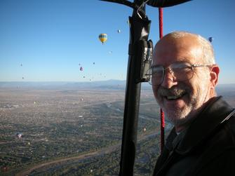
Dave Sullivan

Notable – Ed Yost Master Pilot Award, Shields Trauger Award

125 Redwood Circle,
Fayetteville, Georgia 30214
770-719-9492 (office) / 678-357-3271 (cell)
info@balloonacyltd.com
BACKGROUND
Retired military officer / former helicopter instructor pilot with over 2800 hours of flight experience. Owner/operator of balloon repair station since 1994, owner/school administrator for sole balloon flight training program in the Southeast with FAA approval.
Previous consulting positions include maintenance data program analysis and changeover for Delta Air Lines, tech writer for contractor for rewrite of FAA training handbooks. Former contract training manager for Raven/Aerostar; developing training program for major manufacturer / supplier of aerostat surveillance programs and equipment to U.S. and foreign government / military agencies.
EDUCATION
- BS, Education/Sociology, Excelsior University, Albany, NY
- Graduate work in Aviation Management/Safety Management, Embry-Riddle Aeronautical University
- Military Instructor Pilot Course, U.S. Army Aviation Center, Fort Rucker, Alabama
Human Factors and Risk Mitigation Course, U.S. Army Safety Center, Fort Rucker, Alabama
- Accident Investigator’s Course, U.S. Army Safety Center, Fort Rucker, AL
500+ hours safety seminar continuing education in current standards of pilot decision-making, federal regulations, accident analysis, weather and maintenance/repair by the nation’s leading authorities in ballooning.

OCCUPATION
- Commercial Pilot, Rotary-Wing/Instrument, and Lighter-than-Air, Free Balloon (limited to airborne heater).
- Balloon Instructor Pilot; Flight Instructor for FAA Air Agency Part 141 Flight School
- Military Instructor Pilot, Rotary-Wing, CH-47 Initial Qualification and Transition Courses
- Hot Air Balloon Repairman; FAA Repairman Certificate 3714815
- Certificated Flight Instructor, Rotary-Wing, 2684028CFI (expired)
- Designated Pilot Examiner SO-11-61
- Corporate Balloon Program Manager/Pilot

CORPORATE SPONSORS
- Harley-Davidson
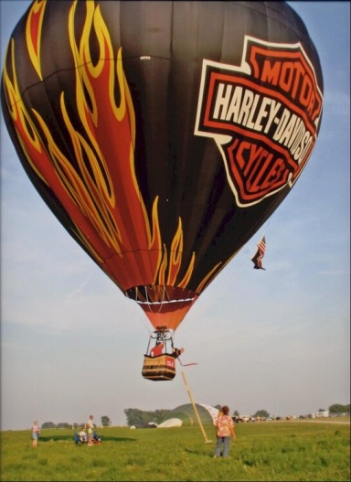
- Evoshield
- Ringling Brothers & Barnum and Bailey Circus (Feld
Entertainment)
- World Championship Wrestling
- FOX Television

PUBLICATIONS – BOOKS
- Lead Technical Writer/Author, Balloon Flying Handbook, FAA-H-8083-11A
- Technical Writer/Contributor, Aviation Instructor’s Handbook, FAA-H-8083-9A
- Technical Writer/Contributor, Rotorcraft Flying Handbook, FAA-H-8083-21A
- Technical Writer/Contributor, Pilot’s Handbook of Aeronautical Knowledge, FAA-H-8083-25A
- Project Manager for rewrite of FAA General, Airframe, and Power Plant Training handbooks
- Numerous technical publications, field manuals, and concept documents for U.S. Army Aviation Center, Fort Rucker, Alabama
INDUSTRY ACHIEVEMENTS
- Conceptualized and fielded first fully mobile hot-air balloon repair station in the United States.
- Attended major competitions and events to provide on-site repair and maintenance
services for competition balloon pilots.
- Consulted with the Federal Aviation Administration in first major rewrite of Private and
Commercial Pilot Practical Test Standards, setting requirements and guidelines for
balloon pilot testing and certification.
- Provided the only federally recognized (FAA Part 141) balloon flight training program on the East Coast. In October 2012, the school was selected as one of the top 50 flight training programs in the United States by AOPA (Aircraft Owners and Pilots Association).
- In 2013, designated as parts supplier for Raven/Aerostar balloons, which ceased manufacturing In 2008. Provides parts and consumable for the Aerostar line of balloons worldwide. Took possession of the Aerostar type certificate in December, 2021.
- Currently hold repair station authority for Ball Variometer line of instruments as used in hot air balloons, the only such facility worldwide.
- Certified and brought to market the Digitool DBI3 flight instrument, in partnership with Digitool AB, Stockholm, Sweden. Conceptualized instrument in conjunction with the Design team, and achieved full STC certification in September, 2017. Serves as worldwide distributor and certification holder on three continents for same.
- Recipient of the Balloon Federation of America’s Ed Yost Master Pilot Award, for completing 40 years or more of safe flying Recipient of the Balloon Federation of America’s Shields-Trauger Memorial Award, for “lasting contributions to Safety in Ballooning”
SEMINAR INSTRUCTION – FEATURED SPEAKER, BFA SANCTIONED SAFETY SEMINARS
- Balloon Federation of America National Convention
- Heart of Dixie Balloon Club, Decatur, Alabama
- Georgia Balloon Association
- Hot Air Balloons in Tallahassee (Florida)
- Wisconsin Balloon Group
- Indiana Balloon Association Carolina Balloon Association
EXPERIENCE
- Balloon Pilot since 1974; helicopter pilot since 1985. Total of over 2800 hours experience with outstanding safety record.
- Balloon repairman since 1994; maintains client base of approximately 105 customer.
- Designated Pilot Examiner, Lighter-than-Air, Free Balloon (limited to airborne heater)
Previously served as Aviation Safety Counselor, Atlanta FSDO, Atlanta, Georgia
RELEVANT EXPERIENCE
- Nine years as military paralegal; primary focus in military criminal law, with both
prosecution and defense experience; claims laws and adjudication.
- Served as defense counsel in military summary court actions.
- Has consulted on several civilian litigation actions regarding balloon accidents.
- Provides advice and counsel to National Transportation Safety Board investigators regarding pilot training/aeronautical decision making and risk management
procedures
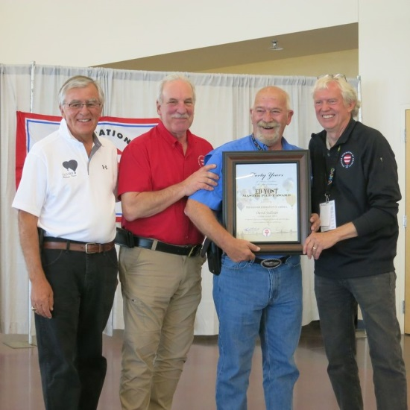
NOMINATON OF DAVID SULLIVAN
FOR THE 2021 SHIELDS TRAUGER AWARD
On behalf of the entire ballooning community, we’d like to nominate David Sullivan for the 2021 Shields-Trauger Award for his important long-term contributions to flying safety.
Dave was truly instrumental in the design, testing, and worldwide certification of Digitool flight instruments, but his 40 years of flying expertise is literally weaving the fabric of ballooning’s future. Founding a Part 141 flight school and serving as an aviation counselor for the Atlanta FSDO were just the beginning. Dave is one of only several certified legal experts in ballooning who has testified in court and defused frivolous charges and claims before they reached a court. By FAA request, he has served on several working groups including aviation rulemaking and practical test standards. He has also advised NTSB investigators regarding LTA training, decision-making, and risk management. His expertise is both renowned and demanded.
Dave freely shared and codified this expertise with military precision as lead technical writer for the FAA’s 2008 Balloon Flying Handbook (and also served as lead advisor on the forthcoming edition). A complete rewrite of the 2001 edition, it provides comprehensive instructional and legal guidance for our industry as no other document ever has or does. This document provided clear legal standards used in ballooning’s defense during a 4-year proceeding for wrongful death of a crew chief against the State of New York beginning in 2016. These standards proved sufficient to show neither additional Dept. of Labor nor OSHA regulation – including workmen’s comp taxes on all crew on every flight nationwide – were required within our industry. See the 2021 BFA Online Seminar presentation “The Gravity of Safety” – which he also sponsored - for a complete account of this story.
Though preferring his behind-the-scenes role, Dave has also publicly supported our most visible safety programs. He has served as a BFA featured speaker at numerous seminars (GA, NC, FL, AL, WI, and others) and has donated merchandise as door prizes as well. To further continuing education for pilots and crew, he has sponsored BFA online seminar accident review presentations for many consecutive years. To reach tomorrow’s pilots, he has donated cases of Balloon Flying Handbooks to BFA junior balloonist camps. Generously sharing to the highest standards is what Dave does.
Most importantly, Dave serves as one of ballooning’s few go-to resources with guidance and perspective on every aspect of flying. Legal, technical, instructional, or operations questions? Call Dave for straight answers. We all do – including BFA board members. Dave’s safety fingerprints cover my writing on crew and flight safety, honing them long before they’re printed . Without any concern for attention, Dave has named every balloonist as a beneficiary of his crucial and prolific work. One small way we can repay him is by honoring his work in service to us all with the 2021 Shields Trauger Award. Thank you for considering this nomination for David Sulllivan’s unmatched contributions to our collective flying community and future.

Submitted by: Gordon Schwontkowski
Alyssa Sullivan

