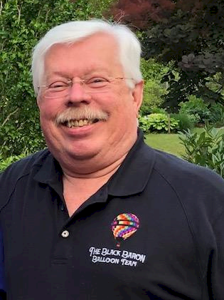
John Herbst

Notable – Ed Yost Master Pilot Award

John Herbst, of Lexington, Kentucky, is a commercial pilot who is forever grateful to his long-time friend and mentor, Ollie James Schoo for getting him started in the sport. It all started in 1976 when Jim assisted John and students at the University of Kentucky (UK) in organizing the first hot air balloon event at any university in the United States to raise money for scholarships. After those early Little Kentucky Derby hot air balloon races at UK, John served as Jim Schoo’s crew chief for about 10 years.
Then in 1988 John went with Mr. Schoo to Louisville to have a balloon inspected. On the trip back to Versailles, Jim took a detour. When John asked where we were going, Jim would only say, “I’m taking you to buy your first hot air balloon.” John protested, “Schoo, I can’t afford a hot air balloon.” Well-known for sharing his wisdom, Jim proclaimed, “If you wait until you think you can afford to do something in life, you will be too old to do it.” So, John’s story of becoming a pilot began that day. After buying the Cameron Viva 77 from the mysterious seller, Bob Corey, he soon soloed on June 21 and achieved his private certificate on October 20. He then got his commercial pilot certificate on November 11 of the following year and has since accrued over 650 hours of flight time.
Continuing Jim Schoo’s community service legacy, John took over as the Clean Air For Kentucky hot air balloon pilot and principal environmental educator for The Division of Air Quality, Kentucky Cabinet for Natural Resources, Commonwealth of Kentucky from 1996 to 2008. During those years John traveled to nearly every county in the state talking to thousands of students and their teachers about the importance of conserving natural resources and protecting the environment, as well as discussing aviation and weather. This program became nationally-recognized as an innovative teaching model. There are very few pilots in the state who have exposed more students to the sport of ballooning than John Herbst.
John has flown in many hot air balloon events throughout the United States including festivals in Arkansas, Tennessee, New York and Kentucky. For several decades he organized the annual UK Little Kentucky Derby Balloon events, and for many years the Fourth of July hot air balloon events for the Lexington Festival Commission. He is a long-time member of Balloon Society of Kentucky (BSOK) and the Balloon Federation of America.
Like many members of BSOK, John learned about more than just balloons from founding member Jim Schoo. One sage piece of advice from him was about raising John's son Marshall. “Give children all the education and travel experiences you can,” Schoo said. “Those are the only two things in life that no one can ever take away from them.” So when he bought his second balloon, a Cameron C-80, John gave his son an opportunity to be part of that endeavor. "It was color-designed by Marshall when he was 7 years old," John recalled. In addition to studying to fly a balloon under his father, Marshall has continued to study internationally and travel extensively, completing his Baccalaureate Degree from Hanover College (IN), his Masters Degree in Education from UK, his International Certification for Montessori Education, and his Doctor of Medicine from UK.
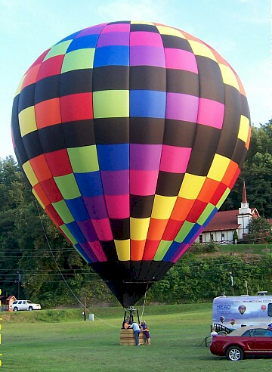
John credits his ballooning success to several members of BSOK: Bob Corey for his flight training, Mike Ehrler for his first pilot certificate, Bob Boswell for being the greatest friend who taught him more about balloons than anyone, and of course, Ed LaFontaine, who always helped and worked with Schoo and him with their flight reviews. He is also thankful to all the hot air balloon enthusiasts who have been such remarkable part of his life.
John received his Baccalaureate degree from SUNY Geneseo, and his Master of Education Degree from Boston College. He is the Executive Director Emeritus of the UK Gatton Student Center where he served since 1997. Previously, he was the Director of Student Activities at UK. John has also produced a number of entertainment shows for television and Lexington Gala Fundraisers, including serving as Executive Producer for "Ladies of Note," recognized by the National Educational Television Association as the first place major concert live performance in a major market. With all his education and life skills, John Herbst has been an inspiration in the lives of many young people in his state, and is a true asset to the entire ballooning community. John received the Balloon Federation of America Ed Yost Master Pilot Award for 40 years of safe flying in 2022.

