BALLOON FEDERATION OF AMERICA
HALL OF FAME COMMITTEE
RECOMMENDATION FOR INDUCTION IN 2022

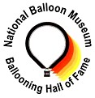

UNITED STATES BALLOONING HALL OF FAME
A Partnership of the Balloon Federation of America and the National Balloon Museum

Candidate Information Form

Date Submitted: 6/11/2021

CANDIDATE NAME: Mike Emich

Contact Information:

Address: 1595 Juniata Rd

City: Akron State: OH ZIP: 44305-1336

Telephone: (330)606-6598 E-mail: emichmike@aol.com

Briefly describe the basis for the submission:

Mike Emich has pursued aviation adventure since early childhood. As a youth, his father would take him out to Akron Municipal Airport to see the Goodyear blimps, the great airship hanger and all of the aviation activity that would take place there in the 1960’s. Emich obtained a student pilot license at age 17, and earned his commercial pilot certificate for hot air balloons in 1974 at 18 years of age. He subsequently upgraded that certificate in 1983 to include gas ballooning.
He built his first hot air balloon in the mid 1970’s, a 21,000 cubic foot Tyvec balloon with a chair gondola. He has gone on to build numerous other amateur built experimental balloons and restored to flying status two WW II US Navy Gas balloons. In 1980 he was a founding board member of NOBPA (Northern Ohio Balloon Pilots Association).
On October 26-27, 1985, he and co-captain William Armstrong launched from Akron in a 43 year old US Navy surplus 19,000 cu ft hydrogen balloon they restored. Their efforts paid off when they landed the next morning 515 miles downwind in Northboro, Mass., setting the US National Distance Record for FAI Category AA-4. For this flight Emich and Armstrong were awarded the Balloon Federation of America’s Shields-Trauger Award, the highest award in American Ballooning.
Starting in 1991, he had extensive involvement in the Earthwinds TransGlobal Balloon Flight. Enthused from his work on the Earthwinds project and a skilled experimental balloon builder by this time Emich decided to design and build an AX-5 hot air balloon to attempt to exceed the current distance record. He was successful on January 10th, 1998 when he set a new AX-5 world distance record in a 270 mile flight from Washington, IL to St. Mary’s, OH. In 1999 he designed and built a smaller AX-4 balloon in which he set the world distance record in a 184 mile flight from Galesburg, IL to Centralia, IL.
Emich continues to fly and build experimental balloons and competes on a local and regional basis in sanctioned balloon events and participates in the BFA National Ranking System.

Provide references: Identify two individuals that can speak to the quality and significance of the achievement, and to the character of the candidate.

Reference Name: Bill Armstrong E-Mail: billarmstrongjr@gmail.com

Reference Name: Maury Sullivan E-mail: tequilatom@aol.com

See letters of recommendation at end of this document.

PERSON MAKING THE SUBMISSION:

Name: Mick Murphy

Address: PO Box 14528 City: Litchfield State: CT ZIP: 06759-4955

Telephone: (203) 910-4955 E-mail: info@aerblarney.com

CANDIDATE HISTORY:

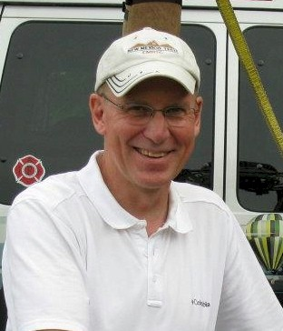
Michael C. Emich

Notable – Ed Yost Master Pilot Award, Record Holder, Shields Trauger Award

Current Contact Info: 1595 Juniata Road
Akron, OH 44305-1336
(303) 606-6598

Solo Date: 9/8/1974 Balloon License Date: 10/27/1974

No balloon accidents - No FAA enforcement actions

A native of Akron, the cradle of American lighter-than-air aviation, Mike Emich has pursued aviation adventure since early childhood. As a youth, his father would take him out to Akron Municipal Airport to see the Goodyear blimps, the great airship hanger and all of the aviation activity that would take place there in the 1960’s.
Emich became a member of The Lighter-Than-Air-Society at age 12. He built and flew competitively a number of model hot air balloons, culminating with three consecutive wins that retired the LTA Society’s Montgolfier Trophy. During his membership he became one of the youngest board members of the LTA Society. His association with the LTA Society helped him find National Lighter than Air, later to become Balloon Flyers of Akron (BFA). The BFA was an active flying club with one of the largest collection of gas balloons in the nation. As a high school student, he would hitchhike out to Wingfoot Lake Airship Base in suburban Akron to assist the club’s senior gas pilots in restoring and flying gas balloons, at that time virtually a disappearing art. His association with this club allowed him to meet and fly with such early balloon pioneers as Ward T. Van Orman, three time Gordon Bennett winner in the 20’s and 30’s, James Contos, Tony and Mike Fairbanks and many others.
Emich’s first balloon flight was a tether flight with Dr. Fred Kissell at the 50th Anniversary of Lakehurst Naval Air Station in 1971. Kissell owned a Raven 105 with a Piccard basket and burner. Later that year Emich rode with Kissell, this time in free flight from Randolph, Ohio to Ravenna, Ohio.
He participated in the support team for the Category AX-7 through AX-10 hot air balloon world duration record set by Bobby Sparks in 1972.
Emich obtained a student pilot license at age 17, and earned his commercial pilot certificate for hot air balloons in 1974 at 18 years of age. Robert Zanella provided much of that training and his check ride. He subsequently upgraded that certificate in 1983 to include gas ballooning.
He built his first hot air balloon in the mid 1970’s, a 21,000 cubic foot Tyvec balloon with a chair gondola. It now resides in the BFA Museum in Indianola, Iowa. It is quite possibly is one of the first hoppers built in the US. He has gone on to build numerous other amateur built experimental balloons and restored to flying status two WW II US Navy Gas balloons.
In 1980 seeing the growing number of hot-air balloons in the northern Ohio area, Emich along with several other pilots saw the need for a pilot’s organization for the new group of enthusiastic hot-air pilots and was a founding board member of NOBPA (Northern Ohio Balloon Pilots Association)
Following a series of overnight gas balloon training flights, he attempted a gas balloon record. On October 26-27, 1985, he and co-captain William Armstrong launched from Akron in a 43 year old US Navy surplus 19,000 cu ft hydrogen balloon they restored. Their efforts paid off when they landed the next morning 515 miles downwind in Northboro, Mass., setting the US National Distance Record for FAI Category AA-4. They eclipsed the previous mark of 478 miles set in 1927 by Lt. (later Vice Adm.) Thomas G. W. Settle, the Navy’s ace balloonist of the racing era. For this flight, Emich and Armstrong were awarded the Balloon Federation of America’s Shields-Trauger Award, the highest award in American Ballooning and The Lighter-Than-Air-Society’s Achievement Award, the highest award given by that organization. (Larry Newman and the crews of Double Eagle II and Double Eagle V and Joe Kittinger were previous recipients).
Starting in 1991, he had extensive involvement in the Earthwinds TransGlobal Balloon Flight, serving in a number of assignments ranging from NAA Directing Official to assistant launch master and finally being selected as co-captain of the first 1993 launch attempt.
Enthused from his work on the Earthwinds project and a skilled experimental balloon builder by this time Emich decided to design and build an AX-5 hot air balloon to attempt to exceed the current distance record. He was successful on January 10th, 1998 when he set a new AX-5 world distance record in a 270 mile flight from Washington, IL to St. Mary’s, OH. In 1999 he designed and built a smaller AX-4 balloon in which he set the world distance record in a 184 mile flight from Galesburg, IL to Centralia, IL.
Emich continues to fly and build experimental balloons and competes on a local and regional basis in sanctioned balloon events and participates in the BFA National Ranking System.
In addition to lighter than air flight Emich holds SEL, MEL, Instrument fixed wing ratings and owns a Cessna 150 that he flies regularly. In the 1970’s, 80’s and 90’s Emich was also a very active skydiver with over 1300 jumps to his credit. His highest jump was from 21,000 feet and the most interesting jump was from a Boeing 727 jet.
Now retired, Emich served as a Lieutenant for the Akron, Ohio Fire Department for the past 25 years as a company officer in charge of Akron Station #11, Paramedic, Acting Battalion Captain and State Certified Fire Inspector.

Affiliations:
- Member Balloon Flyers of Akron and past President
- Member Balloon Federation of America
- Founding Member Northern Ohio Balloon Pilots Association
- Honorary Life Member The Lighter-Than-Air Society
- Member United States Parachute Association
- Life Member Akron Skydivers
- Life Member Alliance Sport Parachute Club
- Founding Member Aero Club of America NC Chapter
- Balloon Federation of America Gas Balloon Division Vice Chairman 2014-2015
- Balloon Federation of America Gas Balloon Division Chairman 2016
- Balloon Federation of America Gas Balloon Division Chairman 2017

Awards and Recognition
- US National Record Category AA-4 Distance 1985
- US National Record Category AX-4 Distance 1999
- US National Record Category AX-5 Distance 1998
- World Record Category AX-4 Distance 1999
- World Record Category AX-5 Distance 1998
- FAI Sporting Badge- Complete Silver
- FAI Sporting Badge- Gold -Duration and Goal
- FAI Sporting Badge- Diamond -Distance
- FAI Group Diploma of Honor- 2015 Aero Club of America for the significant contribution to the progress of Aeronautics through their contribution to the progress of Gas Ballooning in the USA
- Balloon Federation of America Shields -Trauger Award 1986
- Balloon Federation of America – Ed Yost Master Pilot Award 2014
- The Lighter-Than-Air Society’s Achievement Award 1986
- NOBPA Gayle Myers Founders Award 2010
- NOBPA Robert Zanella Club Champion Award 2010
- Balloon Federation of America -Master Instructor
- United States Parachute Association- Gold Wings
- 7th Place 2014 America’s Challenge Gas Balloon Race
- 5th Place 2016 America’s Challenge Gas Balloon Race
- BFA Gas Balloon Division Chair 2016-2019
- Completed FAI Gold Sporting Badge with 1 Diamond - 2018.
One of two Gold Badges given world wide that year. Both to US pilots.
- BFA Directors Award At Large, 2019
- Lighter Than Air Society P. Rendall Brown Lifetime Achievement Award - 2019
- Americas Challenge Results – 2016, 5th Overall & 3rd US – 2017, 6th Overall & 3rd US

Safety Seminar Participation:
- Many presentations made at BFA Safety Seminars on Pilot Decision Making, Experimental Balloon Building, Gas Ballooning and Record Setting.
- Served as Safety Officer at many local and regional balloon events.
- Presented at regional and national safety seminars on various topics.
- Presenter at BFA National Convention in Louisville, KY and Reno, NV

Most Memorable Flights:
- 1995 night crossing of Lake Erie and Lake Ontario in a WW II US Navy Gas Balloon with Bill Armstrong
- 1993 flight across Horseshoe Falls at Niagara Falls, Canada with Carol and Kenny Weiner in the special Shape “Mr. Winter”
- 1986 Gas flight from the lawn of the Air Force Museum in Dayton, Ohio celebrating the 40th Anniversary of the US Air Force

See 19 Sept 2019 article from FAI on following pages.

FÉDÉRATION AÉRONAUTIQUE INTERNATIONALE WORLD AIR SPORTS FEDERATION
19 Sep 2019

MICHAEL EMICH, FROM HUMBLE BEGINNINGS TO THE FAI/CIA SPORTING BADGE GOLD WITH ONE DIAMOND

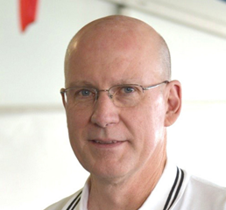
Michael Emich is an accomplished balloonist who has been pushing boundaries and records since the 1980s. He pilots both Hot Air and Gas balloons, and he has built his own balloons to further the pursuit of his goals. He was awarded this year with the prestigious FAI/CIA Sporting Badge, Gold with one Diamond, in recognition of his achievements.

HUMBLE BEGINNINGS

Michael (Mike) Emich got his start in aviation as a child, watching the Goodyear blimps at his local municipal airport with his father. From then on, he hit the ground running. At the age of 12, Mike became a member of the Lighter-Than-Air-Society, based in Akron, Ohio USA.
By the time Mike reached high school, gas ballooning was a disappearing sport. Based at a nearby small airstrip in Ohio, a group of senior pilots were restoring and flying gas balloons. Mike would hitchhike his way out the airstrip to get hands on experience and assist in the restorations.
Emich got his first taste of the sky in 1971 when he got the chance to go on a tethered balloon flight for the 50th Anniversary of Lakehurst Naval Air Station. In just three short years, Mike became Pilot in Command and flew his own balloon solo in September of 1974.

BUILDING SUCCESS

Not long after gaining his Commercial pilot certificate at the age of 18, Mike built his very own balloon. This was a 21,000 cubic foot “Cloud Hopper” balloon constructed of Tyvek with a chair gondola. This balloon is now on display at the National Balloon Museum in Indianola, Iowa, USA.
Since then, Mike has built and restored numerous other experimental balloons, including two WWII US Navy Gas Balloons with friend Bill Armstrong. It was in one of these balloons that Mike and Bill set a US National AA distance record in 1985, a flight lasting 17 hours covering 828.8 kilometers. Mike is a recipient of the Balloon Federation of America (BFA) Shields Trauger Award (highest award given by the BFA) for this notable flight.

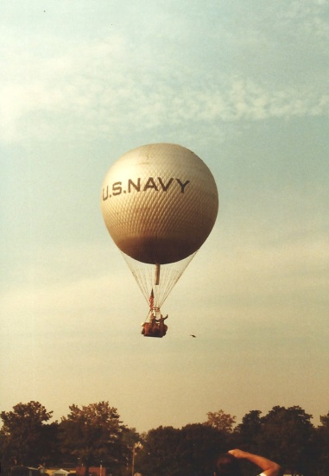
Navy Gas Balloon restored by Mike Emich and Bill Armstrong.
This flight earned Mike US National AA distance record in 1985.

GOING FOR GOLD

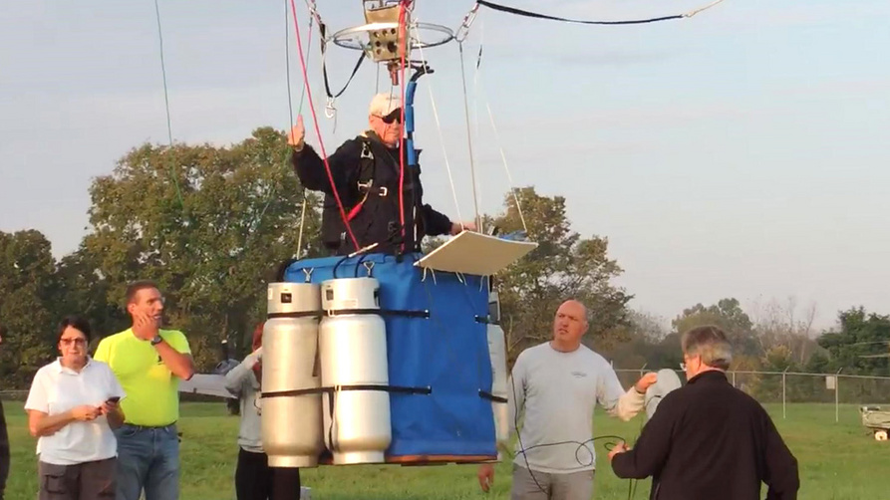
Emich launches in his homebuilt balloon in pursuit of the FAI Gold Badge Altitude.

On March 15, 2019, Mike Emich received the prestigious FAI/CIA Sporting Badge, Gold with 1 Diamond. Emich used his record flight from 1985 as the platform for his Gold Duration and Gold with Diamond Distance needed for his badge.
A 2016 BFA sanctioned event in Middletown, Ohio provided the perfect place to secure a Gold Goal performance of 0.3 meters. All that was left was an altitude flight over 6000 meters. In the US, balloon flights over 5,486 meters (18,000 feet) require advance notice and special permission from the Federal Aviation Administration (FAA). Months of meetings and planning with the FAA all lead up to one day. On October 7, 2018, Emich launched from Lancaster, Ohio, USA in a homebuilt balloon climbing to an altitude of 6,766.6 meters (22,200 feet), successfully accomplishing the needed Gold Altitude. Emich’s incredible Gold Sporting Badge achievement was one of only two Gold Sporting Badges awarded in 2018. Mike shared his feeling about accomplishing these records: “I think what I am most proud of is all of the hot air records and altitude flight were done in balloon systems of my own design and construction.”

BEYOND THE BADGe

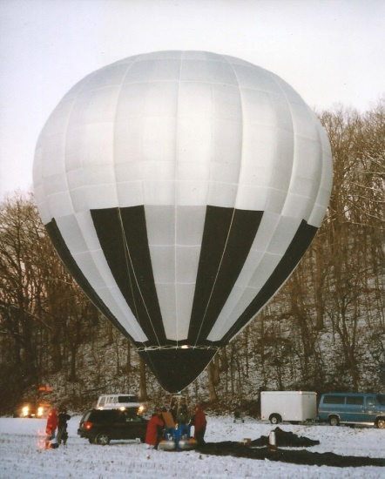
The “Silver Shadow”, and AX-05 balloon designed and built by Mike Emich.
Emich launched on January 11, 1998 and covered 434.7 km, obtaining the world distance record.

Emich also set two World Records in AX-04 and AX-05 Distance. The first was in January 1998 flying an AX-05 balloon of his own design 434.7 km. He was back at it the following year in February 1999. This time in another homebuilt AX-04 flying a distance of 295.85 km.
Mike was a recipient of the BFA Ed Yost Master Pilot Award. The Balloon Federation of America's Ed Yost Master Pilot Award recognizes lighter than air (LTA) pilots who have demonstrated professionalism, skill and aviation expertise by maintaining safe operations for 40 or more consecutive years as active pilots. Mike has been flying for more than 45 years and has more on his list to accomplish. He’s not done yet. For aviators like Mike, the sky is not the limit, the sky is home.

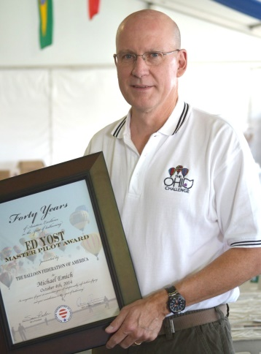
Mike Emich receiving the Balloon Federation of America Ed Yost Master Pilot Award
for 40 consecutive years of demonstrated professionalism, skill, and safe aviation expertise.
Presented on October 4th, 2014
Story by Kimberly Magee
Letters of Recommendation

LETTER IN SUPPORT OF THE NOMINATION OF
MICHAEL C. EMICH
TO THE
BALLOON FEDERATION OF AMERICA
BALLOONING HALL OF FAME

To Whom it may concern:
I have known and respected Mike Emich for more than 40 years. When we met about 1981, both of us already held our commercial hot air balloon certificates and owned our own balloons.
Growing up in northeast Ohio, we both belonged to the (Wingfoot) Lighter-Than-Air Society, and to the Balloon Flyers of Akron (the nation’s largest gas balloon club). Mike joined The Wingfoot LTA Society and the Balloon Flyers of Akron (formerly National LTA) at age 12; decades later, he became president of the gas balloon club. In the early 1980s, he helped to form the Northeast Ohio Balloon Pilots Association (NOBPA) and served as one if its founding directors.
Mike was already a well-respected aeronaut.
As a youth, he built and flew competitively model hot air balloons, culminating with three consecutive wins that retired the LTA Society’s Montgolfier Trophy. He became one of the youngest board members of the LTA Society. His association with National LTA allowed him to meet and fly with balloon pioneers Ward T. Van Orman, Don Overs, James Contos, Roger Wolcott, Tony and Mike Fairbanks and many others.
He was part of the support team for the hot air balloon world duration records set by Bobby Sparks in 1972.
In 1983, Mike and I, flying under the instruction of Don Overs (a founder of the Balloon Federation of America), logged enough gas balloon hours to remove the “airborne heater” restriction from our licenses. We made numerous gas balloon ascents using Navy surplus 19,000 cubic foot training balloons filled with hydrogen, and 35,000 cubic foot racing balloons with helium. On one of our flights, we established a national distance record (829 km) for FAI Category AA 4 balloons, flying from Akron to a Boston suburb. For this we were co-recipients of the BFA Shields-Trauger Award and the Lighter-Than-Air Society Achievement Award.
Starting in 1991, Mike had extensive involvement in the Earthwinds TransGlobal Balloon Flight, serving in assignments ranging from NAA Directing Official to assistant launch master for the Akron launch attempts and finally being selected as co-captain of the second launch attempt in 1994 from Reno, Nevada.
Mike subsequently competed in several America’s Challenge gas balloon competitions and was elected to the BFA Gas Division board, serving as chairman from 2016-2019. He co-founded the Aero Club of America, which operates a 25,000 cu.ft. gas balloon to train gas balloonists and make recreational flights.
In hot air ballooning, Mike Emich competes in regional sanctioned balloon events and participates in the BFA National Ranking System, flying commercial type-certified balloons as well as balloons of his own manufacture.
Since the 1970s, he has been designing and building hot air balloons, including a 21,000-cu.ft. Tyvek balloon with a chair gondola that now resides in the BFA Museum in Indianola, Iowa (one of the early hoppers in the U.S.); an AX-5 hot air balloon in which he set a new world distance record on a 270-mile flight in 1998, and an AX-4 model in which he set a world distance record in a 184-mile flight in 1999. His 2018 ascent in a home-built AX-5 racer to 22,200 feet helped him qualify for the FAI Gold Sporting Badge, one of only eight U.S. pilots to earn this distinction. He has designed, built and flown more than 16 sport hot air balloons.
He received the Ed Yost Master Pilot Award in 2014 and is a co-recipient of the 2015 FAI Diploma of Honor for the Aero Club of America’s contribution to the progress of aeronautics
In general aviation, Mike holds commercial single-engine-land, multi-engine-land, and instrument fixed wing ratings, and owns a Cessna 150 (N8976S) that he flies regularly. For three decades he was an active skydiver, logging more than 1,500 jumps. His highest jump was from 21,000 feet and his most interesting jump was from a Boeing 727.
Mike has always been generous with his time and his knowledge, making numerous safety seminar presentations and sharing his knowledge with other members of the aviation community. His presentations cover topics such as Pilot Decision Making, Experimental Balloon Building, Gas Ballooning and Record Setting.
In 2021, he coauthored the highly acclaimed definitive history of gas ballooning in the Midwest, a 342-page book entitled “HANDS OFF! Epic Adventures of the Balloon Flyers of Akron” with Bill Armstrong.
In professional life, Mike served as a Lieutenant for the Akron, Ohio Fire Department for 25 years, where he was a company officer in charge of an Akron Station, Paramedic, Acting Battalion Captain and State Certified Fire Inspector and an officer on the Summit County Special Operations Response Team.
He and his wife Rosanne live in Akron, Ohio.
Mike Emich belongs in the Ballooning Hall of Fame, where his presence will inspire others to emulate his good fellowship, strong safety record and his remarkable creativity.
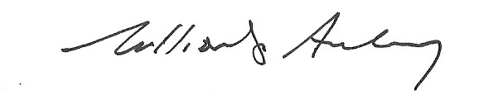

William G. Armstrong Jr.

